Pär Björkander

[Draw your reader in with an engaging abstract. It is typically a short summary of the document. When you’re ready to add your content, just click here and start typing.]

Windows Intormation Protection

The Ultimate Guide

**Windows Information Protection (WIP) – the basics** 4

**Data separation & Windows Information Protection** 5

**Corporate data** 5

**Personal data** 5

**Enlightened applications vs Unenlightened applications** 5

**App Protection Policies with WIP** 5

**WIP with Enrollment** 5

**WIP without Enrollment (WIP-WE)** 6

**Prerequisites for WIP** 6

**Good to know** 6

Configuring Intune MDM User Scope and MAM User Scope for Windows 10 7

Prerequisites 7

Configuring MDM User Scope and MAM User Scope 8

MDM users scope 9

MAM users scope 12

Misconceptions about MDM and MAM user scope 13

Reasons to only manage the apps (MAM) 14

Different scenarios worked out 14

Final thoughts 15

Windows Information Protection without enrollment 15

Prerequisites 16

Configuring your MAM provider 16

Creating a WIP Protection Policy 16

Adding apps to your WIP Policy 17

Configure required settings 19

Windows Information Protection Network boundary 21

Piloting and deploying WIP 25

Monitoring Deployment status 26

Conclusion 26

Windows Information Protection with Enrollment 26

Prerequisites 27

Configuring your MDM user scope 27

Creating a WIP Protection Policy 27

Adding apps to your WIP Policy 28

Configure required settings 30

Windows Information Protection Modes 31

WIP Learning Mode 31

Windows Information Protection Network boundary 31

Other settings to configure on the advanced settings blade 34

Piloting and deploying WIP 36

Monitoring Deployment status 37

Conclusion 38

**Windows Information Protection User Experience** 38

**Prerequisites** 38

**Windows Information Protection configuration** 39

**Windows Information Protection User experience** 39

**Enlightened vs unenlightened apps** 39

**Copy paste restrictions between applications** 40

**Unapproved browsers** 42

**Approved browsers** 44

**OneDrive for Business: Relocating protected files** 44

**Relocating WIP protected files to OneDrive Personal** 47

**Relocating WIP protected files to Dropbox** 48

**Relocating WIP protected files to USB drives** 49

**Windows Information Protection – Block Mode** 51

**Conclusion** 52

**WIP-WE User Experience** 52

**Prerequisites** 52

**Configuring your MAM provider** 53

**WIP-WE Considerations** 53

**MDM Device Enrollment restrictions** 53

**Windows Information Protection configuration** 54

**Windows 10 test device configuration** 54

**Azure AD registration** 54

**Check your Azure AD registration** 57

**WIP-WE User experience** 58

**Copy paste restrictions between applications** 59

**Unapproved browsers** 60

**Approved browsers** 61

**OneDrive for Business: Relocating protected files** 61

**Relocating WIP-WE protected files to OneDrive Personal** 62

**Relocating WIP-WE protected files to Dropbox** 63

**Relocating WIP-WE protected files to USB drives** 64

**Saving attachments from e-mails** 64

**Conclusion** 65

**Azure Rights Management for WIP** 65

**Prerequisites** 66

**Azure Information Protection Labels** 66

**Windows Information Protection mode** 67

**Azure RMS for WIP User experience** 68

**Preventing data leaks on USB drives** 69

**Conclusion** 70

**WIP Without Enrollment Selective Wipe** 70

**Prerequisites** 70

**Before the selective wipe** 71

**Part 1: Admin triggered selective wipe** 72

**User Experience after a admin triggered selective wipe** 74

**OneDrive for Business after a selective wipe** 74

**Microsoft Office Outlook after a selective wipe** 76

**Part 2: User disconnects Azure AD registered device** 77

**Part 3: Microsoft Outlook offline data files and WIP** 78

**What happens to OST files upon selective wipe?** 79

**What can I do with OST files, once I copied or moved them?** 79

**My personal thoughts on this OST issue** 81

**What can you do?** 82

**Final Thoughts** 82

Troubleshooting Windows Information Protection on Windows 10 82

Troubleshooting Windows Information Protection 83

Troubleshooting WIP topics: 83

Your WIP policy does not apply 83

You want to limit access to SharePoint or Exchange Online on BYOD 84

Downloads from SharePoint or OWA in 3rd party browsers are unprotected 84

You have no internet connection with 3rd party browsers and WIP 85

File downloads from SharePoint or OneDrive have no WIP protection 85

Personal devices automatically MDM enroll with Intune 87

WIP-WE does not work without Azure AD registration 87

Office Outlook offline data files (PST and OST files) are not protected 89

Your RMS template does not apply to your WIP protected devices 89

**Monitoring and collecting WIP audit event logs** 90

**Prerequisites** 91

**WIP monitoring Limitations** 91

**WIP and Azure Log Analytics Workspace** 91

**Analyzing WIP event logs** 94

**Microsoft-Windows-EDP-Application-Learning/Admin** 95

**Microsoft-Windows-EDP-Audit-Regular/Admin** 96

**Microsoft-Windows-EDP-Audit-TCB/Admin** 97

**Searching in Azure Log Analytics logs** 97

**Unenlightened apps** 99

**Other limitations or considerations** 99

**Administrators job – What to do with all this?** 102

**Windows Information Protection (WIP) – the basics**

Certainly Windows Information Protection (WIP) is a great solution for companies who want to enable a bring-your-own-device solution and at the same time protect corporate data. In a previous blog I wrote about [managing BYOD devices with Intune MAM Without Enrollment](https://allthingscloud.blog/manage-byod-devices-with-intune-mam-without-enrollment) and how to manage BYOD with Intune MAM without the need to fully enroll devices into MDM. That blog post focused on mobile devices like phones and tablets running iOS or Android. Let’s have a look at the different options we have with WIP and how we can secure corporate data on Windows 10 without restricting users who want to work on their personal devices too much.

In this post I’ll give an introduction to WIP and talk about how to help protect organizations against data loss and leakage.

This post is part of a series and in upcoming posts will be about Microsoft Cloud App Security, Limiting Access to Exchange Online or SharePoint on unmanaged devices. Combining the power of these tools, will give you a great solution to enable a bring-your-own-device scenario. This first post in the series will focus on Windows Information Protection.

1. **Introduction to Windows Information Protection (this post)**
2. [Configuring MDM user scope and MAM user scope](https://allthingscloud.blog/configuring-intune-mdm-user-scope-and-mam-user-scope/)
3. [WIP without enrollment (WIP-WE / BYOD)](https://allthingscloud.blog/windows-information-protection-without-enrollment/)
4. [Windows Information Protection with Enrollment](https://allthingscloud.blog/windows-information-protection-with-enrollment/)
5. [Windows Information Protection User Experience](http://allthingscloud.blog/windows-information-protection-user-experience/)
6. [WIP-WE User Experience – WIP Without MDM enrollment](http://allthingscloud.blog/wip-we-user-experience/)
7. [Set up Azure Rights Management for WIP](https://allthingscloud.blog/azure-rights-management-for-wip/)
8. [WIP Without Enrollment Selective Wipe](https://allthingscloud.blog/wip-without-enrollment-selective-wipe/)
9. [Troubleshooting Windows Information Protection](https://allthingscloud.blog/troubleshooting-windows-information-protection-on-windows-10/)
10. [Monitoring and collecting WIP audit event logs](https://allthingscloud.blog/monitoring-and-collecting-wip-audit-event-logs/)
11. WIP Learning mode
12. Limiting Access to SharePoint Online on unmanaged devices
13. Limiting Access to Exchange Online on unmanaged devicec

**Data separation & Windows Information Protection**

The main idea behind Windows Information Protection (WIP) is to keep work and personal data separate and protect corporate data. As a result, WIP can help reduce the risk of (accidental) data leaks through for example apps and email services like g-mail which are outside of the enterprise’s control. Therefore, WIP needs to know the difference between personal and work related data.

**Corporate data**

WIP adds a tag to corporate data defined by your corporate identity like contoso.com and network boundaries like contoso.sharepoint.com. Therefore data is automatically encrypted when saved from these corporate sources to your device using Windows Encrypting File System (EFS). In other words, WIP does not encrypt your files on SharePoint or OneDrive. It only encrypts corporate data saved to your device. Using [WIP without enrollment (MAM)](https://allthingscloud.blog/windows-information-protection-without-enrollment/), administrators can identify which apps are allowed to access corporate data and whether users can copy data from those files and then paste that data into personal documents.

**Personal data**

Performing a selective wipe will not delete personal files and when the user removes his or her workplace account only corporate data is removed. Protected corporate data will be revoked and inaccessible once a device is unenrolled from Azure AD. Administrators can also remotely wipe corporate data from the device while leaving personal data untouched.

**Enlightened applications vs Unenlightened applications**

There are two kinds of applications you need to know about; [Enlightened applications (MAM aware)](https://docs.microsoft.com/en-us/windows/security/information-protection/windows-information-protection/enlightened-microsoft-apps-and-wip) and [Unenlightened (MAM Unaware) applications](https://docs.microsoft.com/en-us/windows/security/information-protection/windows-information-protection/app-behavior-with-wip). The difference is that enlightened apps can differentiate between corporate and personal data whereas unenlightened apps cannot. Office 365 ProPlus apps like Word, Excel, PowerPoint, OneNote, and Outlook are enlightened apps. Google Chrome, Firefox or Wordpad are examples of unenlightened apps.

If you want unenlightened apps to be able to access corporate data and encrypt files, you will have to add it to the WIP policy as an allowed (managed) application. When you do configure unenlightened apps as corporate-managed they will consider all data to be corporate, encrypting everything created or edited by default so think about this before you add unenlightened apps. Microsoft recommends only adding LOB apps to your allowed apps list.

**App Protection Policies with WIP**

You can configure two kinds of policies for Windows Information Protection (WIP) to ensure corporate data remains safe or contained in a managed app. WIP with Enrollment in Mobile Device Management (MDM) and WIP Without Enrollment in MDM. Choosing the right solution will help you target the right group of users. WIP with enrollment in MDM  is for organizations managing devices using a MDM solution like Microsoft Intune. If you only want to manage the applications and data, you can use the  mobile application management (MAM) solution where there is no need to fully MDM enroll devices. A policy can be a rule that is enforced when the user attempts to copy/past corporate data to a unsanctioned application or location.

**WIP with Enrollment**

When you enroll a device in a mobile device management solution like Microsoft Intune you can manage the device from a central management portal. In most cases MDM enrolled devices will be corporate. These devices are targeted with WIP policies for enrolled devices (WIP With Enrollment) and you will have full control over these devices.

**WIP without Enrollment (WIP-WE)**

Users find full device management for BYO devices somewhat intrusive and rather prefer a less intrusive method where only the data in applications are managed. Assuming you don’t have automatic MDM enrollment enabled for your tenant, upon adding a work account the device will register in Azure AD and you will be able to manage corporate data without the need to fully manage the device with Microsoft Intune. These users can be targeted with WIP Without Enrollment (WIP-WE).

Windows information protection without enrollment is sometimes referred to as WIP-WE or MAM-WE. Mobile Application Management protects an organization’s data within an application. With MAM without enrollment (MAM-WE), an app that contains corporate data can be managed on corporate devices or personal devices in bring-your-own-device scenarios. MAM only manages the data in applications, where MDM can manage a device.

**Prerequisites for WIP**

To get you going you’ll need to have the following in place;

* Intune enabled as the MDM authority
* Windows 10 1703 and above (Pro, Enterprise, Education)
* EMS E3 licenses (or at the very least Intune and Azure AD premium P1)
* Configure your MAM provider in Azure AD (for WIP without enrollment)

**Good to know**

* Windows Home edition supports WIP for MAM-only
* WIP doesn’t support multi-identity. Only one managed identity per device
* WIP protects enterprise data locally and on removable media
* WIP gives admins the ability to revoke corporate data, while leaving personal data alone

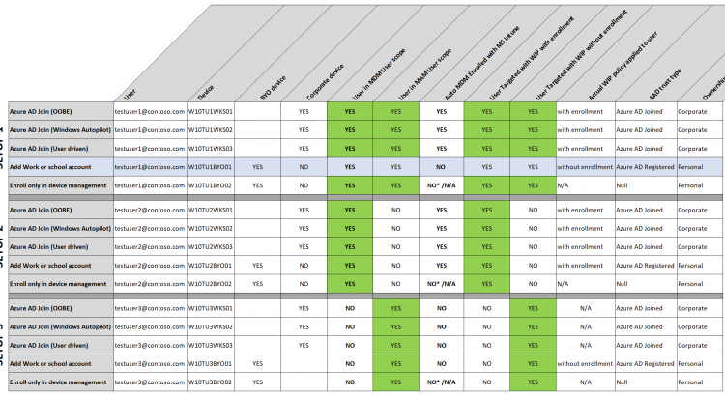

## Configuring Intune MDM User Scope and MAM User Scope for Windows 10

 In a previous blog I wrote about the [basics on Windows Information Protection (WIP)](https://allthingscloud.blog/windows-information-protection-wip/). If you did not read that post, I suggest you go back and read it for a complete understanding before continuing. If you’re here to learn more about MDM User scope and MAM user scope, then I hope this post will be of add value for you too.

This post is part of a series and in upcoming post I’ll also write about Microsoft Cloud App Security, Limiting Access to Exchange Online or SharePoint on unmanaged devices, and Azure AD Conditional access policies. Combining the power of these tools, will give you the best possible solution to enable a bring-your-own-device scenario. This post will focus on configuring Intune MDM user scope and MAM user scope.

1. [Introduction to Windows Information Protection](https://allthingscloud.blog/windows-information-protection-wip/)
2. **Configuring Intune MDM user scope and MAM user scope for Windows 10 (this post)**
3. [WIP without enrollment (WIP-WE / MAM)](https://allthingscloud.blog/windows-information-protection-without-enrollment/)
4. [Windows Information Protection with Enrollment](https://allthingscloud.blog/windows-information-protection-with-enrollment/)
5. [Windows Information Protection User Experience](http://allthingscloud.blog/windows-information-protection-user-experience/)
6. [WIP-WE User Experience – WIP Without MDM enrollment](http://allthingscloud.blog/wip-we-user-experience/)
7. [Set up Azure Rights Management for WIP](https://allthingscloud.blog/azure-rights-management-for-wip/)
8. [WIP Without Enrollment Selective Wipe](https://allthingscloud.blog/wip-without-enrollment-selective-wipe/)
9. [Troubleshooting Windows Information Protection](https://allthingscloud.blog/troubleshooting-windows-information-protection-on-windows-10/)
10. [Monitoring and collecting WIP audit event logs](https://allthingscloud.blog/monitoring-and-collecting-wip-audit-event-logs/)
11. WIP Learning mode
12. Limiting Access to SharePoint Online on unmanaged devices
13. Limiting Access to Exchange Online on unmanaged devices

## Prerequisites

Make sure you have all the prerequisites in place;

* Intune enabled as the MDM authority
* Windows 10 1703 and above for testing
* EMS E3 licenses (or at the very least Intune and Azure AD premium P1)

## Configuring MDM User Scope and MAM User Scope

There seems to be a lot of confusion when it comes to configuring the **MDM users scope** or **MAM user scope** and what these scopes do or which one to use. I hope to shed some light on these setting before we actually configure the WIP-WE (MAM) policy in another post. These settings/scopes only apply to Windows 10 devices. Therefore iOS and Android devices are NOT affected.

To configure your MDM and MAM user scope go to:

**Microsoft Intune> Device enrollment> Windows enrollment> Automatic Enrollment**

Note: if the MAM Discovery URL is missing,or you’re not sure if it’s correct select “Restore default MAM URLs”

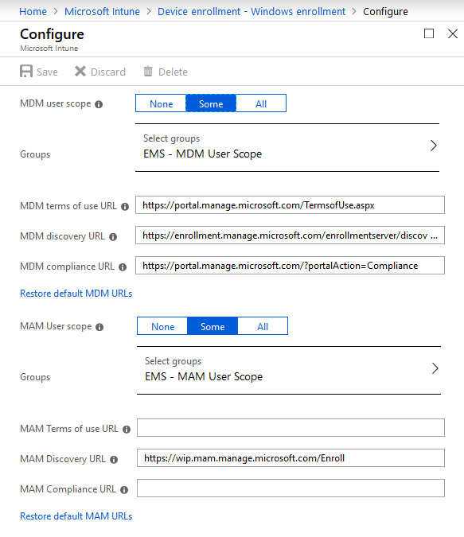

In this example I’ve set both scopes to **Some** and selected a user group for the purpose of this blog post.

### MDM users scope

The MDM user scope is configured to enable **Windows 10 automatic enrollment** for management with Microsoft Intune. When users in this scope Azure AD join a device or register a work or school account, the device will automatically enroll into MDM management with Microsoft Intune. When you don’t enable automatic MDM enrollment, you still can enroll the corporate device in Intune manually. In other words; The MDM user scope can be used to roll out automatic MDM enrollment with Microsoft Intune to only a select group of users, giving you the option to perform phased roll-outs of the feature.

The screenshot below shows a device that has been Azure AD joined and automatically MDM enrolled while going through the OOB experience. The join type is **Azure AD joined** and MDM has been set to **Microsoft Intune**.

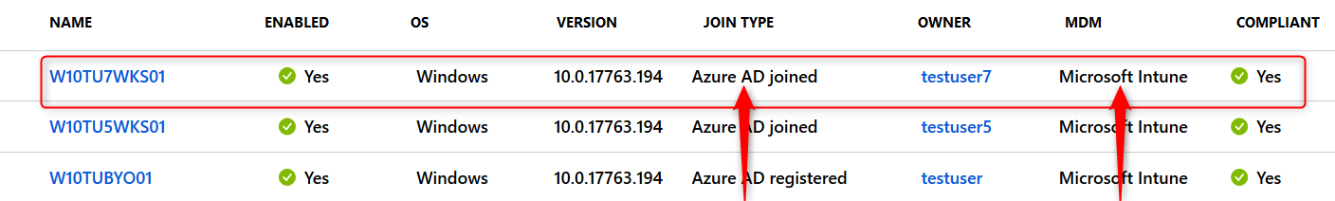

The same thing happens when this user adds a work or school account by going to**Windows Setting> Accounts> Access work or school> Connect> Setup a work or school account.**The join type will then be **Azure AD registered** and MDM will again be set to **Microsoft Intune.**

You can verify MDM policies apply by going to **Windows Setting> Accounts> Access work or school>**then select your work account and click on the Info button

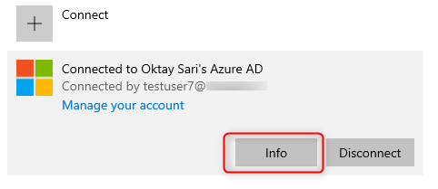

Scroll down to the Connection info part and have a look at the configuration. The Management Server Address should be something like this:

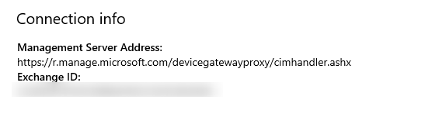

Another way is to use the cmd command dsregcmd /status. The Device State section will show **AzureADJoined: YES**. There will also be extra information about the device and the tenant.

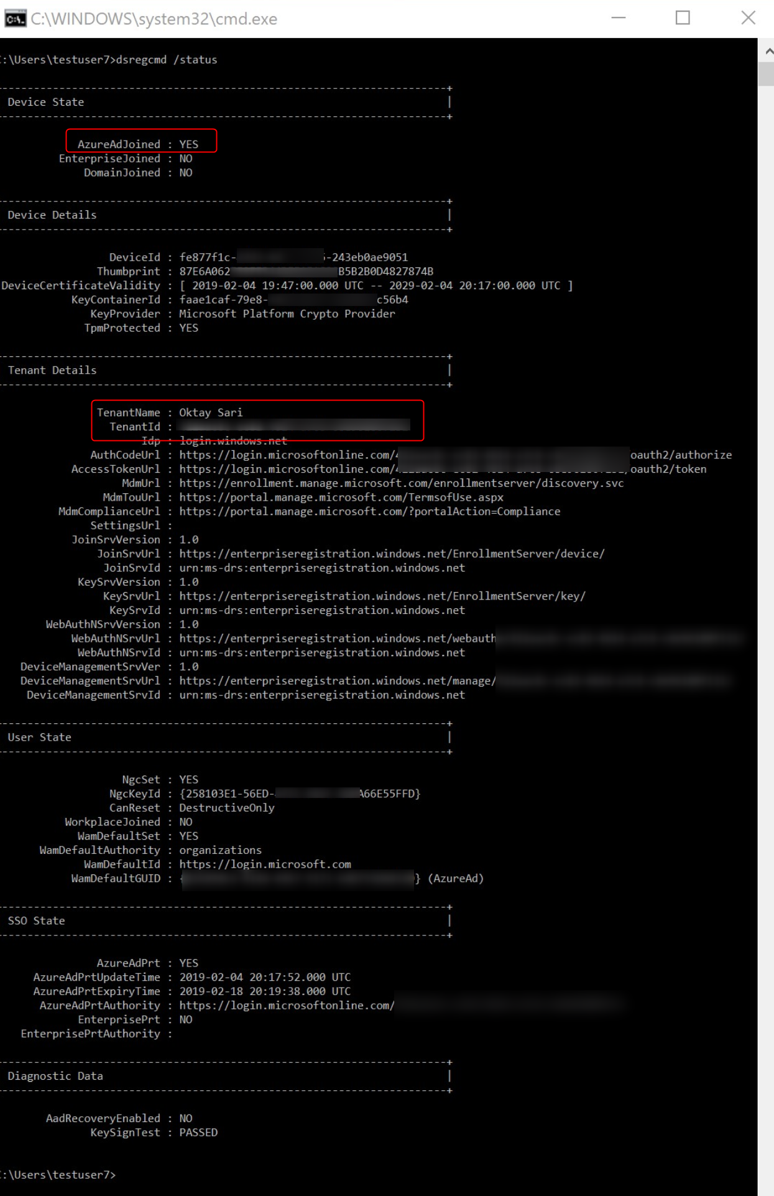

### MAM users scope

When users in this scope add a Work or School Account the device doesn’t get enrolled in Intune but it will be registered in Azure AD. If you have configured Windows Information Protection, only WIP without Enrollment (MAM policy) is applied. However, before creating your WIP-WE policy, you need to set up your MAM provider or the MAM URLs in Azure AD. To enable WIP-WE for Windows 10 devices, the MAM Discovery URL must be configured. Without it the users cannot enroll into MAM management.

The screenshot below shows a device that has been registered in Azure AD but not MDM enrolled in Microsoft Intune. The join type is **Azure AD registered** and MDM has been set to **None**. The user registered the device by going to**Windows Setting> Accounts> Access work or school> Connect> Setup a work or school account.**This device also does not need to be compliant and therefore shows N/A.

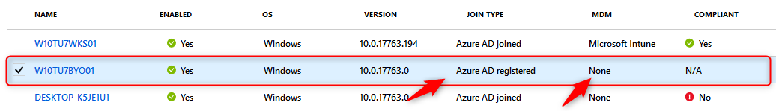

You can verify only MAM policies apply by going to **Windows Setting> Accounts> Access work or school>**then select your work account and click on the Info button

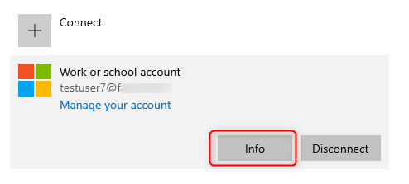

Scroll down to the Connection info part and have a look at the configuration. The Management Server Address should be http://**wip.mam**.manage.microsoft.com:444/checkin

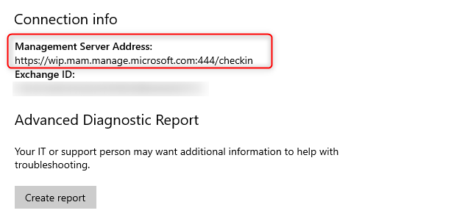

Another way is to use the cmd command dsregcmd /status. The User state shows WorkplaceJoined: YES. Also note the WorkplaceMdmUrl. This is the MAM discovery URL from your MAM user scope settings.

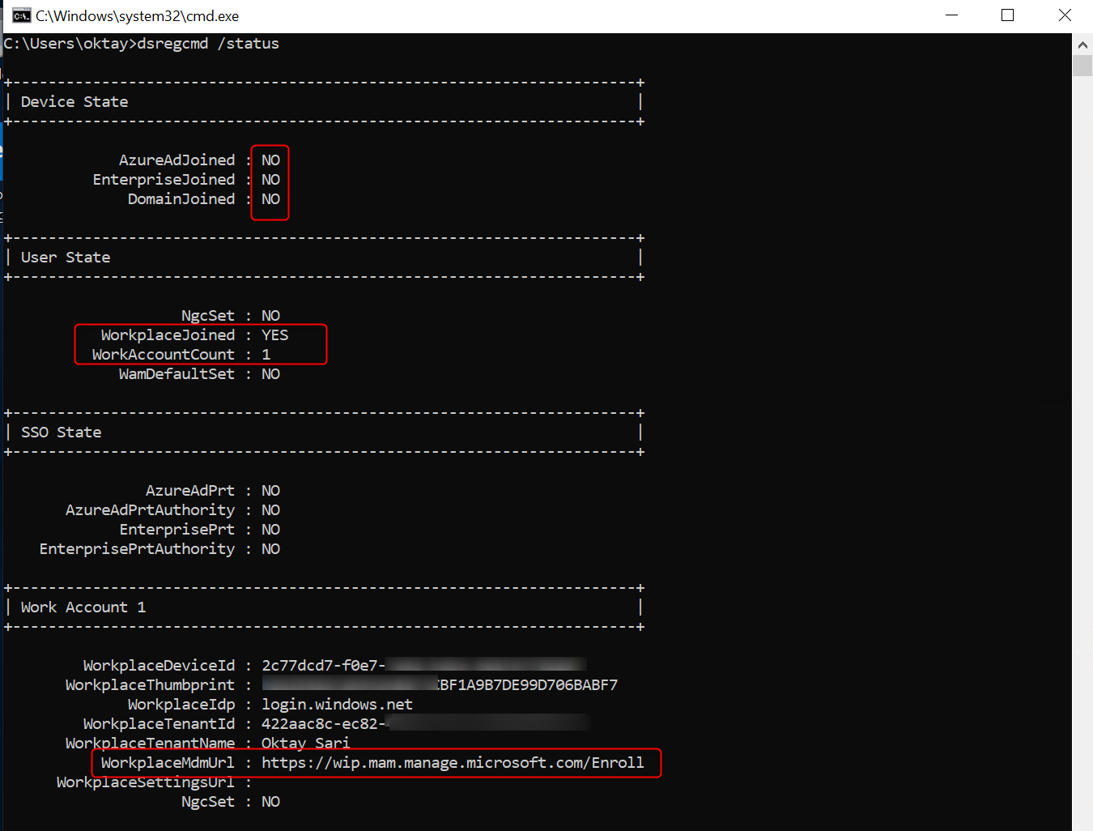

### Misconceptions about MDM and MAM user scope

Don’t confuse Azure AD domain join or registration with Intune MDM enrollment. They often go hand in hand but don’t need to. You need to figure out, which user’s you need to automatically enroll to MDM so you can control the devices and apps using MDM and which user’s need to enroll only to MAM so you can control the apps they use, but don’t require the device to enroll to MDM. The latter one is obviously for BYOD scenario’s.

What if you have users with corporate devices that need to be MDM enrolled but at the same time, these users have the need to use personal devices (BYOD) as well, without fully MDM enrolling their BYOD in Microsoft Intune. In other words; you want the same user or group of users to be in both the MDM users scope as well as the MAM user scope.

Here is a quote from the Microsoft website:

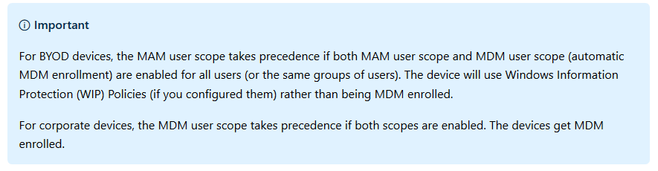

Simply put; You can have the same user or group of users in both the MAM User scope and MDM user scope. If you don’t have a specific use case for it like a phased rollout or a pilot, you can set both these scopes to **All Users**and be done with it. You will however need to understand the impact of this kind of setup.

#### Identifying devices as corporate-owned

The real question you should ask yourself is how and when a device is identified as corporate or personal. For a Windows 10 device to be identified as corporate it needs to be;

* Azure AD Joined (OOBE / Windows AutoPilot / User driven)
* Enrolled with a DEP account
* Set as corporate in the device properties (in Intune, after enrollment)

##### Corporate device

If a user is in both the MAM user scope and MDM user scope and the device is Azure AD Joined it will be identified as corporate and the device will automatically enroll in Intune.

##### Personal device

If a user is in both the MAM user scope and MDM user scope and the user adds a work or school account, the device will be workplace joined (Azure AD registered) and NOT automatically enrolled in Intune

### Reasons to only manage the apps (MAM)

You might have a specific reason to only manage the apps with MAM. Obviously MAM without MDM enrollment is very popular for organizations that support BYOD and here are some of the reasons I come across when implementing Information Security and enabling a bring-your-own-device scenario.

##### Pilot:

Needless to say but you should start with a contained pilot user group.

##### Phased rollout:

You want to start with a subset of your users before deploying company wide. This way you can target specific departments or regions.

##### Compliance

You need to comply with policies that require less management capabilities on BYOD.

##### User experience

Less intrusive or alarming for users.

## Different scenarios worked out

I’ve created a table where I also take Windows Information Protection (WIP) policies into account. There are 3 scenario’s (setups) here but feel free to play with your own scenario’s. I’m thinking SETUP 1 is a good solution in many occasions. You will have full control over corporate devices and users will have the option to add a work or school account on a BYO devices and be managed by MAM (WIP-WE) on their personal devices.

If you or the users need more control on BYOD, then the users can also **enroll only in device management**. In this case the user will have to enroll twice. First **Adding a work or school account** will Azure AD register the device, and followed by **enrolling only in device management** will also MDM enroll with Microsoft Intune.

[Click on the image to open the original file](http://allthingscloud.blog/wp-content/uploads/2019/02/word-image-12.png)

[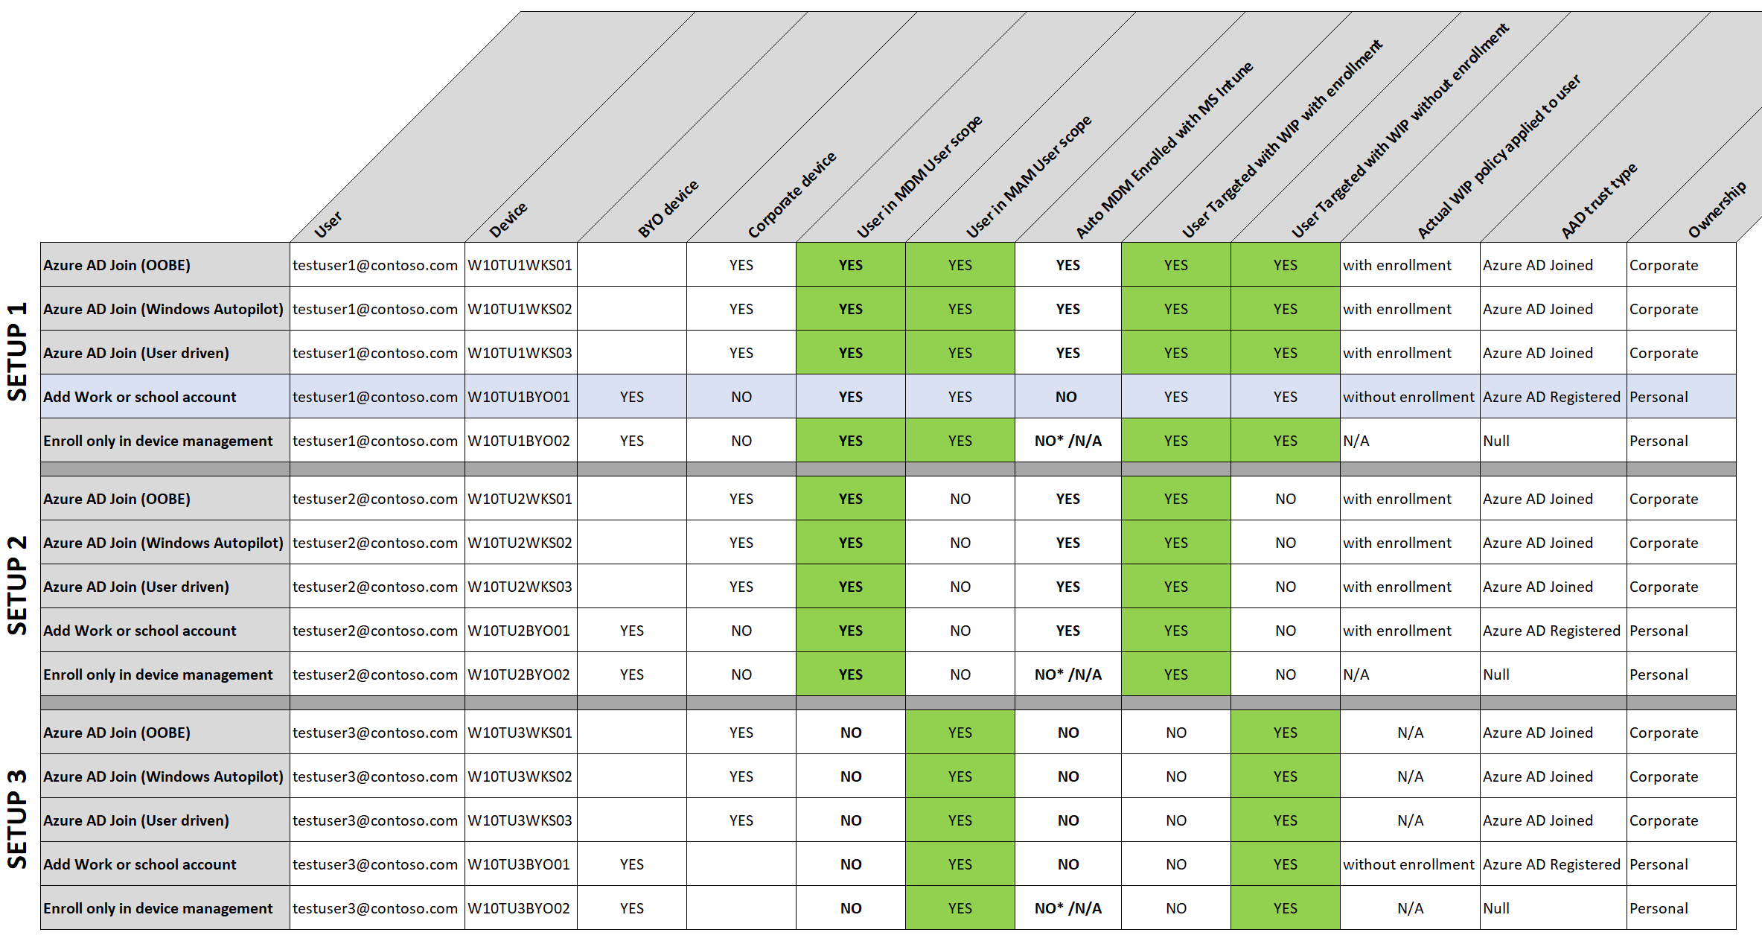](http://allthingscloud.blog/wp-content/uploads/2019/02/word-image-12.png)

\***enroll only in device management** will obviously MDM enroll the device in MS Intune so auto enrollment is not applicable here.

## Final thoughts

I didn’t think I could come up with this much to write about the MDM user scope and MAM user scope but I had fun writing it and hope it will be of value. If you have any thought you would like to share with me and other readers then please leave a comment below. While I wrote this post to the best of my knowledge I’m still human and make mistakes. If you happen to see an error then please let us know.

# Windows Information Protection without enrollment

Please read about the [basics of Windows Information Protection](https://allthingscloud.blog/windows-information-protection-wip/) in my previous blog. First of all WIP Without Enrollment is a great solution for organizations supporting a BYOD solution but at the same time, want to manage the corporate applications and data securely.

As always, I ask you to also check the [official Microsoft documentation](https://docs.microsoft.com/en-us/windows/security/information-protection/windows-information-protection/protect-enterprise-data-using-wip) as they are very complete and probably will update their documentation more frequently. Most importantly, this post (and any other) is based on my own experiences in the field deploying and configuring Microsoft solutions.

This post is part of a series. In upcoming post I’ll write about Microsoft Cloud App Security, Limiting Access to Exchange Online or SharePoint on unmanaged devices. Combining the power of these tools, will give you a nice solution to enable a bring-your-own-device scenario.

1. [Introduction to Windows Information Protection](https://allthingscloud.blog/windows-information-protection-wip/)
2. [Configuring MDM user scope and MAM user scope](https://allthingscloud.blog/configuring-intune-mdm-user-scope-and-mam-user-scope/)
3. **Windows Information Protection without enrollment (WIP-WE / MAM) (this post)**
4. [Windows Information Protection with Enrollment](https://allthingscloud.blog/windows-information-protection-with-enrollment/)
5. [Windows Information Protection User Experience](http://allthingscloud.blog/windows-information-protection-user-experience/)
6. [WIP-WE User Experience – WIP Without MDM enrollment](http://allthingscloud.blog/wip-we-user-experience/)
7. [Set up Azure Rights Management for WIP](https://allthingscloud.blog/azure-rights-management-for-wip/)
8. [WIP Without Enrollment Selective Wipe](https://allthingscloud.blog/wip-without-enrollment-selective-wipe/)
9. [Troubleshooting Windows Information Protection](https://allthingscloud.blog/troubleshooting-windows-information-protection-on-windows-10/)
10. [Monitoring and collecting WIP audit event logs](https://allthingscloud.blog/monitoring-and-collecting-wip-audit-event-logs/)
11. WIP Learning mode
12. Limiting Access to SharePoint Online on unmanaged devices
13. Limiting Access to Exchange Online on unmanaged devices

## Prerequisites

Make sure you have all the prerequisites in place;

* Intune enabled as the MDM authority
* Windows 10 1703 and above (Pro, Enterprise, Education)
* EMS E3 licenses (or at the very least Intune and Azure AD premium P1)
* [Configure your MAM provider in Azure AD](https://allthingscloud.blog/configuring-intune-mdm-user-scope-and-mam-user-scope/) for WIP without enrollment

## Configuring your MAM provider

Before you create your WIP-WE policy, you need to set up your MAM provider or the MAM URLs in Azure AD. Configure the MAM Discovery URL to enable WIP-WE for Windows 10 devices . **Without it the users cannot enroll into WIP-WE (MAM) management.**

I dedicated another blog post on [configuring **MDM users scope** and **MAM user scope**](https://allthingscloud.blog/configuring-intune-mdm-user-scope-and-mam-user-scope/). Therefore, read that post if you want to learn more about configuring MDM and MAM scopes. If you already  configured the MAM provider  continue reading.

## Creating a WIP Protection Policy

* Sign in to the [Azure portal](https://portal.azure.com/) and Choose **All Services** > **Intune**.
* Select**Client apps**>**App protection policies**
* Click on **Create policy**to create your WIP protection policy

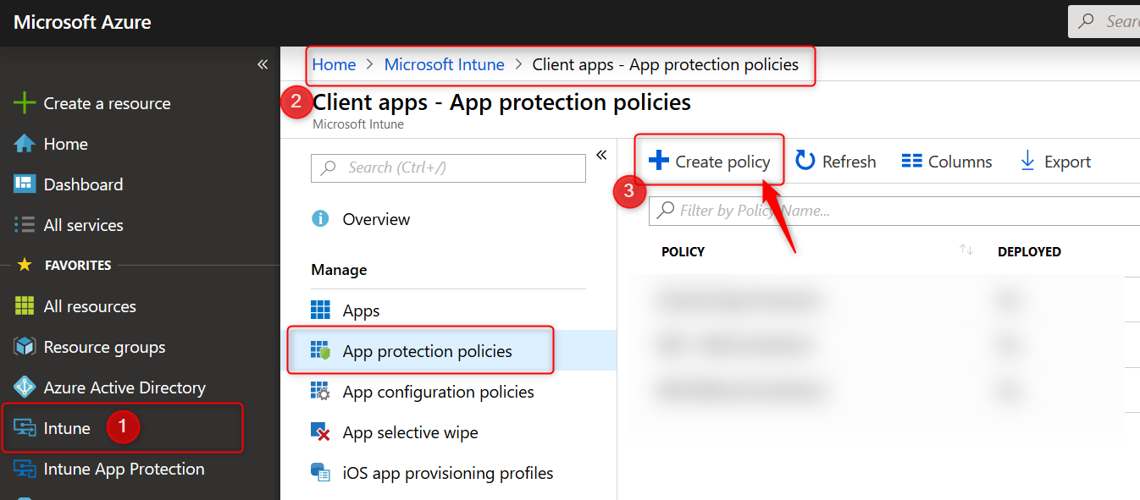

* Give the policy a name and a description. Choose **Windows 10**as the **platform** from the drop-down menu.
* Finally select the **Enrollment state.** In this case we are creating a WIP policy for unmanaged BYO devices. That is why I choose “**without enrollment**”

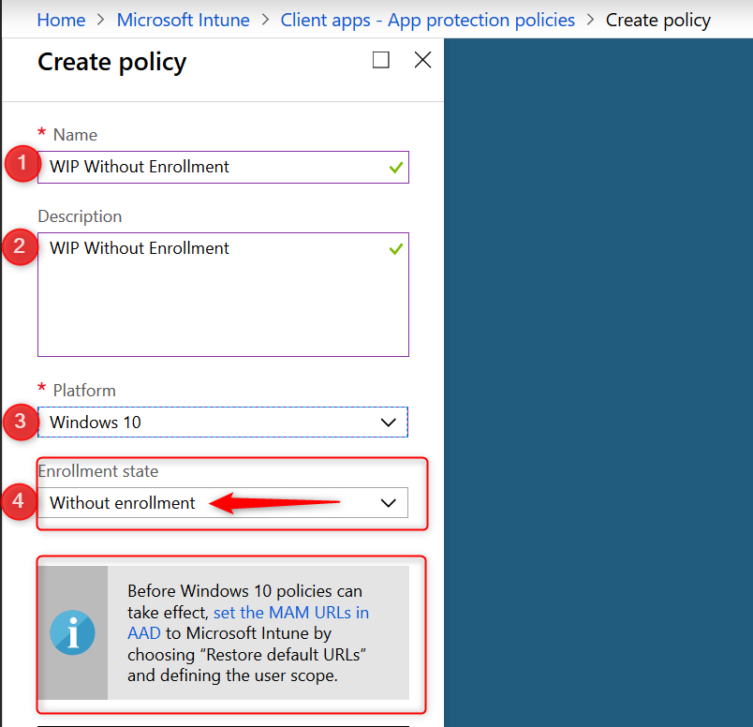

Please note the warning about [configuring the MAM URLs in AAD](https://allthingscloud.blog/configuring-intune-mdm-user-scope-and-mam-user-scope/).

### Adding apps to your WIP Policy

In the next section you will select apps you want to allow or deny access to your corporate data. There are two kinds of applications you need to know about; [Enlightened applications (MAM aware)](https://docs.microsoft.com/en-us/windows/security/information-protection/windows-information-protection/enlightened-microsoft-apps-and-wip) and [Unenlightened (MAM Unaware) applications](https://docs.microsoft.com/en-us/windows/security/information-protection/windows-information-protection/app-behavior-with-wip). The difference is that enlightened apps can differentiate between corporate and personal data whereas unenlightened apps cannot. Read my [previous post about WIP Basics](https://allthingscloud.blog/windows-information-protection-wip/) to fully understand the solution. Also read the [Microsoft blog](https://docs.microsoft.com/en-us/windows/security/information-protection/windows-information-protection/create-wip-policy-using-mam-intune-azure#add-apps-to-your-protected-apps-list) for more information about configuring WIP policies and adding apps to your WIP policy.

* When you are ready to continue, click on **Protected apps** and then click on **Add apps**

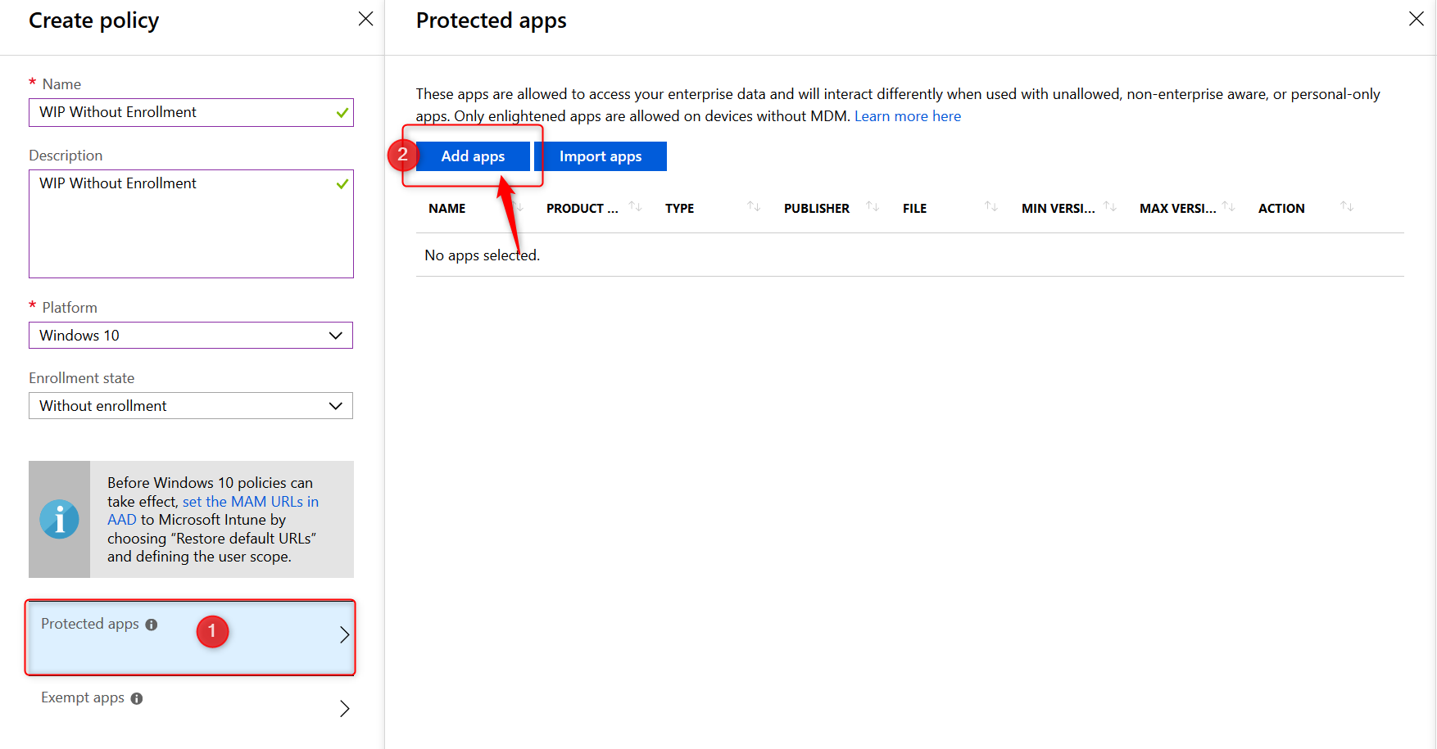

* On the Add apps blade choose **Recommended apps** from the drop-down menu.
* Click on the select box next to **NAME** (See the arrow below). This will select all the recommended applications in the list.
* All applications are allowed by default when you add them to your protected apps list. Make changes here before you continue
* click on **OK** at the bottom of the page.

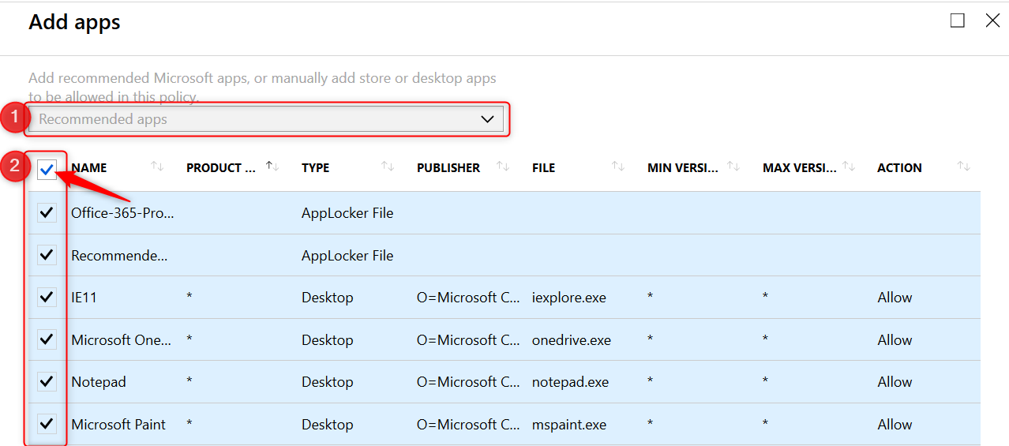

Back the Protected apps blade. Have a look at the **Action**column where you can see which applications are allowed or denied access.

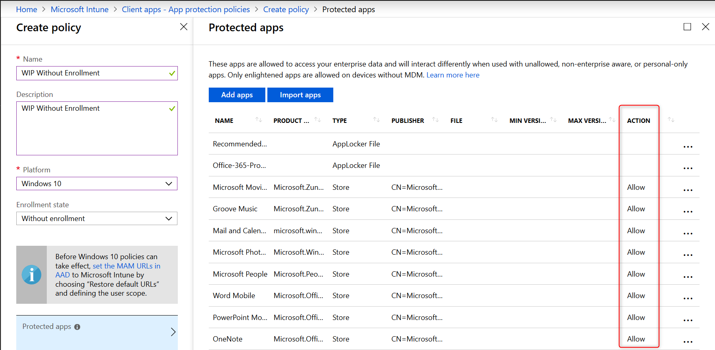

* On the protected apps blade, click on **OK** at the bottom of the page.

**Note:** There is no need to add all of the Office 365 Pro Plus suite applications manually to this list. Read more [here](https://docs.microsoft.com/is-is/windows/security/information-protection/windows-information-protection/enlightened-microsoft-apps-and-wip#adding-enlightened-microsoft-apps-to-the-allowed-apps-list).



Microsoft helps by adding the “Office-365-ProPlus-1810-Allowed.xml” applocker file when you add recommended apps. Download the XML file from the above link or [here](https://download.microsoft.com/download/7/0/D/70D72459-D72D-4673-B309-F480E3BEBCC9/O365%20ProPlus%20-%20WIP%20Enterprise%20AppLocker%20Policy%20Files.zip), to have a look at the code if you like.

* Back on the Create policy blade, click on **Configure required settings**

### Configure required settings

This policy only applies to Windows 10 Creators Update and higher. For the required settings you will need to set the **protection mode**, and your **corporate identity**.

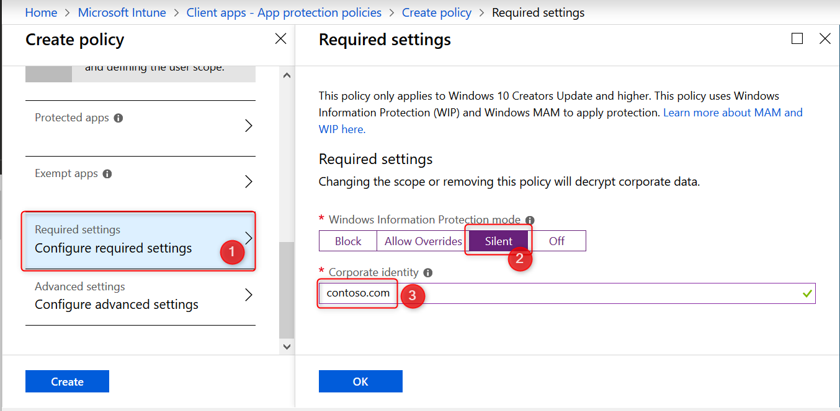

#### Windows Information Protection Modes

For the remainder of this post I will assume you have set the **Windows Information Protection mode** to **Block**. Have a look at the [Microsoft documentation](https://docs.microsoft.com/en-us/windows/security/information-protection/windows-information-protection/create-wip-policy-using-mam-intune-azure#manage-your-required-settings) for a complete description of all modes.

* **Block:** Blocks enterprise data from leaving protected apps
* **Allow overrides:** User is prompted when attempting to relocate data from a protected to a non-protected app.
* **Silent:** User is free to relocate data off of protected apps.
* **Off:** User is free to relocate data off of protected apps.

**Note:** The Off mode is **not recommended**. It’s best to start with Silent and from there work your way to Block.

* Select **Block** and continue with setting your corporate identity

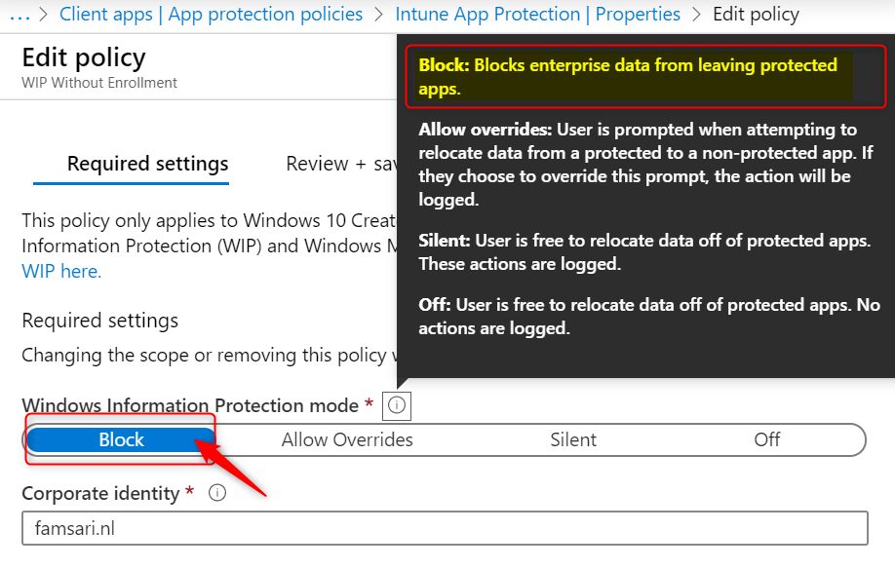

The **corporate identity** field should contain only your primary domain. Add additional domains as **‘Protected domains’** under the **‘Network perimeter’** in the ‘Advanced settings’ tab. The **corporate identity** field is auto-defined. If it’s not correct, change it and click on **Save** to close the Required Settings blade.

**IMPORTANT:** Unlike Azure AD Joined and MDM enrolled devices, you have a lot less control over personal devices that are only Azure AD registered and not MDM enrolled.

If you do not set your WIP protection mode to block, users are allowed to change file ownership and decrypt files. When users change file ownership from work to personal, the action is written to the local event log but you cannot collect event log entries to Azure Log Analytics. For this to work, you need the Microsoft Monitoring Agent installed on the device. And since deploying apps to Windows 10 requires a device to be MDM enrolled, you don’t have a lot of other options. That is why I choose to set the protection mode to **block**.

#### WIP Learning Mode

When you first start with Windows Information Protection and don’t know if the recommended apps will be enough, consider starting with the **Protection Mode** set to **Silent**.

WIP Learning mode essentially monitors all applications that access corporate data. Because in silent mode WIP will not block any action but will log inappropriate data sharing, giving you the opportunity to monitor your WIP enabled apps but also apps you did not add to your WIP policy.

I will write about setting up and configuring WIP Learning Mode if you want to explore that path first, but that is for another post. It will explain how to setup Device Health and where to find the WIP learning app reports you can use to fine-tune your WIP policies.

### Windows Information Protection Network boundary

Identify corporate cloud resources by configuring WIP network boundaries and help protect corporate data by encrypting data that is downloaded from there to devices. In the next section you will add your network boundaries. The **Cloud resource SharePoint** is added by default.

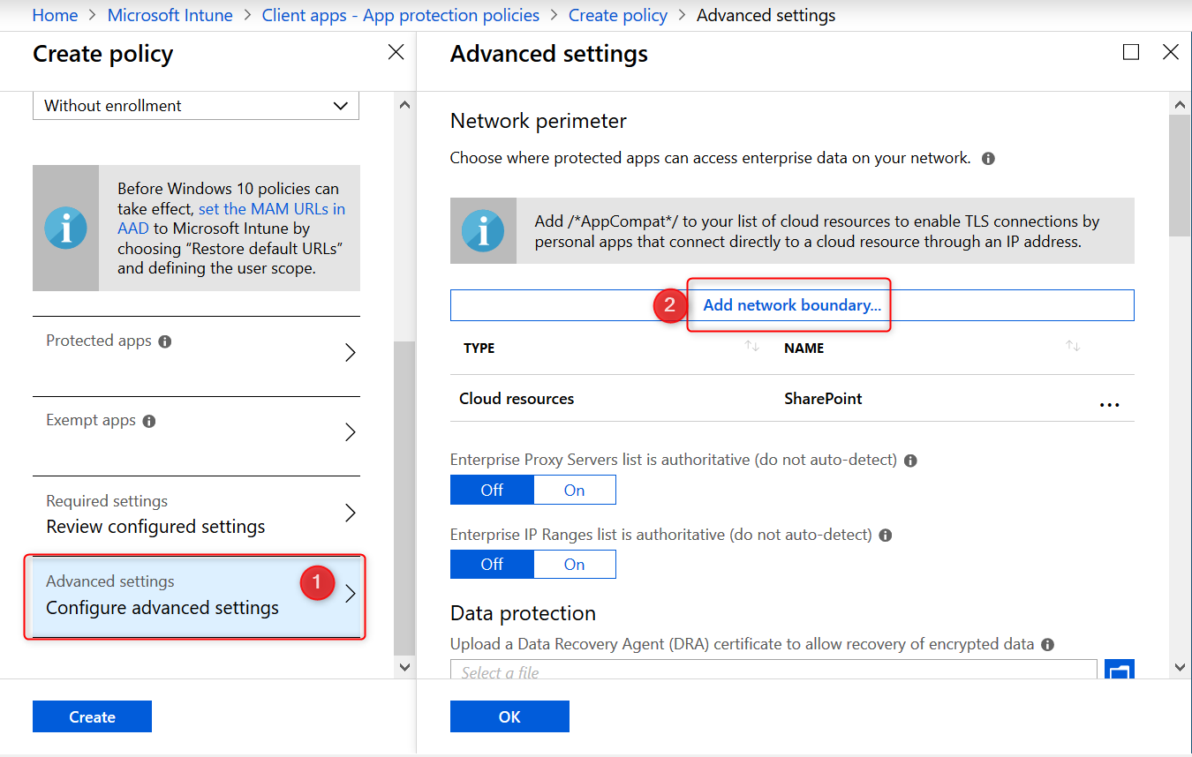

Have a look at the table below to get you started or check out the [Microsoft documentation](https://docs.microsoft.com/en-us/windows/security/information-protection/windows-information-protection/recommended-network-definitions-for-wip#recommended-enterprise-cloud-resources) for more tips.

|  |  |  |
| --- | --- | --- |
| **Type** | **Name** | **Value** |
| Cloud Resources | Office 365 | portal.office.com|tasks.office.com|protection.office.com|meet.lync.com|teams.microsoft.com |
| Cloud Resources | Outlook Online | outlook.office.com|outlook.office365.com |
| Cloud Resources | AppCompat | /*AppCompat*/ |
| Cloud Resources | SharePoint | contoso.sharepoint.com| contoso-my.sharepoint.com| contoso-files.sharepoint.com |
| Neutral Resources | Neutral | login.windows.net,login.microsoftonline.com |

After adding your Cloud Resources the configuration should look like this:

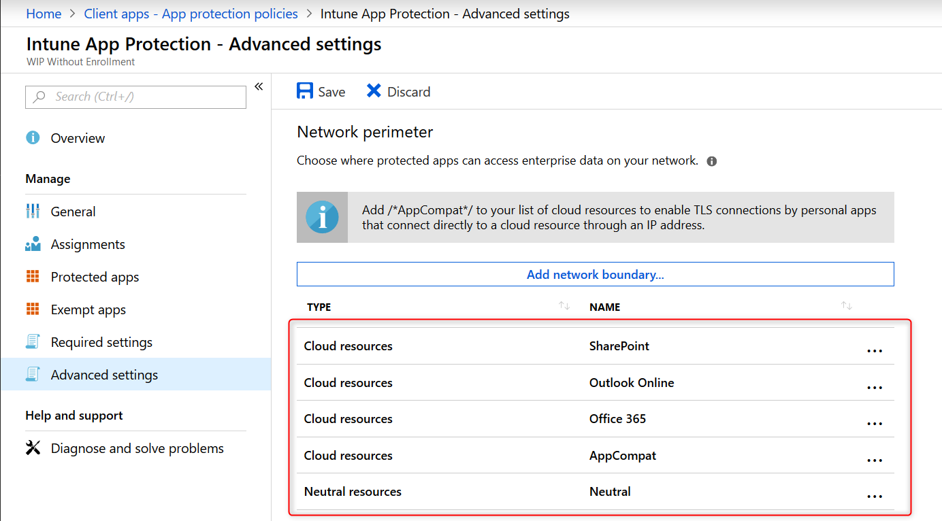 `

**Note:** Have a look at this /*AppCompat*/ notification:

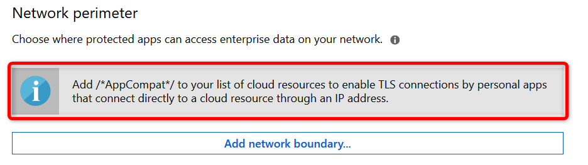

When I started testing I missed this notification and later found that I could not use browsers like Chrome or FireFox. They would simply not load any internet page. I could use 3rd party browsers after adding /*AppCompat*/ to my cloud resources.

When an unenlightened app tries to connect to a cloud resource through an IP and Windows can’t determine whether to allow the app to connect, it will automatically block the connection. Read [this](https://docs.microsoft.com/en-us/windows/security/information-protection/windows-information-protection/app-behavior-with-wip) Microsoft document a few times and you will understand ? Here is a another important piece of information from the [Microsoft blog post](https://docs.microsoft.com/en-us/windows/security/information-protection/windows-information-protection/create-wip-policy-using-mam-intune-azure#manage-your-advanced-settings):

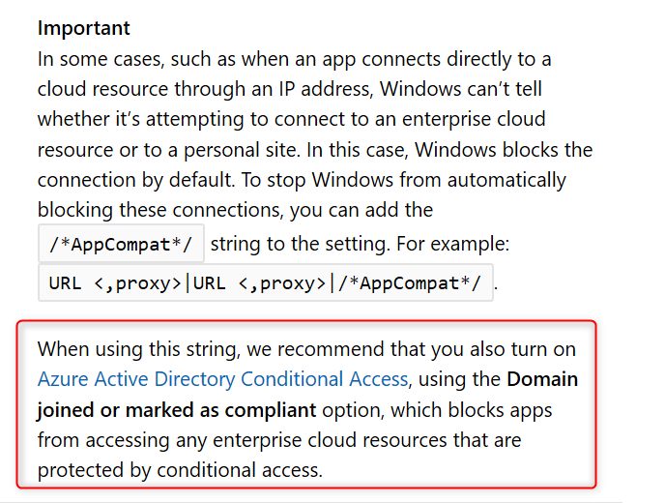

**Note:**I will write another blog post in this series about troubleshooting WIP and my experience from the field. There are some important limitations and considerations you need to be aware of when configuring the Network boundaries. I’ve found some undocumented domains you might want to add to your Cloud Resources list to make WIP even more secure, but for now suggest you start with a pilot and test everything you can, before you deploy WIP company wide. Come back again and read all about it soon!

#### Other settings to configure on the advanced settings blade

##### Data Protection

The tool-tips tells us and I quote;

“A recovery certificate is a special Encrypting File System (EFS) certificate you can use to recover encrypted files if your encryption key is lost or damaged. You need to create the recovery certificate, and specify it here. More information is [here](https://technet.microsoft.com/en-us/itpro/windows/keep-secure/create-and-verify-an-efs-dra-certificate) “

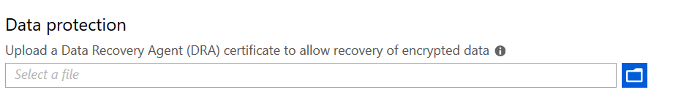

Using a DRA certificate isn’t mandatory. However, [Microsoft strongly recommends](https://docs.microsoft.com/en-us/windows/security/information-protection/windows-information-protection/create-wip-policy-using-mam-intune-azure#manage-your-advanced-settings) using it.

##### Set up Azure Rights Management with WIP

WIP can integrate with Microsoft Azure Rights Management to enable secure sharing of files when users want to use removable drives such as USB drives. For this to work , you must already have Azure Rights Management set up. This feature works great and enables your users to share files among each other by encrypting files that are saved to USB with Azure Rights Management (Azure RMS). Azure RMS is the protection technology used by Azure Information Protection (AIP)

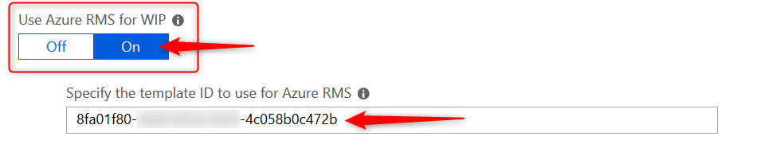

For now you will have to do with the [official Microsoft documentation](https://docs.microsoft.com/en-us/windows/security/information-protection/windows-information-protection/create-wip-policy-using-mam-intune-azure#choose-to-set-up-azure-rights-management-with-wip) but I will be writing another blog post in this series on setting up and configuring Azure Rights Management with WIP.

Finish the WIP configuration policy.

* On the Advanced settings blade, click on **OK** at the bottom of the page.
* Back on the Create Policy blade, click on Create to wrap it up

### Piloting and deploying WIP

The final step is deploying your newly create WIP policy to a **pilot** group of users. Just remember that MAM policies are deployed to users and not devices.

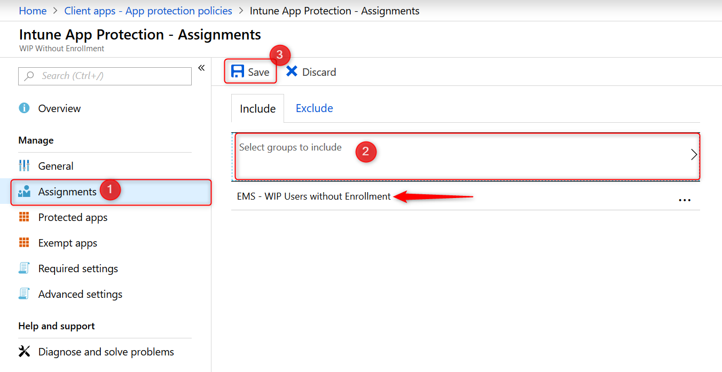

Once you’ve configured a WIP policy, they will be applied the next time devices sync with Intune. Depending on you configuration the user experience can be different. Assuming you’ve set your protection mode to “Allow overrides” users will get notified when they mix corporate and private workspace and data. This protection mode will also audit when users change file ownership from corporate to private.

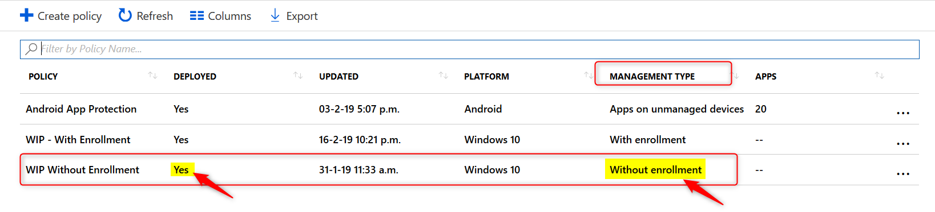

I will write another dedicated blog post in this series on user experience with WIP. Come back again or follow me on twitter to get notified.

### Monitoring Deployment status

When you are piloting your WIP policies, you’ll most likely have test devices at hand where you can immediately see the effect of your policies, once the device is in sync with Microsoft Intune. You can also monitor and report about your policies and their deployment status from Azure.

* Sign in to the [Azure portal](https://portal.azure.com/) and Choose **All Services** > **Intune**.
* Select**Client apps**>**App protection status**
* Download the report you want
  + **App Protection Report:**WIP without Enrollment
  + **App Protection Report:**WIP via MDM

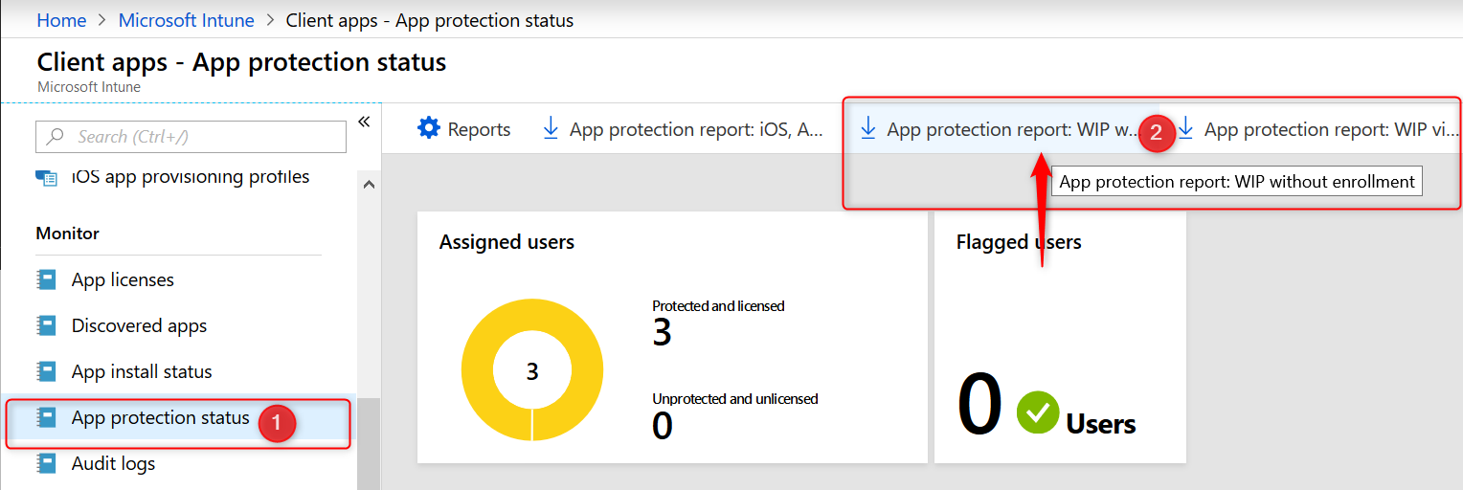

The reports contain information about the user and device name but also the App Protection Policy that applied to the user. The example below shows testuser6 has 2 BYO devices where data is managed and protected with the “WIP Without Enrollment” policy.

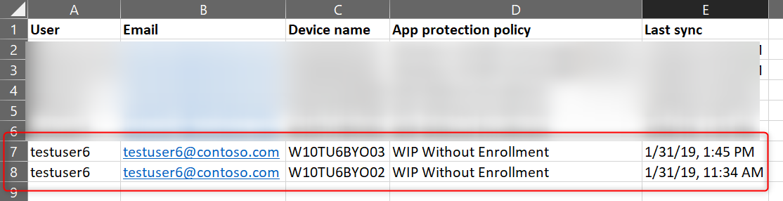

### Conclusion

WIP provides a robust solution by protecting work data that is downloaded to Windows 10 devices. It works because it can separate personal and work data, helping prevent unintentional information sharing. This makes WIP a good choose for companies wanting to support a BYOD scenario. Combined with AIP it adds an extra layer of security making it possible for your users to share data amongst each other.

As with other methods used to protect information and devices, you need to find a good balance between security and business productivity. If users set their mind on stealing information, they will find a way. Lucky for us admins, most users don’t have malicious intent.

# Windows Information Protection with Enrollment

 In this post I’ll configure Windows Information Protection with enrollment for devices that are managed with Microsoft Intune. If you’ve configured automatic MDM enrollment for Windows 10, then all devices for users in the MDM user scope will automatically enroll in MDM. Therefore the Windows Information Protection with enrollment (WIP-MDM) policy will apply. In a previous post I wrote about [configuring Intune MDM User Scope and MAM User Scope](https://allthingscloud.blog/configuring-intune-mdm-user-scope-and-mam-user-scope/) for Windows 10. It contains lots of relevant information so have a look at it.

For many organizations, data is something we take for granted as being safe, stored somewhere in the cloud or on-site servers hidden in a broom closet. A common misconception is that only the big organizations, governments, and businesses get targeted by cyber criminals. That’s just not true.

“There are only two types of companies: those that have been hacked, and those that will be.” Robert Mueller FBI Director, 2012

No matter what kind of data you’re storing in the cloud or on-site, data protection should be one of your biggest priorities.

This post is part of a series. Have a look at my other posts for more information

1. [Introduction to Windows Information Protection](https://allthingscloud.blog/windows-information-protection-wip/)
2. [Configuring MDM user scope and MAM user scope](http://allthingscloud.blog/configuring-intune-mdm-user-scope-and-mam-user-scope/)
3. [WIP-WE / MAM – Windows Information Protection without enrollment](http://allthingscloud.blog/windows-information-protection-without-enrollment/)
4. **Windows Information Protection with Enrollment (this post)**
5. [Windows Information Protection User Experience](http://allthingscloud.blog/windows-information-protection-user-experience/)
6. [WIP-WE User Experience – WIP Without MDM enrollment](http://allthingscloud.blog/wip-we-user-experience/)
7. [Set up Azure Rights Management for WIP](https://allthingscloud.blog/azure-rights-management-for-wip/)
8. [WIP Without Enrollment Selective Wipe](https://allthingscloud.blog/wip-without-enrollment-selective-wipe/)
9. [Troubleshooting Windows Information Protection](https://allthingscloud.blog/troubleshooting-windows-information-protection-on-windows-10/)
10. [Monitoring and collecting WIP audit event logs](https://allthingscloud.blog/monitoring-and-collecting-wip-audit-event-logs/)
11. WIP Learning mode
12. Limiting Access to SharePoint Online on unmanaged devices
13. Limiting Access to Exchange Online on unmanaged devices

## Prerequisites

Make sure you have all the prerequisites in place;

* Intune enabled as the MDM authority
* Windows 10 1703 and above (Pro, Enterprise, Education)
* EMS E3 licenses (or at the very least Intune and Azure AD premium P1)

## Configuring your MDM user scope

Although it’s not a requirement, I recommend setting up Windows 10 automatic enrollment by configuring your MDM user scope in Azure AD. I dedicated another blog post on [configuring **MDM users scope** and **MAM user scope**](https://allthingscloud.blog/configuring-intune-mdm-user-scope-and-mam-user-scope/). If you need to know more about configuring these scopes make sure to read that post before you continue.

## Creating a WIP Protection Policy

* Sign in to the [Azure portal](https://portal.azure.com/) and Choose **All Services** > **Intune**.
* Select**Client apps**>**App protection policies**
* Click on **Create policy**to create your Windows Information Protection with enrollment policy



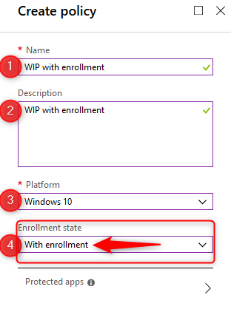

* Give the policy a name and a description. Choose **Windows 10**as the **platform** from the drop-down menu.
* Finally select the **Enrollment state.**In this case we are creating a WIP policy for MDM managed devices, so select “**with enrollment**”

## Adding apps to your WIP Policy

Let’s continue and select apps you want to allow or deny access to your corporate data. There are two kinds of applications you need to know about; [Enlightened applications (MAM aware)](https://docs.microsoft.com/en-us/windows/security/information-protection/windows-information-protection/enlightened-microsoft-apps-and-wip) and [Unenlightened (MAM Unaware) applications](https://docs.microsoft.com/en-us/windows/security/information-protection/windows-information-protection/app-behavior-with-wip). The difference is that enlightened apps can differentiate between corporate and personal data whereas unenlightened apps cannot. Read my [previous post about WIP Basics](https://allthingscloud.blog/windows-information-protection-wip/) to fully understand the solution. Also read the [Microsoft blog](https://docs.microsoft.com/en-us/windows/security/information-protection/windows-information-protection/create-wip-policy-using-intune-azure) for more information about configuring WIP policies and adding apps to your WIP policy.

When you are ready to continue, click on **Protected apps** and then click on **Add apps**

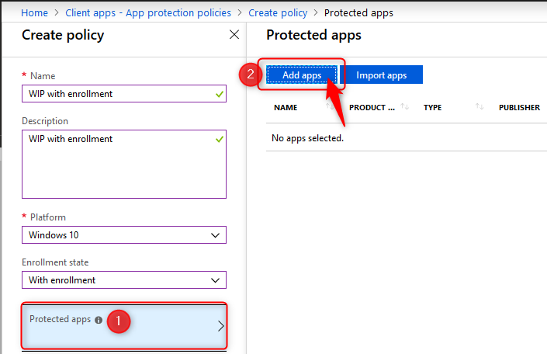

* On the Add apps blade choose **Recommended apps** from the drop-down menu.
* Click on the select box next to **NAME** (See the arrow below). This will select all the recommended applications in the list.
* When you add applications to your protected apps list, they are setup as allowed by default. Make changes here before you continue
* click on **OK** at the bottom of the page.



The **Action**column shows which applications are allowed or denied access.

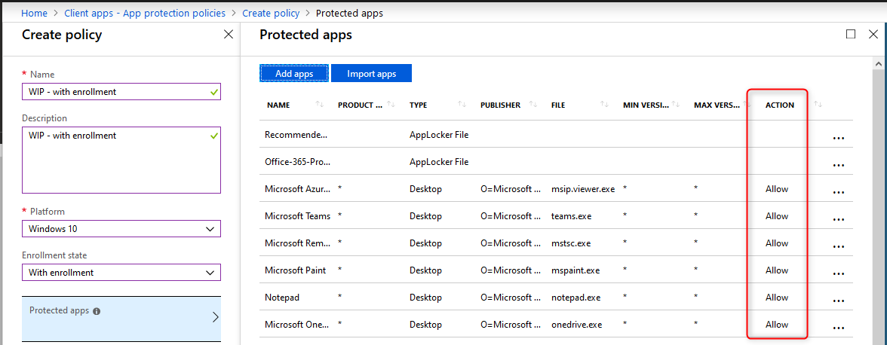

* On the protected apps blade, click on **OK** at the bottom of the page.

**Note:** There is no need to add all of the Office 365 Pro Plus suite applications manually to this list. Read more [here](https://docs.microsoft.com/is-is/windows/security/information-protection/windows-information-protection/enlightened-microsoft-apps-and-wip#adding-enlightened-microsoft-apps-to-the-allowed-apps-list). 

Microsoft helps by adding the “Office-365-ProPlus-1810-Allowed.xml” applocker file when you add recommended apps. Download the XML file from the above link, to have a look at the code if you like.

* Back on the Create policy blade, click on **Configure required settings**

## Configure required settings

For the required settings you will need to set the **protection mode**, and your **corporate identity**.

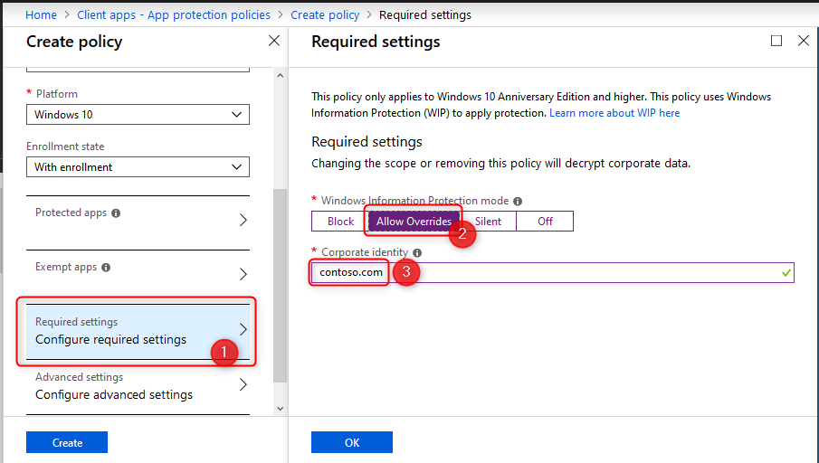

## Windows Information Protection Modes

For the remainder of this post I will assume you have set the **Windows Information Protection mode** to **Allow Overrides**. Have a look at the [Microsoft documentation](https://docs.microsoft.com/en-us/windows/security/information-protection/windows-information-protection/create-wip-policy-using-intune-azure#manage-the-wip-protection-mode-for-your-enterprise-data) for a complete description of all modes.

* **Block:** Blocks enterprise data from leaving protected apps
* **Allow overrides:** User is prompted when attempting to relocate data from a protected to a non-protected app.
* **Silent:** User is free to relocate data off of protected apps.
* **Off:** User is free to relocate data off of protected apps.

**Note:** The Off mode is **not recommended**. It’s best to start with Silent and from there update to Allow Override or Block.

* Select Allow Overrides and continue with setting your corporate identity

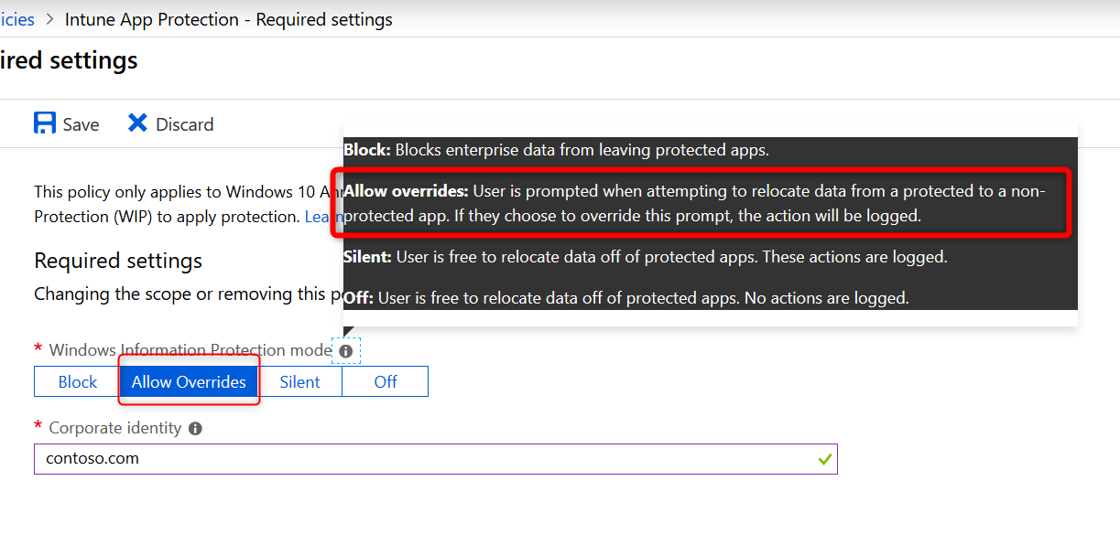 The **corporate identity** field should contain only your primary domain. Add additional domains as **‘Protected domains’** under the **‘Network perimeter’** in the ‘Advanced settings’ tab. The **corporate identity** field is auto-defined so check it and if it’s not correct, change it and click on **Save** to close the Required Settings blade.

## WIP Learning Mode

When you first start with Windows Information Protection and don’t know if the recommended apps will be enough, consider starting with the **Protection Mode** set to **Silent**.

WIP Learning mode essentially monitors all applications that access corporate data. Because in silent mode WIP will not block any action but will log inappropriate data sharing, giving you the opportunity to monitor your WIP enabled apps but also apps you did not add to your WIP policy.

I will write about setting up and configuring WIP Learning Mode if you want to explore that path first, but that is for another post. It will explain how to setup Device Health and where to find the WIP learning app reports you can use to fine-tune your WIP policies.

## Windows Information Protection Network boundary

Corporate cloud resources are identified by configuring WIP network boundaries and help protect corporate data by encrypting data that is downloaded from there to devices. In the next section you will add your network boundaries. The **Cloud resource SharePoint** is added by default. 

Have a look at the table below to get you started or check out the [Microsoft documentation](https://docs.microsoft.com/en-us/windows/security/information-protection/windows-information-protection/recommended-network-definitions-for-wip#recommended-enterprise-cloud-resources).

|  |  |  |
| --- | --- | --- |
| **Type** | **Name** | **Value** |
| Cloud Resources | Office 365 | portal.office.com|tasks.office.com|protection.office.com|meet.lync.com|teams.microsoft.com |
| Cloud Resources | Outlook Online | outlook.office.com|outlook.office365.com |
| Cloud Resources | AppCompat | /*AppCompat*/ |
| Cloud Resources | SharePoint | contoso.sharepoint.com| contoso -my.sharepoint.com| contoso -files.sharepoint.com |
| Neutral Resources | Neutral | login.windows.net,login.microsoftonline.com |

After adding your Cloud Resources the configuration should look like this: 

**Note:** Have a look at this /*AppCompat*/ notification:

When I started testing I missed this notification and later found that I could not use browsers like Chrome or FireFox. They would simply not load any internet page. I could use 3rd party browsers after adding /*AppCompat*/ to my cloud resources.

When an unenlightened app tries to connect to a cloud resource through an IP and Windows can’t determine whether to allow the app to connect, it will automatically block the connection. Read [this](https://docs.microsoft.com/en-us/windows/security/information-protection/windows-information-protection/app-behavior-with-wip) Microsoft document a few times and you will understand Here is a another important piece of information from the [Microsoft blog post](https://docs.microsoft.com/en-us/windows/security/information-protection/windows-information-protection/create-wip-policy-using-mam-intune-azure#manage-your-advanced-settings):



**Note:**I’ll write another post about troubleshooting WIP. There are some important limitations and considerations you need to be aware of when configuring the Network boundaries. I’ve found some undocumented domains you might want to add to your Cloud Resources list to make WIP even more secure, but for now suggest you start with a pilot and test everything you can, before you deploy WIP company wide.

### Other settings to configure on the advanced settings blade

#### Data Protection

The tool-tips tells us and I quote;

“A recovery certificate is a special Encrypting File System (EFS) certificate you can use to recover encrypted files if your encryption key is lost or damaged. You need to create the recovery certificate, and specify it here. More information is [here](https://technet.microsoft.com/en-us/itpro/windows/keep-secure/create-and-verify-an-efs-dra-certificate) “



Using a DRA certificate isn’t mandatory. However, [Microsoft strongly recommends](https://docs.microsoft.com/en-us/windows/security/information-protection/windows-information-protection/create-wip-policy-using-mam-intune-azure#manage-your-advanced-settings) using it.

#### Set up Azure Rights Management with WIP

WIP can integrate with Microsoft Azure Rights Management to enable secure sharing of files when users want to use removable drives such as USB drives. For this to work , you must already have Azure Rights Management set up. This feature works great and enables your users to share files among each other by encrypting files that are saved to USB with Azure Rights Management (Azure RMS). Azure RMS is the protection technology used by Azure Information Protection (AIP)



For now you will have to do with the [official Microsoft documentation](https://docs.microsoft.com/en-us/windows/security/information-protection/windows-information-protection/create-wip-policy-using-mam-intune-azure#choose-to-set-up-azure-rights-management-with-wip) but I will be writing another dedicated blog post in this series on setting up and configuring Azure Rights Management with WIP.

* On the Advanced settings blade, click on **OK** at the bottom of the page.
* Back on the Create Policy blade, click on Create to wrap it up

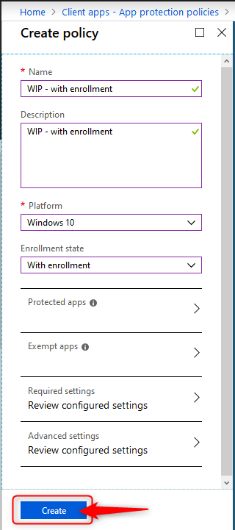

## Piloting and deploying WIP

Deploy your newly create WIP policy to a **pilot** group of users.

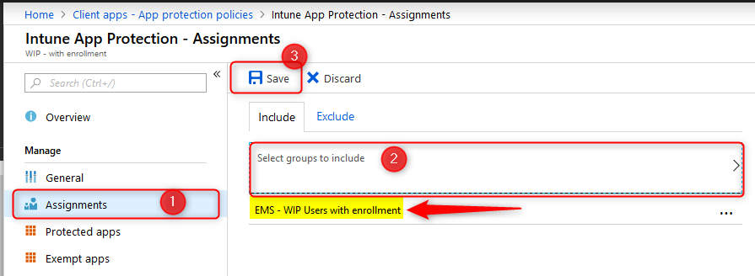

Once you’ve deployed a WIP policy, they will be applied the next time devices sync with Intune. Depending on you configuration the user experience can be different. Assuming you’ve set your protection mode to “Allow overrides” users will get notified when the mix corporate and private workspace and data. This protection mode will also audit when users change file ownership from corporate to private.

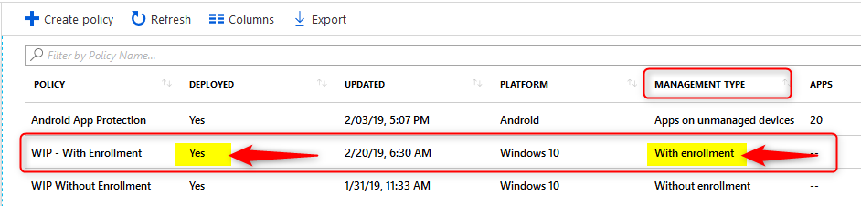

I will write another dedicated blog posts in this series on user experience with WIP and monitoring. Come back again or follow me on twitter to get notified.

## Monitoring Deployment status

When you are piloting WIP policies, you’ll most likely have test devices at hand where you can immediately see the effect of your policies, once the device is in sync with Microsoft Intune. You can also monitor and report about your policies and their deployment status from Azure.

* Sign in to the [Azure portal](https://portal.azure.com/) and Choose **All Services** > **Intune**.
* Select**Client apps**>**App protection status**
* Download the report you want
  + **App Protection Report:**WIP via MDM

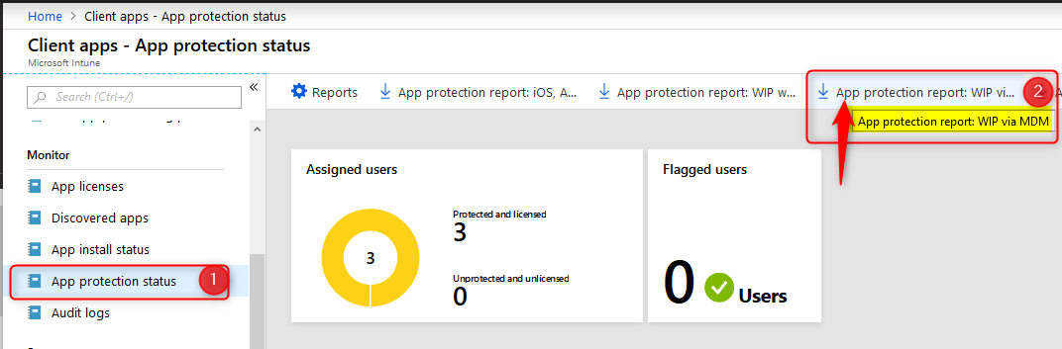

The reports contain information about the user and device name but also the App Protection Policy that applied to the user. The example below shows testuser6 has 2 BYO devices where data is managed and protected with the “WIP Without Enrollment” policy.

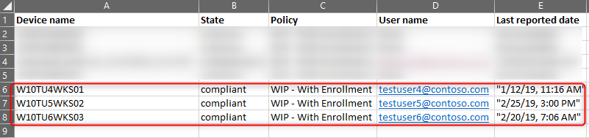

## Conclusion

Windows Information Protection with enrollment provides a robust solution by protecting work data that is downloaded to Windows 10 devices. It works by separating personal and work data, thus helping prevent unintentional information sharing. Combined with AIP it adds an extra layer of security making it possible for your users to share data amongst each other. For example on a USB drive.

As with other methods used to protect information and devices, you need to find a good balance between security and business productivity. If users really set their mind on stealing information, they will find a way to do so, no matter what you do. Lucky for us admins, most users don’t have malicious intent.

Please check the [official Microsoft documentation](https://docs.microsoft.com/en-us/windows/security/information-protection/windows-information-protection/create-wip-policy-using-intune-azure) as they are very complete and probably will update their documentation more frequently. Most importantly, this post (and any other) is based on my own experiences in the field deploying and configuring Microsoft solutions.I hope you have found this blog interesting and of added value considering there are so many other bloggers writing about Microsoft solutions. If you have any feedback I would appreciate it if you would write a line or two.

**Windows Information Protection User Experience**

In this post I’ll focus on Windows Information Protection user experience (WIP) on **MDM enrolled Windows 10 devices**. If you haven’t read my previous post about WIP, have a look below.

This post is part of a series. Have a look at my other posts for more information about WIP.

1. [Introduction to Windows Information Protection](https://allthingscloud.blog/windows-information-protection-wip/)
2. [Configuring MDM user scope and MAM user scope](http://allthingscloud.blog/configuring-intune-mdm-user-scope-and-mam-user-scope/)
3. [WIP-WE / MAM – Windows Information Protection without enrollment](http://allthingscloud.blog/windows-information-protection-without-enrollment/)
4. [Windows Information Protection with Enrollment](http://allthingscloud.blog/windows-information-protection-with-enrollment/)
5. **Windows Information Protection User Experience (this post)**
6. [WIP-WE User Experience – WIP Without MDM enrollment](http://allthingscloud.blog/wip-we-user-experience/)
7. [Set up Azure Rights Management for WIP](https://allthingscloud.blog/azure-rights-management-for-wip/)
8. [WIP Without Enrollment Selective Wipe](https://allthingscloud.blog/wip-without-enrollment-selective-wipe/)
9. [Troubleshooting Windows Information Protection](https://allthingscloud.blog/troubleshooting-windows-information-protection-on-windows-10/)
10. [Monitoring and collecting WIP audit event logs](https://allthingscloud.blog/monitoring-and-collecting-wip-audit-event-logs/)
11. WIP Learning mode
12. Limiting Access to SharePoint Online on unmanaged devices
13. Limiting Access to Exchange Online on unmanaged devices

**Prerequisites**

Make sure you have all the prerequisites in place;

* Intune enabled as the MDM authority
* Windows 10 1703 and above (Pro, Enterprise, Education)
* EMS E3 licenses (or at the very least Intune and Azure AD premium P1)
* My device is managed with Microsoft Intune (MDM enrolled)
* I have configured and assigned WIP policies
* **In this scenario I did not configure Azure RMS**
* I am Using **Microsoft Edge Legacy** because Edge Chromium needs extra configuration

**Windows Information Protection configuration**

I’ve configured the ‘**Windows Information Protection mode**’ to **Allow Overrides**.  When I copy data from a protected to a non-protected app,  I’m prompted with a warning message. The **Network boundaries** are configured as described in my previous post [Windows Information Protection with Enrollment.](http://allthingscloud.blog/windows-information-protection-with-enrollment/)

For the Windows Information Protection User Experience, I have a Windows 10 1909 Enterprise test-device and configured OneDrive for Business, OneDrive Personal and a personal Dropbox account. I’ve also synced a library from SharePoint.

Installed applications are:

* Office 365 ProPlus (with MS Teams)
* 7-zip
* Notepad ++
* Adobe Acrobat Reader DC
* FireFox
* Google Chrome
* Microsoft Edge Legacy
* I also have Edge Chromium browser available

**Windows Information Protection User experience**

Depending on the protected apps you’ve configured, the described Windows Information Protection user experience can be different for you but if you go with the standard apps you can follow along. Do you remember the difference between enlightened apps and unenlightened apps? I’ll quickly explain it here but I encourage you to read my previous post about [WIP Basics](http://allthingscloud.blog/windows-information-protection-wip/).

**Enlightened vs unenlightened apps**

The difference is that enlightened apps can differentiate between corporate and personal data whereas unenlightened apps cannot. Office 365 apps like Word, Excel, PowerPoint, OneNote, MS Teams, and Outlook are enlightened apps. Google Chrome, Firefox, Notepad ++ or Wordpad are examples of unenlightened apps.

If you want unenlightened apps to be able to access corporate data and encrypt files, you will have to add it to the WIP policy as an allowed (managed) application. **When you do configure unenlightened apps as corporate-managed they will consider all data to be corporate, encrypting everything created or edited by default** so think about this before you add unenlightened apps. Microsoft recommends only adding LOB apps to your allowed apps list.

When you open OneDrive for Business you’ll see there is an extra column “**File ownership**”. All the files have famsari.nl (my test tenant) set as the File ownership. The same is true for all the synced files from SharePoint and others sites you have added to your network boundaries. As a result all my documents in OneDrive for Business are protected with Windows Information Protection. Remember that file encryption based on EFS only occurs when downloading files locally on your device. Data is not encrypted online!

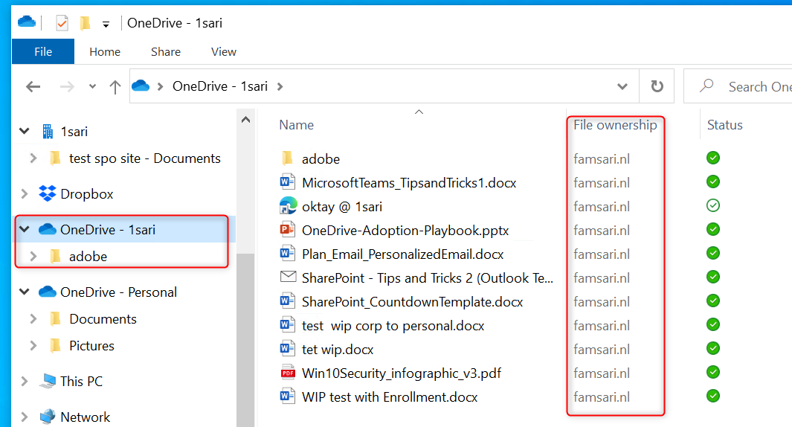

**Copy paste restrictions between applications**

There is a layer of protection based on restricting copy/paste actions from managed to unmanaged applications. In this example configuration, I’ve added the Office 365 Applocker file to allow pre-configured applications to access corporate data.

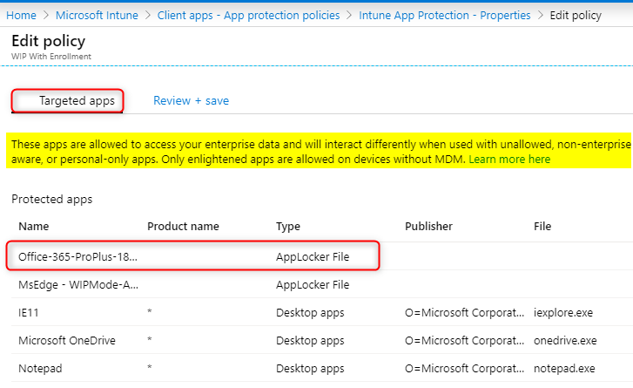

**Note:** There is no need to add all of the Office 365 Pro Plus suite applications manually to this list. Read more [here](https://docs.microsoft.com/is-is/windows/security/information-protection/windows-information-protection/enlightened-microsoft-apps-and-wip#adding-enlightened-microsoft-apps-to-the-allowed-apps-list).

When I open a document from OneDrive for Business with Microsoft Word and try to copy text to an application that is not approved, I see an error message;

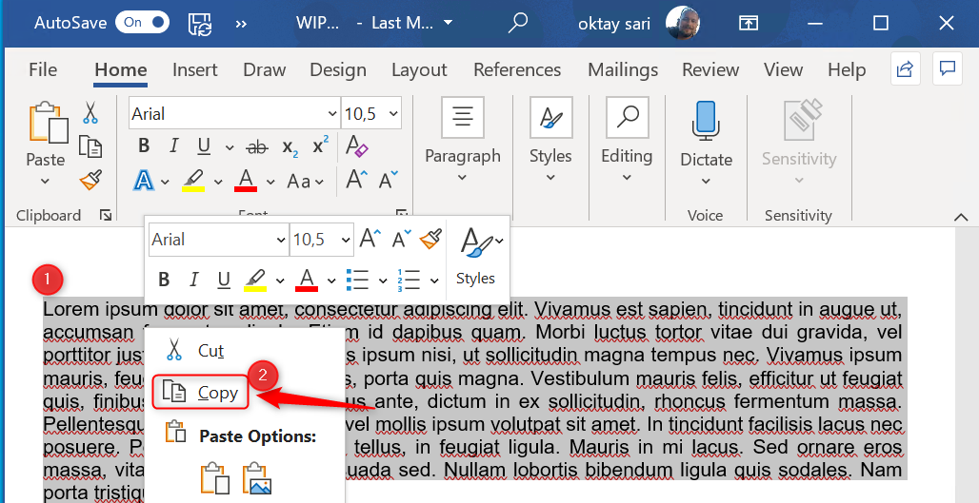

I’m using Notepadd ++ as an example here to paste corporate data.  Instead of pasting the information I copied, an error message is pasted;  “**Your organization doesn’t allow you to use work content with this application**”

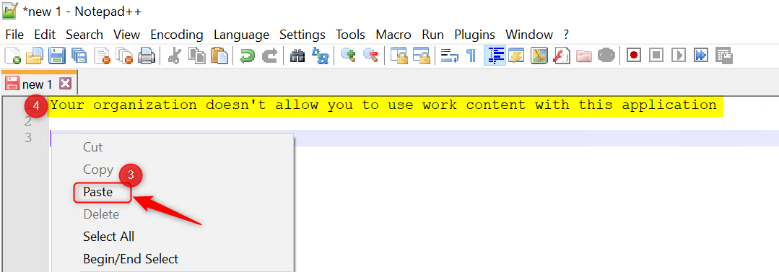

Copy paste from Word to Notepad or any other approved (protected) application works just fine. I can relocate data between approved and protected apps and network boundaries.

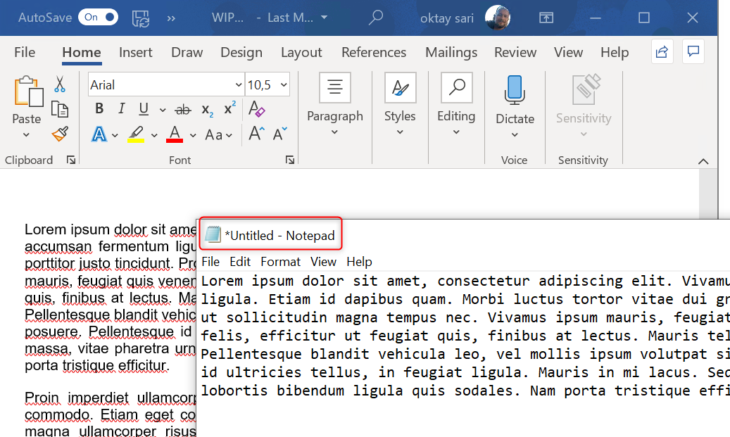

**Unapproved browsers**

When I open Google Chrome and login to Gmail and try to paste data from the same word document it will not allow me to do so. The same error message is pasted again; “**Your organization doesn’t allow you to use work content with this application**”

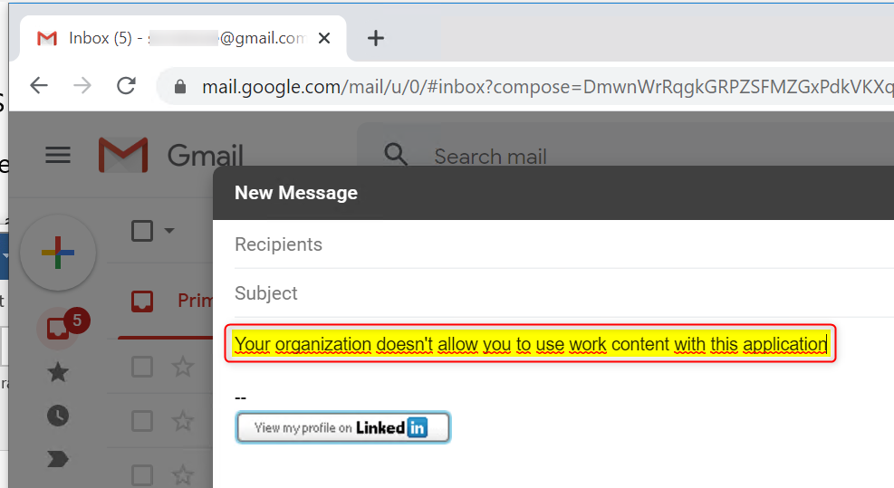

This is true for any other website you open with Google Chrome. For example, I will not be able to paste information to SaaS applications or translate text using Google Translate (with Google Chrome). With approved browsers like Microsoft Edge Legacy (WIP compliant) , I am able to override WIP and paste data to Google Translate.

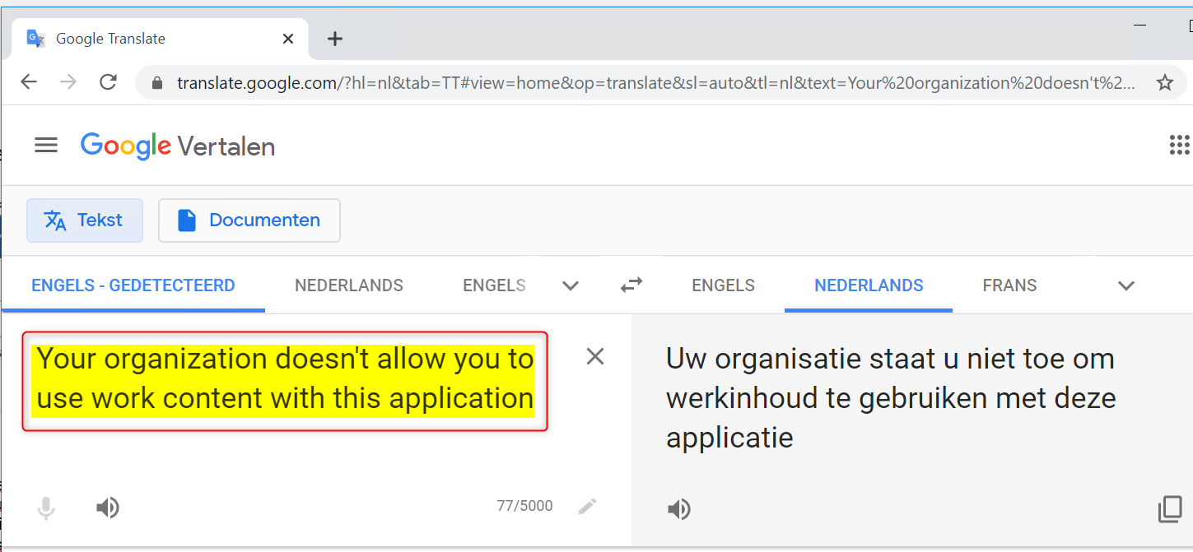

I’m not saying it’s bulletproof because with this configuration **I can upload a WIP protected document as an attachment** and send an e-mail to any recipient. However, I will see a warning message and must click **Yes** to continue. I override WIP and my actions are logged. I’ll write another post about Monitoring and collecting WIP audit event logs shortly. The example below shows that I was able to upload a WIP protected document as an attachment. Doing this removes the encryption and enables the recipient to access and read the document.

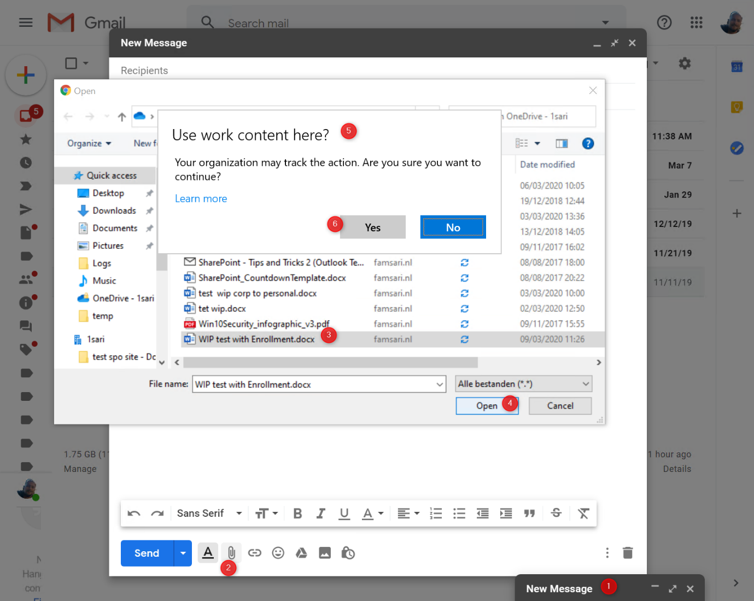

This event is written to the event log.  Have a look at Event Viewer\Applications and Services Logs\Microsoft\**Windows\EDP-Audit-Regular.** The log shows that the File ownership (the famsari.nl tag) has changed from work protected, to personal. It also shows that I was using Google Chrome while doing this.

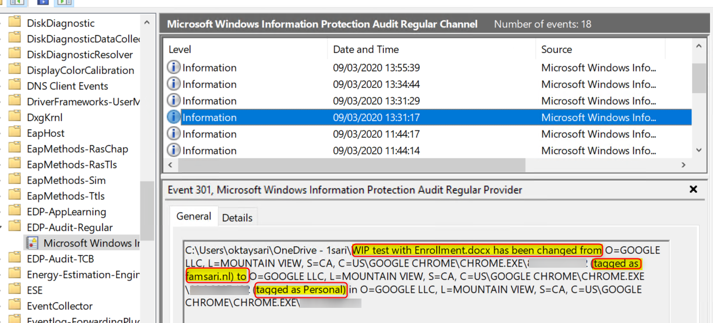

**Approved browsers**

The **Microsoft Edge legacy Browser** supports WIP. When I copy and paste information to Gmail or other websites like SaaS applications, I’m allowed to override WIP and continue. Upon clicking Yes, the copy/paste action is completed and another log entry is written to the event log. The question “**Use work content here?**” helps by making users aware about their actions and possible accidental data leaks.

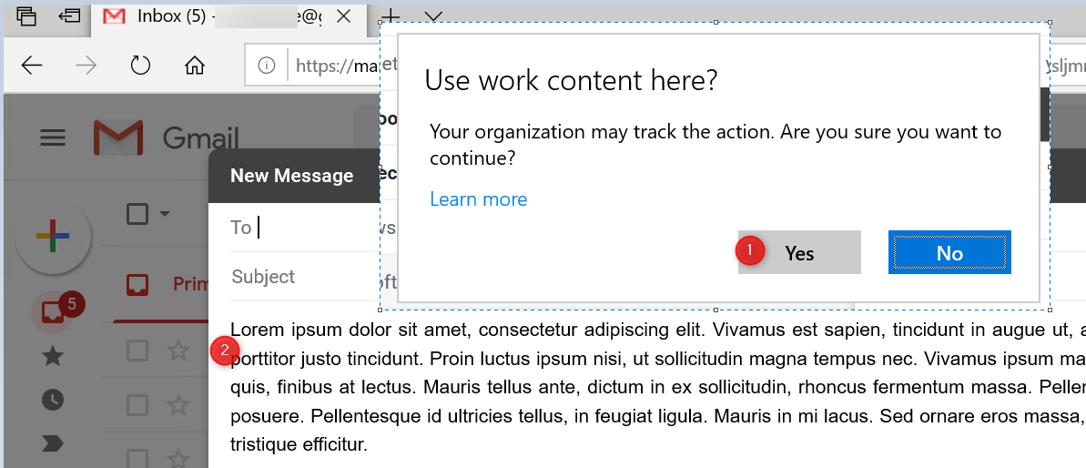

**OneDrive for Business: Relocating protected files**

Windows Information Protection Experience works a little different when I copy and paste or move documents from OneDrive for Business to any other location on my device (like C:\Temp). Documents are still protected with WIP policies after I copy them. You can double check this by looking at the **File ownership** property of your files.

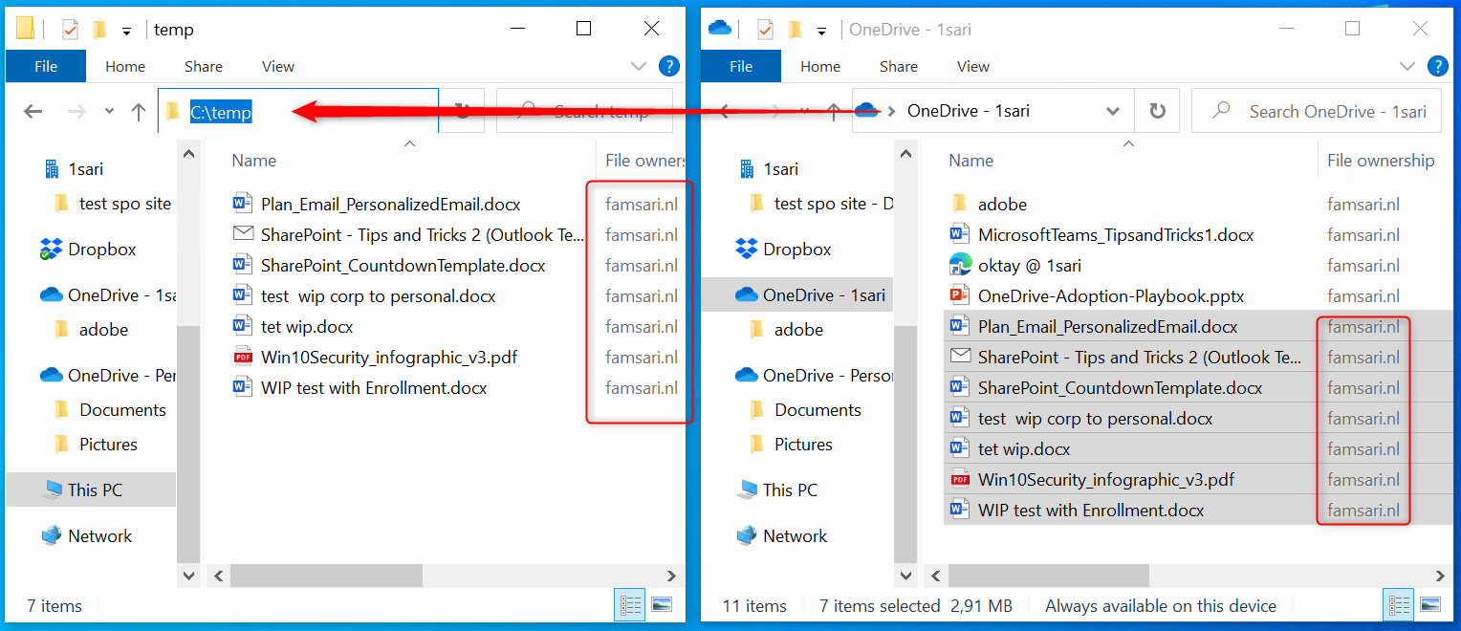

I copied a file to another location on my local hard-drive,  and now I can remove the WIP protection from these files. To do this, right click on any of your files and click on File Ownership in the menu. Next click on Personal.

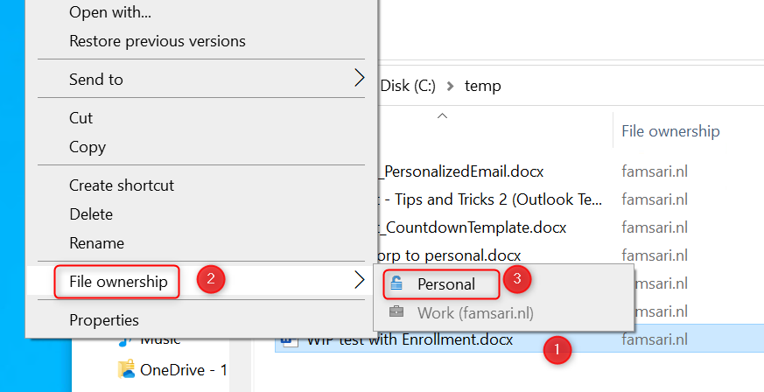

In the example below the WIP protection is removed from the document. You might find yourself in a situation where you want to present a PowerPoint presentation but are not able to do this using your own device. You will have to copy the PowerPoint presentation to a USB drive an use another device for the actual presentation. I’ll show you how you can use USB drives and other devices with Windows Information Protection below.

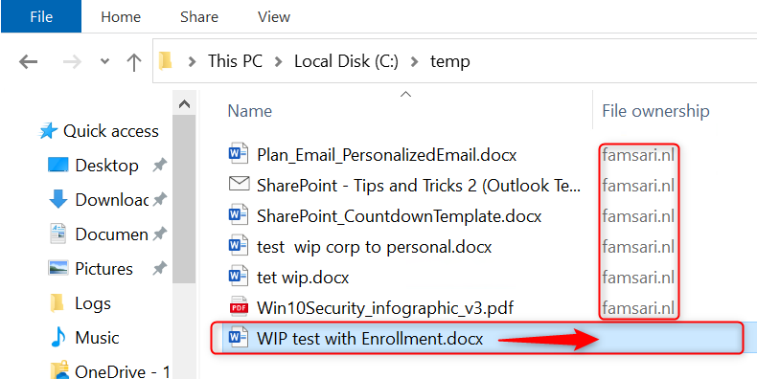

When I change the File ownership from work protected to personal, this action will also be logged. Here is the event in the Event Viewer:  
Event Viewer\Applications and Services Logs\Microsoft\**Windows\EDP-Audit-TCB**

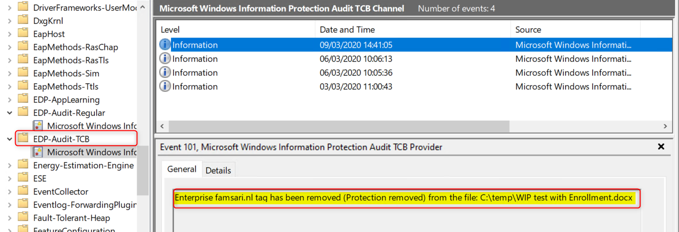

If you have log analytics configured to receive Windows Event logs from your MDM enrolled devices, you can run queries and even set-up alert when certain events happen. I’ll write another post about Monitoring and collecting WIP audit event logs but here’s a sneak peak at the logs in Log Analytics:

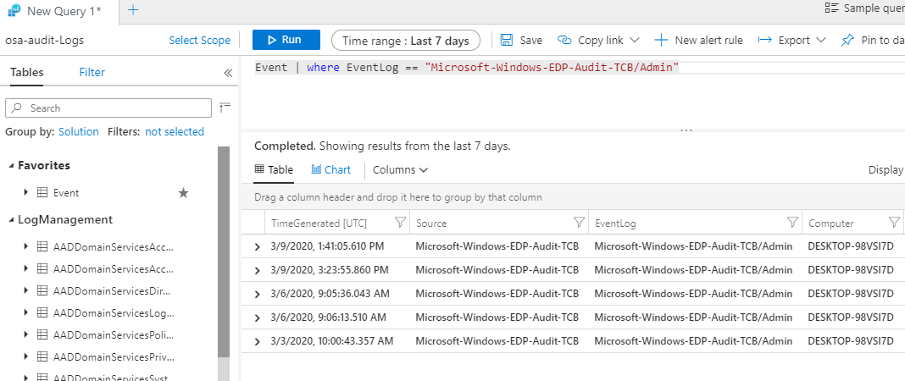

Click one of these events and see all the information you need:

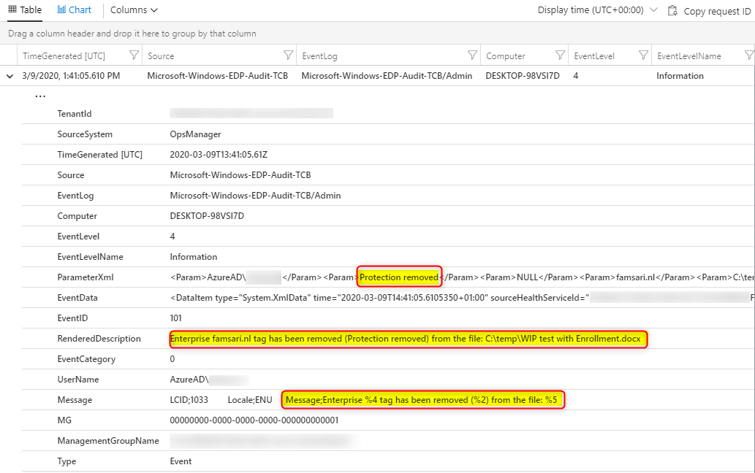

**Relocating WIP protected files to OneDrive Personal**

OneDrive Personal is better integrated with WIP and shows me a warning message when I copy documents. Now I have to change the File ownership to personal before I can copy files or skip it.

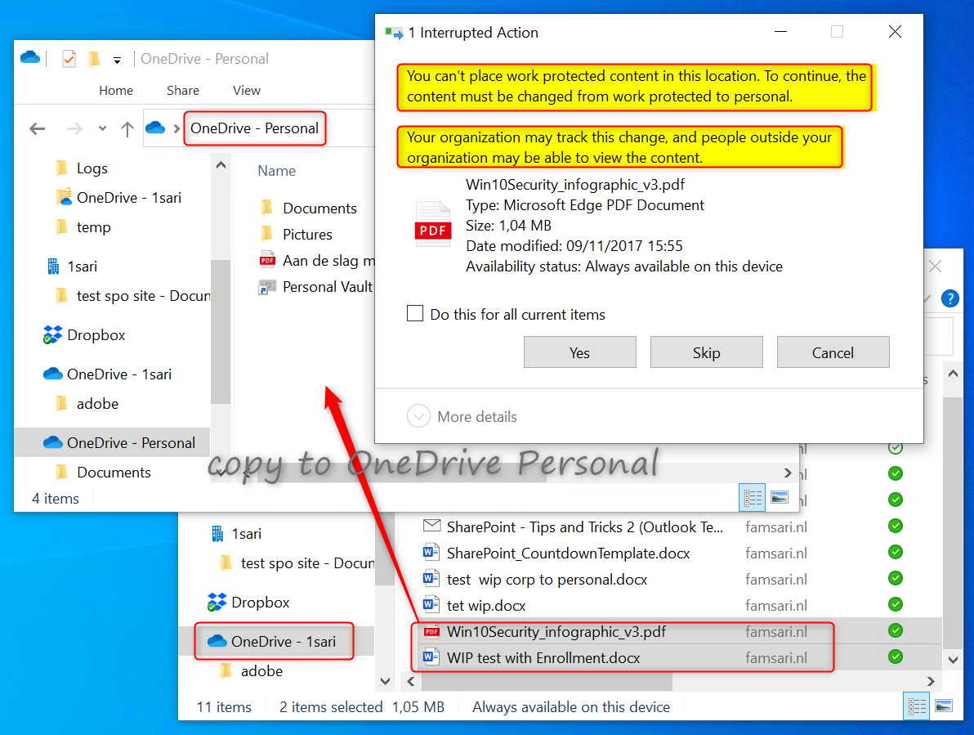

**Relocating WIP protected files to Dropbox**

I the example below I copied WIP protected files from OneDrive for Business to my personal Dropbox account and it looks like the file will sync to Dropbox.This is not true. Look closer and you will see that the files have the corporate file ownership tag and a red cross in the document icons indicating the files will not sync to Dropbox.

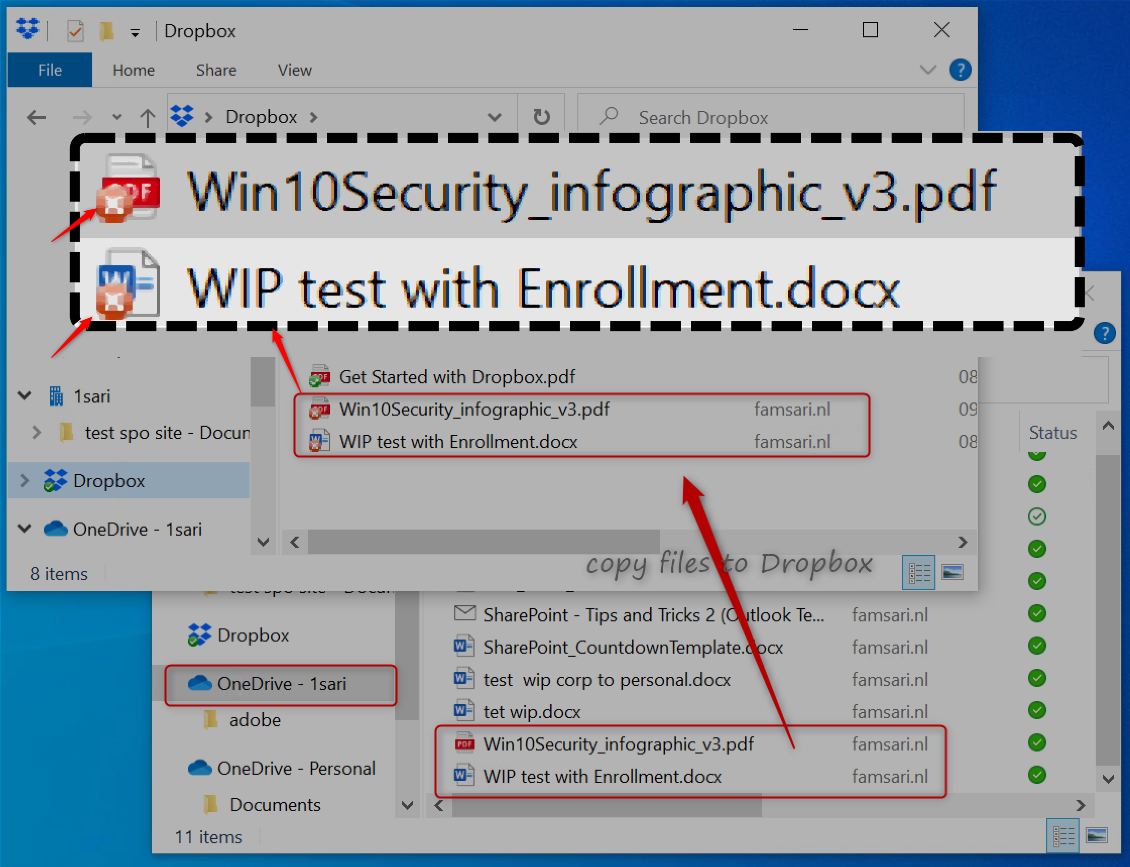

When I change the File ownership from work to private, the files will sync to Dropbox and the action is logged. This works as expected because I have set the ‘**Windows Information Protection mode**’ to **Allow Overrides**. Setting this to **Block** will effectively block file relocation.

**Relocating WIP protected files to USB drives**

When I copy or move WIP protected files to external storage like a USB drive, I’m prompted with a warning about relocating work protected data. **Copy as personal** will set the file ownership to personal and the action will be logged.

In the example below I copied a document by clicking **copy as work protected.**As a result the document can only be accessed on the original device where I copied it to the USB drive. No other user on any other device will be able to open the document. This is by design and you can read more about [Windows Information Protection and it’s limitations here](https://docs.microsoft.com/en-us/windows/security/information-protection/windows-information-protection/limitations-with-wip). It’s because I’m **NOT using Azure RMS**. By configuring Azure RMS, authenticated users in my organization will be able to access the document on their MDM enrolled devices. I’ll write another post about configuring Azure Rights Management with WIP and go through the user experience with Azure RMS configured.

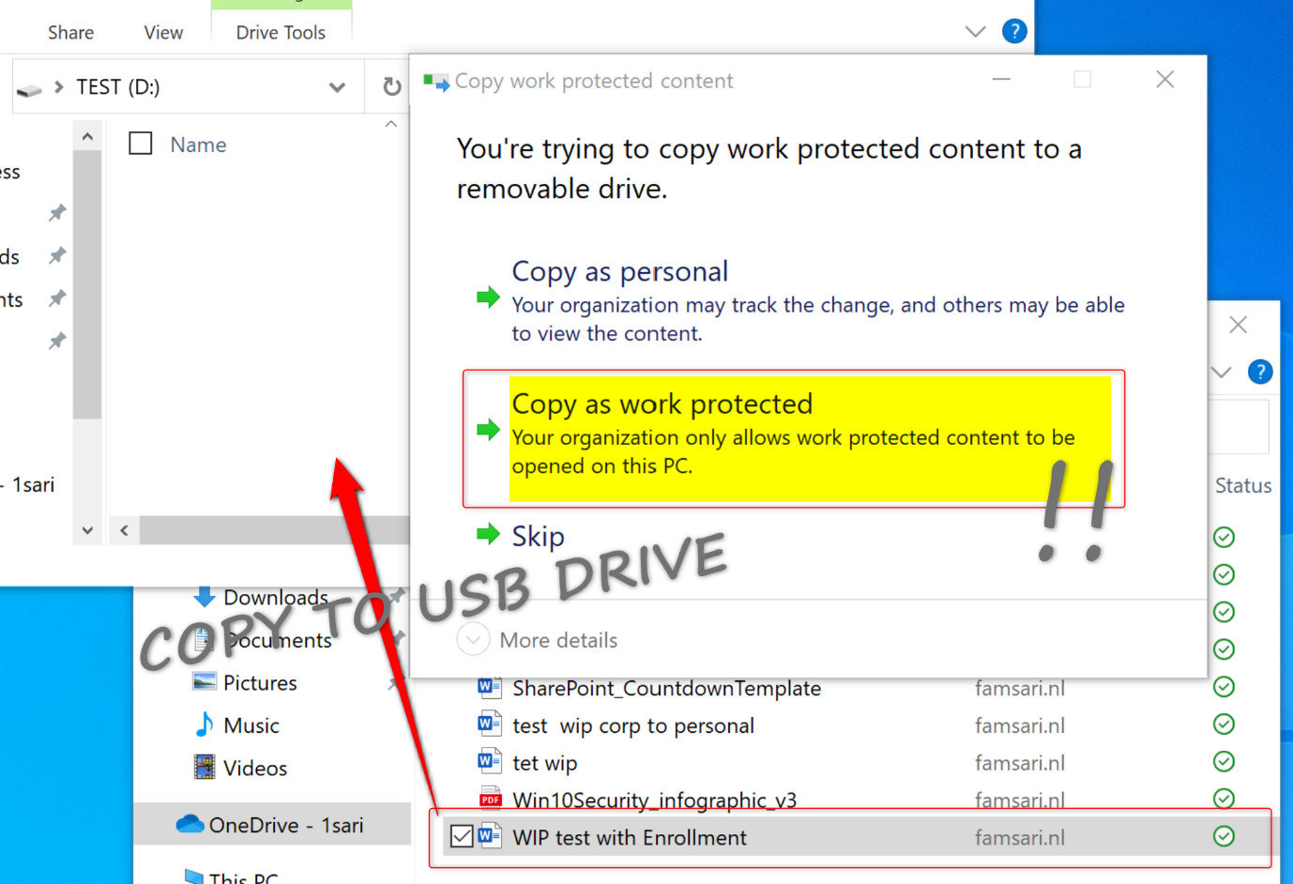

In the example above, I copied one document as personal, and another as **work protected**to a USB drive. When I try to access the documents on another device I can see the work protected document has a key lock in the document icon.

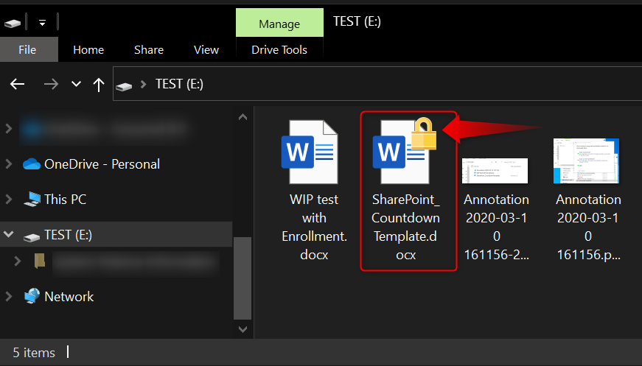

When opening the document, I get a nice error warning about not having the required privileges to access the document.

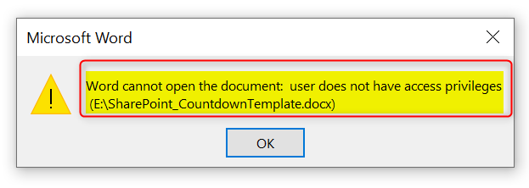

**Windows Information Protection – Block Mode**

Remember that this scenario is based on the ‘Windows Information Protection mode’ set to **Allow Overrides**. When you set the ‘Windows Information Protection mode’ to **Block**, you will only have the option to copy data to a USB drive as work protected or skip the operation.

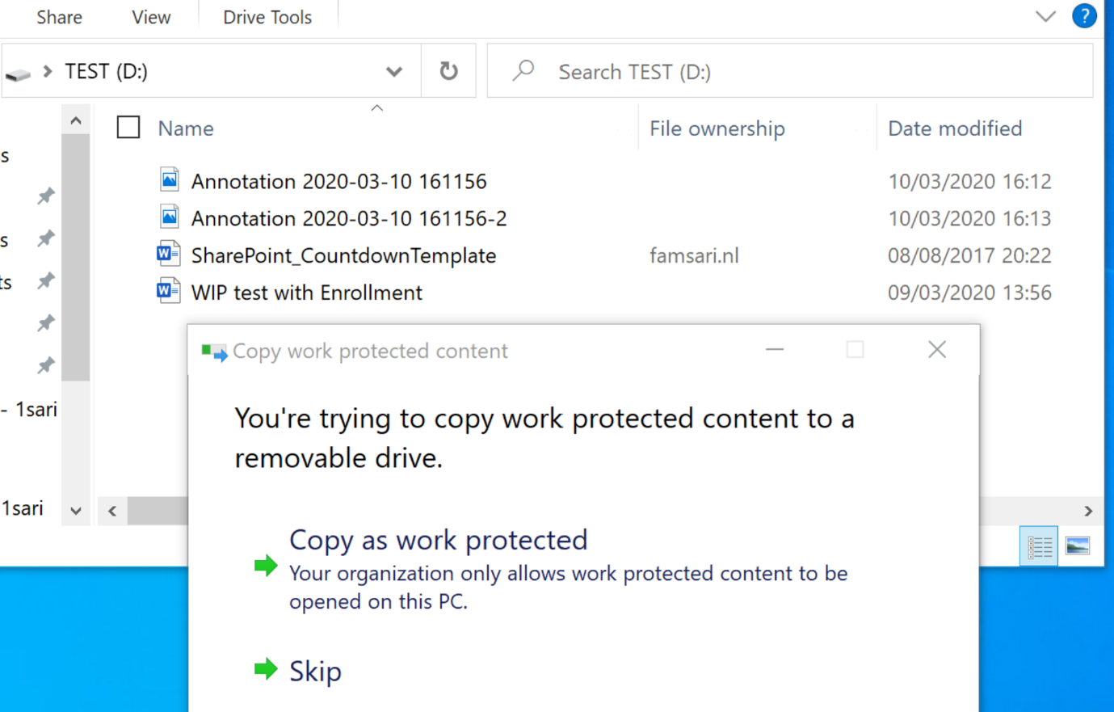

Most of the Windows Information Protection User experiences in this document might be different because by setting it to Block, you are not allowing users to override your WIP security settings.

Users will NOT be able to upload documents as attachments to Gmail or copy data to OneDrive Personal. The option to change the File ownership from work to personal will be grayed out. The **Block** setting is the most restrictive option you have with Windows Information Protection.

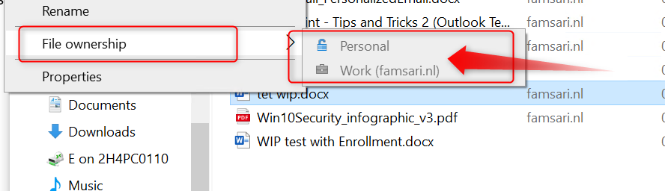

**Conclusion**

I probably forgot something important to write about here but for now I hope you’ve found this post valuable enough. Windows Information Protection works fine but there are some things to keep in mind. I’ll dive into this and more in a future post about **troubleshooting Windows Information Protection** and see what we can do to further protect corporate data.

I encourage you to engage here by leaving a comment so we all can learn more and help each other.

**WIP-WE User Experience**

[March 19, 2020](https://allthingscloud.blog/wip-we-user-experience/)  [Oktay Sari](https://allthingscloud.blog/author/oktay-sari/)  [Enterprise Mobility + Security](https://allthingscloud.blog/category/enterprise-mobility-security/), [Information Protection](https://allthingscloud.blog/category/information-protection/), [Intune](https://allthingscloud.blog/category/intune/), [MAM](https://allthingscloud.blog/category/mam/), [Windows 10](https://allthingscloud.blog/category/windows-10/), [Windows Information Protection](https://allthingscloud.blog/category/windows-information-protection/)

In this post I’ll focus on **WIP-WE** User Experience. Also known as **Windows Information Protection without enrollment** on **Windows 10 devices**. WIP Without Enrollment is a great solution for organizations supporting a BYOD solution. In addition, WIP-WE provides a degree of control to manage and secure corporate data on personal devices. If you want to know how to configure WIP-WE policies, read my previous [post](http://allthingscloud.blog/windows-information-protection-without-enrollment/) covering just that.

This post is part of a series I’m working on. Have a look at my other posts for more information about WIP.

1. [Introduction to Windows Information Protection](https://allthingscloud.blog/windows-information-protection-wip/)
2. [Configuring MDM user scope and MAM user scope](http://allthingscloud.blog/configuring-intune-mdm-user-scope-and-mam-user-scope/)
3. [WIP-WE / MAM – Windows Information Protection without enrollment](http://allthingscloud.blog/windows-information-protection-without-enrollment/)
4. [Windows Information Protection with Enrollment](http://allthingscloud.blog/windows-information-protection-with-enrollment/)
5. [Windows Information Protection User Experience](http://allthingscloud.blog/windows-information-protection-user-experience/)
6. **WIP-WE User Experience – WIP Without MDM enrollment (this post)**
7. [Set up Azure Rights Management for WIP](https://allthingscloud.blog/azure-rights-management-for-wip/)
8. [WIP Without Enrollment Selective Wipe](https://allthingscloud.blog/wip-without-enrollment-selective-wipe/)
9. [Troubleshooting Windows Information Protection](https://allthingscloud.blog/troubleshooting-windows-information-protection-on-windows-10/)
10. [Monitoring and collecting WIP audit event logs](https://allthingscloud.blog/monitoring-and-collecting-wip-audit-event-logs/)
11. WIP Learning mode
12. Limiting Access to SharePoint Online on unmanaged devices
13. Limiting Access to Exchange Online on unmanaged devices

**Prerequisites**

The first part of this document will be about the prerequisites, considerations and my test configuration setup to give you a better understanding about what I worked with. After that, I’ll dive into to the WIP-WE user experience.

Make sure you have the prerequisites in place;

* Intune enabled as the MDM authority
* Windows 10 1703 and above (Pro, Enterprise, Education)
* EMS E3 licenses (or at the very least Intune and Azure AD premium P1)
* [Configure your MAM provider in Azure AD](https://allthingscloud.blog/configuring-intune-mdm-user-scope-and-mam-user-scope/) for WIP without enrollment

**Configuring your MAM provider**

Before you create your WIP-WE policy, you need to set up your MAM provider or the MAM URLs in Azure AD. Configure the MAM Discovery URL to enable WIP-WE for Windows 10 devices . In other words, **without a MAM provider users cannot enroll into WIP-WE (MAM) management.**

I dedicated another blog post on [configuring **MDM users scope** and **MAM user scope**](https://allthingscloud.blog/configuring-intune-mdm-user-scope-and-mam-user-scope/). Please read that post if you want to learn more about configuring MDM and MAM scopes.

**WIP-WE Considerations**

I suggest you have a whiteboard session before you actually configure and  deploy WIP-WE for all your users. Think about what it is exactly that you want to accomplish on NON managed BYO devices. What degree of security are you looking for? Here are a few topics that you may want to consider:

* Can users Azure AD Join and MDM enroll personal devices?
* Can they install and use Office 365 desktop apps to access corporate data?
  + Do you allow access only by using a browser (Online only)?
* Can users Sync OneDrive for Business on their personal Windows 10 devices?
* Is downloading corporate data allowed on personal Windows 10 devices? Think about downloading:
  + E-mail attachments
  + OneDrive files
  + SharePoint Online
  + Microsoft Teams
* Can users remove WIP protection from files?

**MDM Device Enrollment restrictions**

I configured MDM device enrollment restrictions. As a result I don’t allow personal devices to be Azure AD joined. If you do the same, make sure you understand the consequences and limitations. Please read the documentation about [blocking personal Windows 10 devices](https://docs.microsoft.com/en-us/mem/intune/enrollment/enrollment-restrictions-set#blocking-personal-windows-devices).

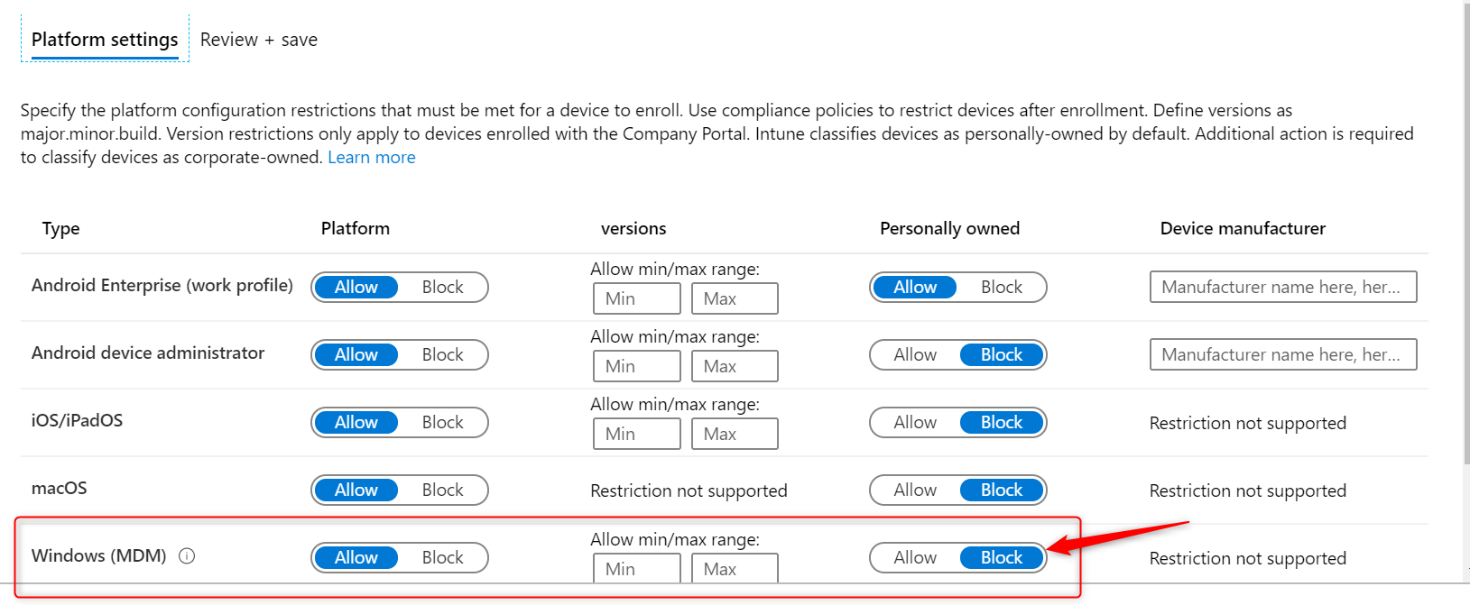

**Windows Information Protection configuration**

I’ve set the ‘**Windows Information Protection mode**’ to **Block**and the **Network boundaries** are configured as described in my previous post [Windows Information Protection without Enrollment.](http://allthingscloud.blog/windows-information-protection-without-enrollment/)

**IMPORTANT:**Unlike Azure AD Joined and MDM enrolled devices, you have a lot less control over personal devices that are only Azure AD registered.

By setting your WIP protection mode to Allow Override, users are allowed to change file ownership and decrypt files. This action is written to the local event log. However, you cannot collect event log entries to Azure Log Analytics. To collect event logs, you need to install Microsoft Monitoring Agent. And since deploying apps to Windows 10 requires a device to be MDM enrolled, you cannot collect event logs. Therefore I set it to Block.

* I have configured and assigned WIP policies
* **As before, In this scenario I did not configure Azure RMS**

**Windows 10 test device configuration**

* I have a personal Windows 10 1909 Pro test-device available for this WIP-WE User Experience.
* The device is NOT managed with Microsoft Intune and is not registered with Azure AD.
* I have a personal OneDrive and Personal Dropbox configured
* Installed my Office 365 desktop apps from the Office 365 portal.
* OneDrive for Business is installed

**Azure AD registration**

WIP-WE works only when a device is Azure AD registered. This can be accomplished by adding a work or school account by going to **Settings –> Accounts –> Access work or school**, or after adding an account to one of the Office 365 apps. For example, In this post I’ll go for the Office 365 apps version to register my device in Azure AD.  And when I start Office Outlook for the first time, I need to login with an account to activate my license.

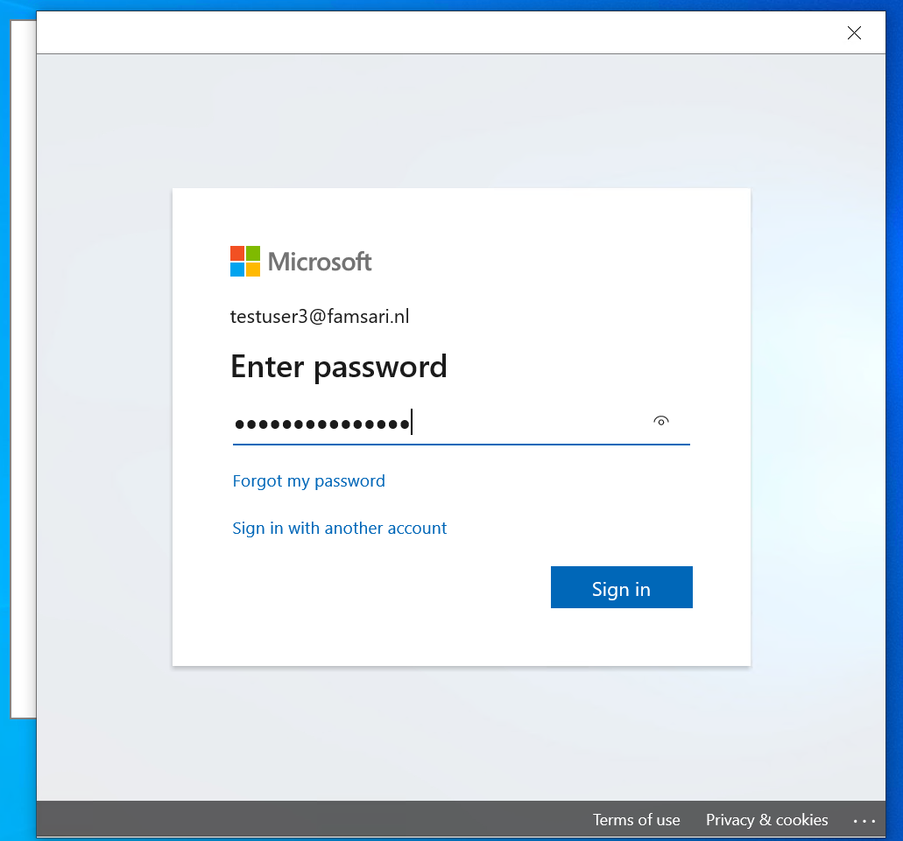

Have a look at this next screen because this screen follows after you login to Office:

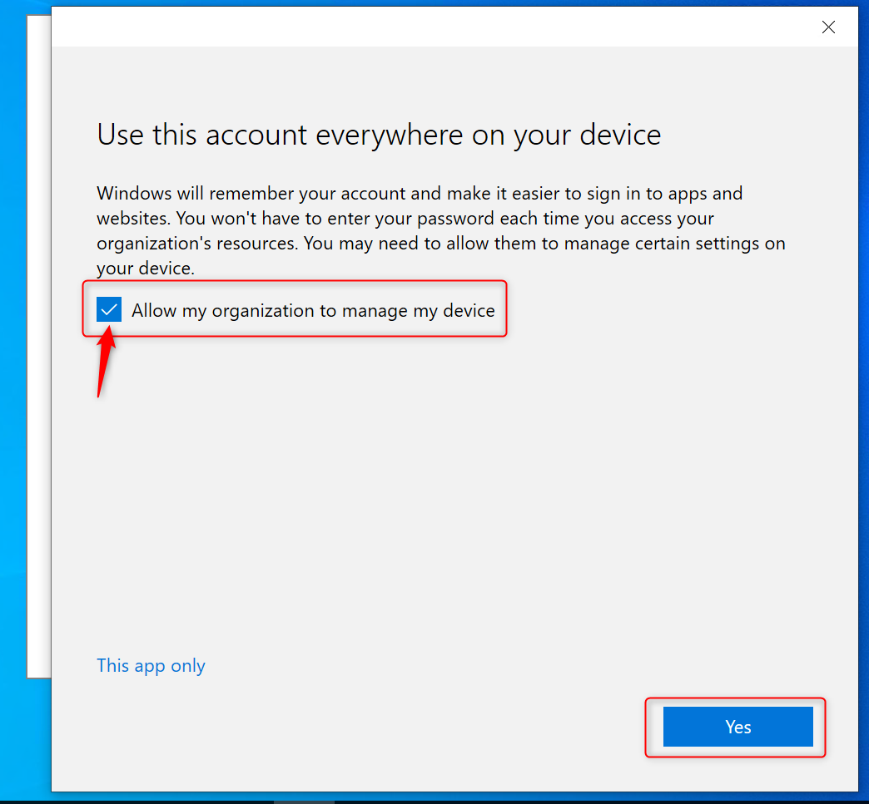

Most users will not pay any attention and just click on **Yes** without unchecking the check box “**Allow my organization to manage my device**”. As a result, the device will try to register in Azure AD. It also works wonders for SSO. For the purpose of this example I’m going to click on **Yes** and continue.

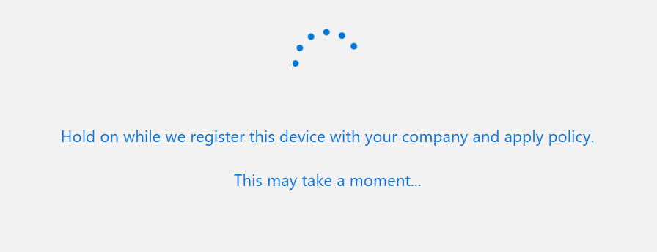

Assuming everything goes as planned and without errors, the device will complete the registration with Azure Active Directory.

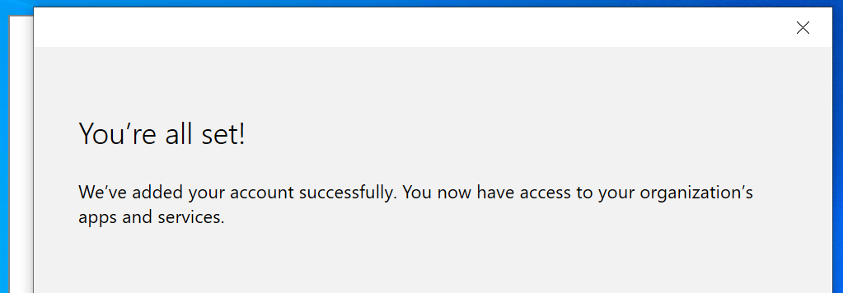

Finally, click on **Done** and complete the setup for Office Outlook.

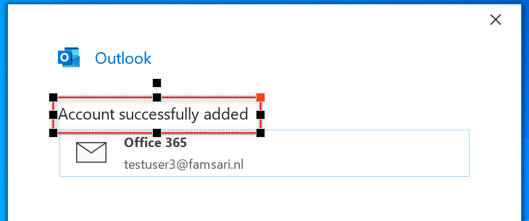

**Check your Azure AD registration**

You can check and see if your work account was added by going to **Settings –> Accounts –> Access work or school**

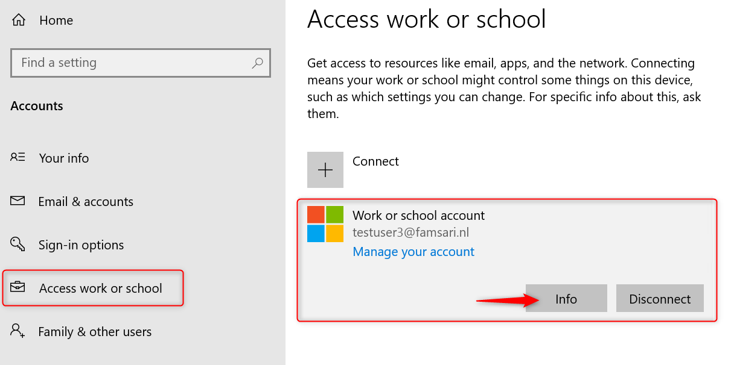

Click on Info to see more about the connection. The management Server Address shows **https://wip.mam.manage.microsoft.com:444/checkin**.

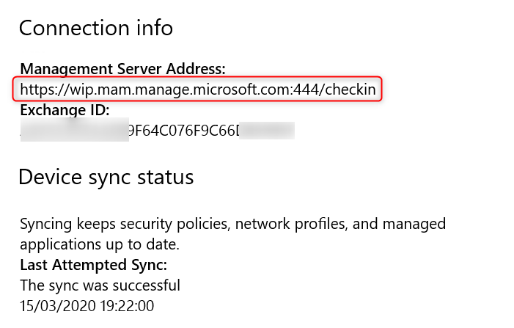

Also have a look at **Azure AD devices**:

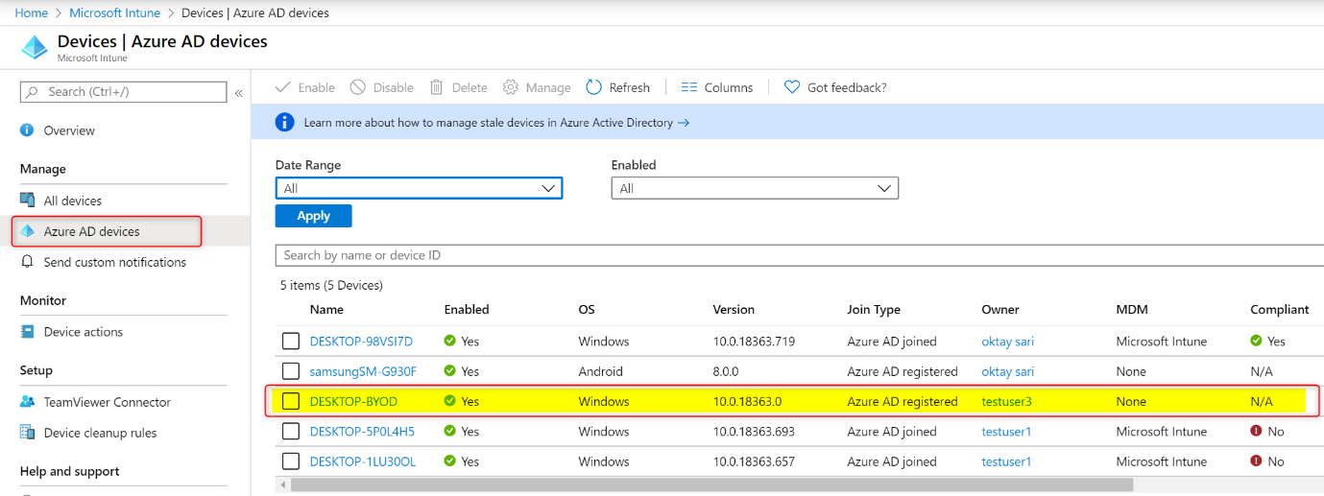

The device is Azure AD registered, not managed by MDM and therefore, does not need to be compliant. Can’t explain it any better than Microsoft, and I quote:

“*The goal of Azure AD registered devices is to provide your users with support for the Bring Your Own Device (BYOD) or mobile device scenarios.*” Read more about [Azure AD registered devices](https://docs.microsoft.com/en-us/azure/active-directory/devices/concept-azure-ad-register) on Microsoft’s website.

**WIP-WE User experience**

The WIP-WE user experience is almost the same as with MDM enrolled devices like I wrote about in my previous blog [Windows Information Protection User Experience](https://allthingscloud.blog/windows-information-protection-user-experience/). However, there are some things to keep in mind:

* **WIP protection mode** is set to **Block** and as a result users are not allowed to change file ownership.  Also copy/paste to unprotected apps or unprotected locations is not allowed. Most importantly, WIP protection cannot be overruled.

OneDrive for Business works the same as with WIP with enrollment. Consequently, you’ll see there is an extra column “**File ownership**”. And all the files have famsari.nl (my test tenant) set as the File ownership. The same is true for all the synced files from SharePoint. File encryption based on EFS only occurs when downloading files locally on your device. That is to say, data is not encrypted online!

Have a look at the screenshot below. You’ll see that all file icons have an extra symbol in the form of a suitcase. This is yet another indication that these files are corporate data. You can enable or disable this icon overlay by setting the WIP configuration option “*Show the enterprise data protection ico*n” to On or Off.

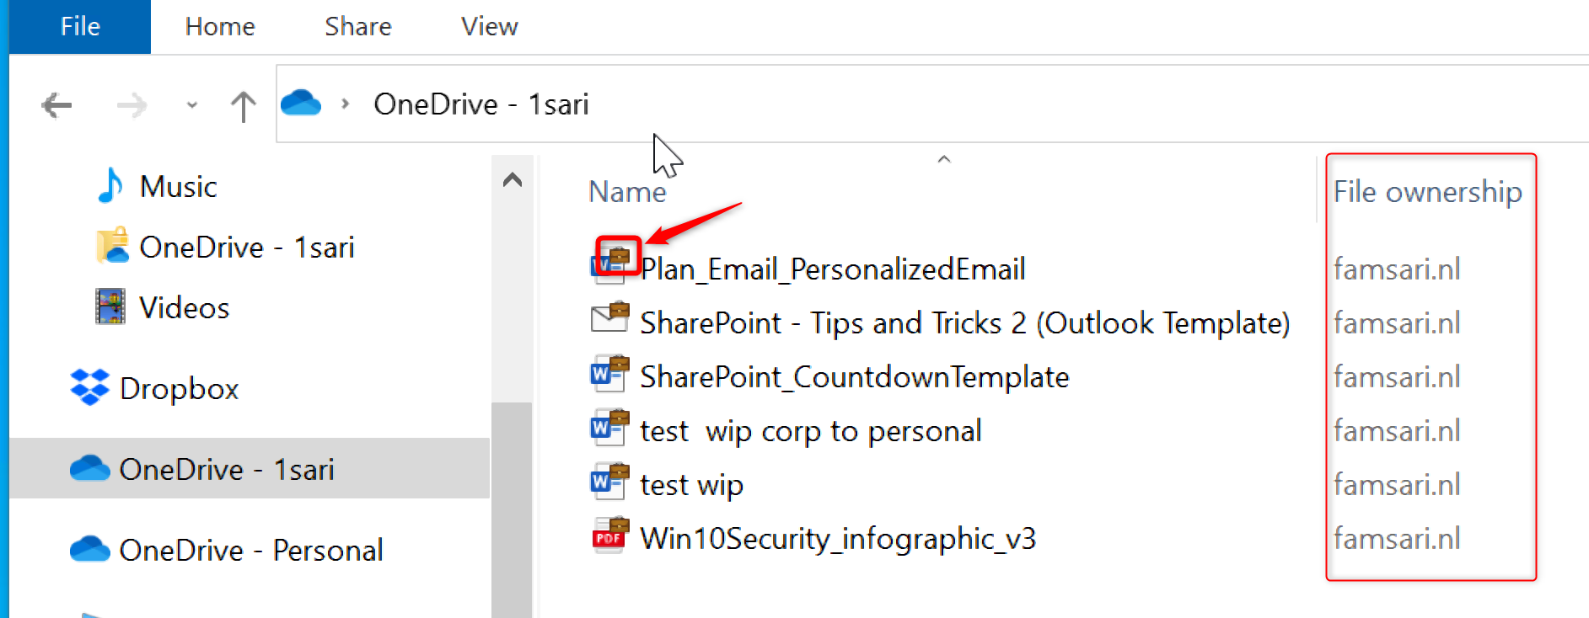

**Copy paste restrictions between applications**

Just like before, the restrictions for copy/paste actions from managed to unmanaged application depend on the targeted applications you have configured for the WIP-WE policy. When I copy data from Outlook (managed application) to Wordpad (unmanaged application), instead of pasting the information I copied, an error message is pasted; “**Your organization doesn’t allow you to use work content with this application**”

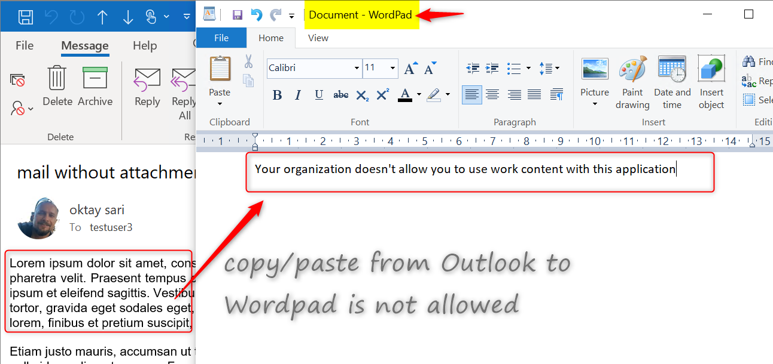

Notepad is configured as a managed application and the Task Manager shows the [Enterprise context](https://docs.microsoft.com/en-us/windows/security/information-protection/windows-information-protection/wip-app-enterprise-context) is set to famsari.nl. Managed (enlightened) applications can differentiate between corporate and personal data. First I’ll open Notepad and just start writing. Have a look at the upper right corner (minimize, restore, close). This file is handled as a personal file and saved without WIP protection.

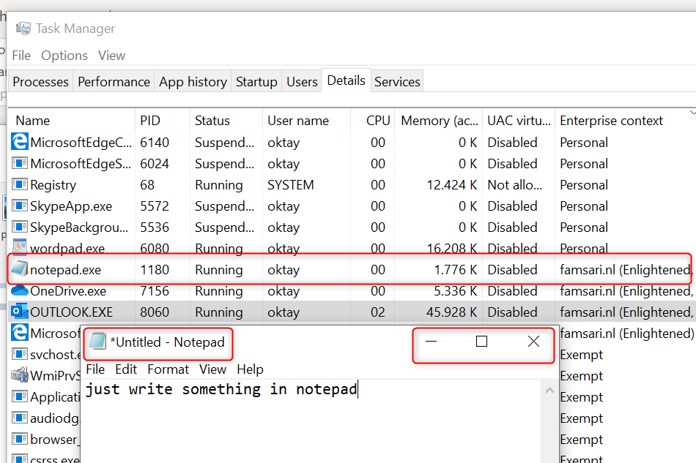

When I copy/paste corporate data from Outlook to Notepad, it knows this is corporate data and shows this with an extra symbol in the upper right corner. Notepad is a managed application and therefore I’m allowed to paste data.

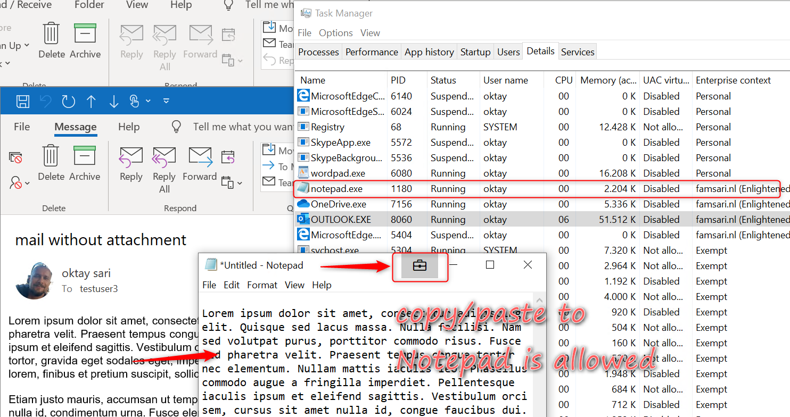

**Unapproved browsers**

Just as with WIP with MDM enrollment, unapproved browsers like Google Chrome will not allow to copy/paste information from documents. In addition, uploading documents is not allowed. There is no option to overrule the WIP-WE protection.

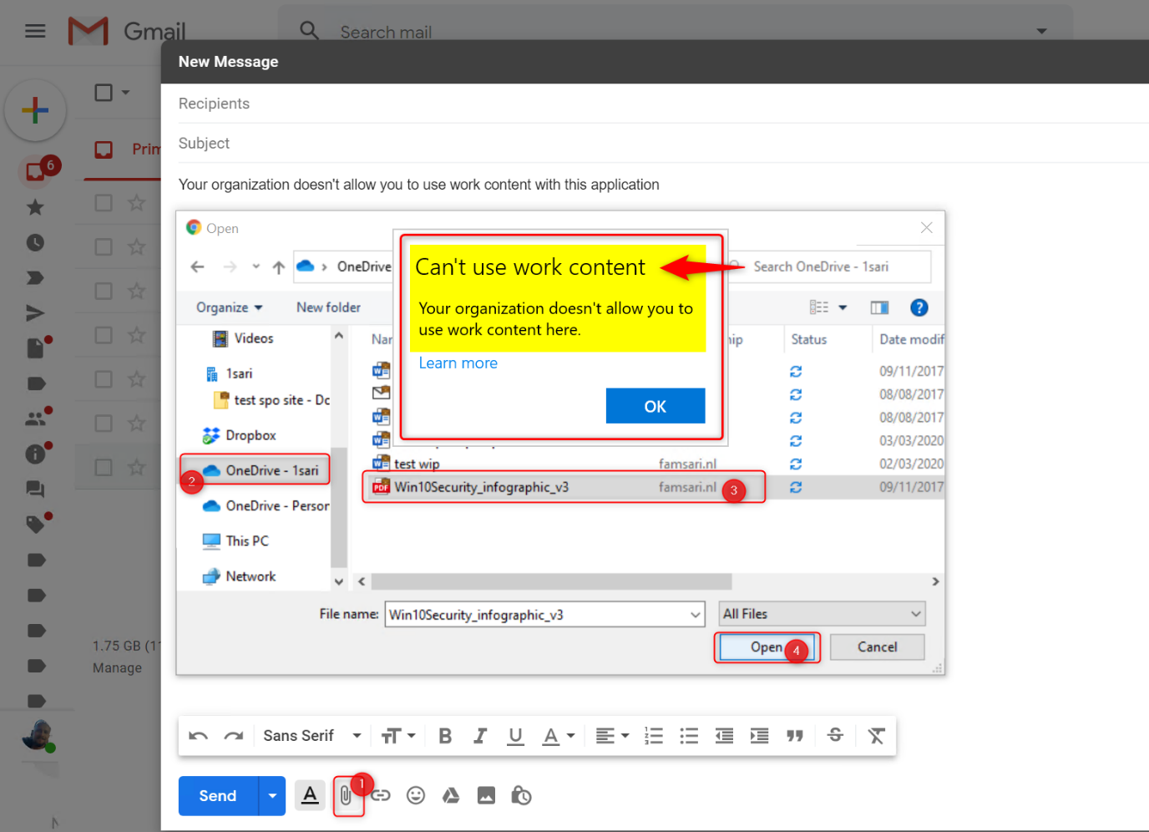

**Approved browsers**

**Microsoft Edge legacy Browser** supports WIP.  However, WIP Protection mode is set to block and as a result my actions to copy/paste or upload an attachment to Google Gmail are blocked.

**OneDrive for Business: Relocating protected files**

WIP-WE will protect files when I copy and paste or move documents from OneDrive for Business to any other location on my device (like C:\Temp). You can double check this by looking at the **File ownership** property of your files.



I can’t remove the WIP protection from these files. Right click on any of your files and click on **File Ownership** in the menu. Personal and Work options are greyed out.

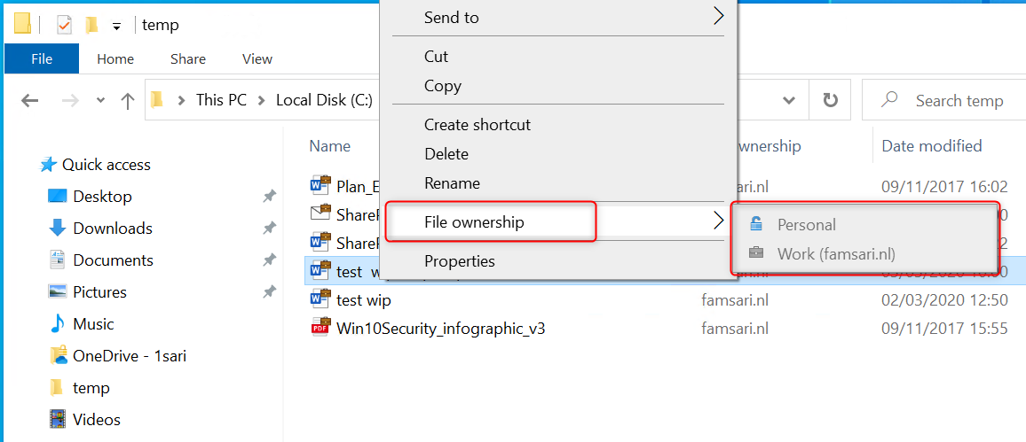

**Relocating WIP-WE protected files to OneDrive Personal**

I am not allowed to copy/paste or move files from OneDrive for Business and SharePoint Online to OneDrive Personal. The action is blocked by WIP-WE.

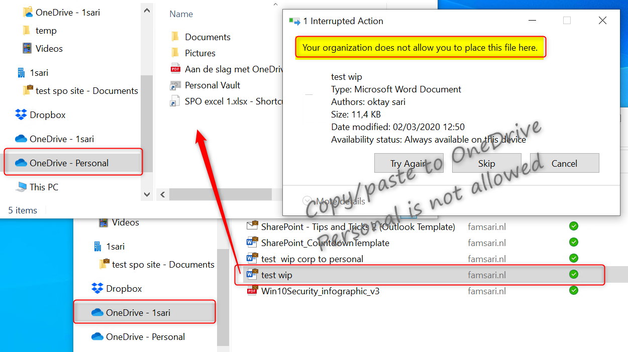

**Relocating WIP-WE protected files to Dropbox**

Copying WIP-WE protected files to Dropbox seems to work but again, files will not sync. Look closer and you will see that the files have the corporate file ownership tag and a red cross in the document icons. As a result, the files will not sync to Dropbox.



And again, I cannot change the File ownership from work to private because I have set the ‘**Windows Information Protection mode**’ to **Block**.

**Relocating WIP-WE protected files to USB drives**

When you set the ‘Windows Information Protection mode’ to **Block**, you will only have the option to copy data to a USB drive as work protected or skip the operation.

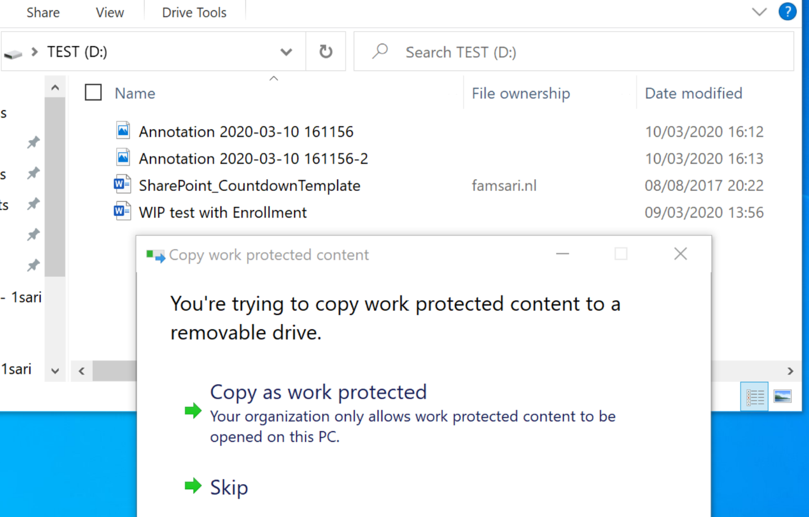

**Saving attachments from e-mails**

When I open an e-mail with an attachment, I can save it as usual, but the file will be protected with WIP wherever I save the file. If I had set the WIP Protection Mode to **Allow Override**, I would have the option to save this file as a personal file. With my WIP Protection Mode set to Block, I only have the option to save files in a corporate context.

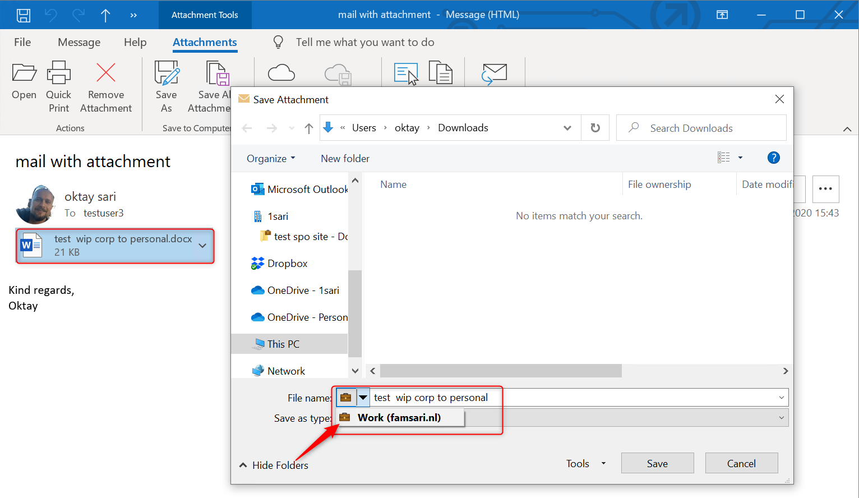

**Conclusion**

WIP is a robust solution for protecting corporate data. Firstly, It can separate personal and work data. Secondly, WIP helps prevent unintentional information sharing. And this makes WIP a good choose for companies wanting to support a BYOD scenario. In addition, combined with AIP it adds an extra layer of security making it possible for your users to share data among each other.

As with other methods used to protect information and devices, you need to find a good balance between security and business productivity. If users set their mind on stealing information, they will find a way. Lucky for us admins, most users don’t have malicious intent.

**Azure Rights Management for WIP**

This post is part of the Windows Information Protection (WIP) series. Firstly I walked through the basic, the actual WIP configuration and deployment. Secondly I wrote about the user experience on both MDM enrolled (company owned) and BYO devices (personally owned). Finally in this post I will focus on Azure Rights Management and how it works together with WIP.

Microsoft Azure Rights Management (**Azure RMS**) helps secure files when users want to share data using removable USB drives. For this to work , you must have Azure Rights Management set up. When Users copy WIP protected files to a USB drive, the protection stays with the data.

This post is part of a series. Have a look at my other posts for more information about WIP.

1. [Introduction to Windows Information Protection](https://allthingscloud.blog/windows-information-protection-wip/)
2. [Configuring MDM user scope and MAM user scope](http://allthingscloud.blog/configuring-intune-mdm-user-scope-and-mam-user-scope/)
3. [WIP-WE / MAM – Windows Information Protection without enrollment](http://allthingscloud.blog/windows-information-protection-without-enrollment/)
4. [Windows Information Protection with Enrollment](http://allthingscloud.blog/windows-information-protection-with-enrollment/)
5. [Windows Information Protection User Experience](https://allthingscloud.blog/windows-information-protection-user-experience/)
6. [WIP-WE User Experience – WIP Without MDM enrollment](http://allthingscloud.blog/wip-we-user-experience/)
7. **Set up Azure Rights Management for WIP (this post)**
8. [WIP Without Enrollment Selective Wipe](https://allthingscloud.blog/wip-without-enrollment-selective-wipe/)
9. [Troubleshooting Windows Information Protection](https://allthingscloud.blog/troubleshooting-windows-information-protection-on-windows-10/)
10. [Monitoring and collecting WIP audit event logs](https://allthingscloud.blog/monitoring-and-collecting-wip-audit-event-logs/)
11. WIP Learning mode
12. Limiting Access to SharePoint Online on unmanaged devices
13. Limiting Access to Exchange Online on unmanaged devices

**Prerequisites**

Make sure you have all the prerequisites in place;

* Intune enabled as the MDM authority
* Windows 10 1703 and above (Pro, Enterprise, Education)
* EMS E3 licenses (or at the very least Intune and Azure AD premium P1)
* I have configured and assigned WIP policies
* **In this scenario I have configured Azure RMS**

**Azure Information Protection Labels**

It might get confusing from here on because I’ll be referring to Azure Rights Management (Azure RMS) and Azure Information Protection (AIP). Azure Rights Management is the protection technology used by Azure Information Protection. Azure RMS uses encryption, identity, and authorization policies to secure files and protection remains with your files, even when it’s saved on a USB drive. Please [read the official documentation](https://docs.microsoft.com/nl-nl/azure/information-protection/what-is-azure-rms) about what Azure RMS is to fully understand the solution.

AIP protect documents and emails by applying labels. Azure RMS with WIP only works when you configure Azure Information Protection labels and template. That is what we will do first.

Go to your **Azure Portal** and then lookup **Azure Information Protection**. When you’re there, click on **Labels** and then **Add new Label.**

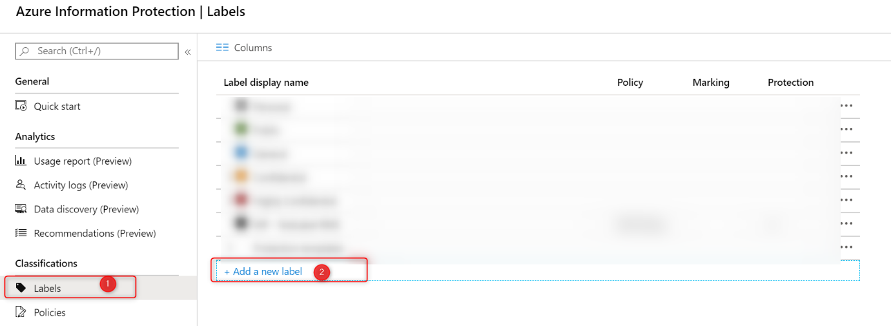

Configure your Azure Information Protection Labels (on the left side) and the actual protection template on the right. Read the Microsoft documentation on [How to configure a label for Rights Management protection](https://docs.microsoft.com/en-us/azure/information-protection/configure-policy-protection) if you are not familiar with AIP labels.

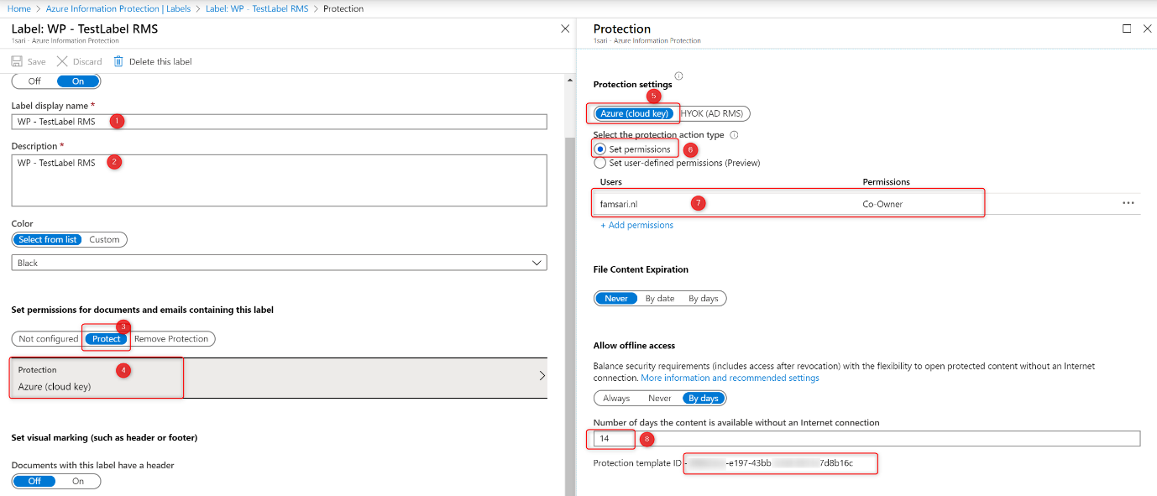

First configure your label and save it. Now the **Protection template ID**is automatically generated after the template is saved. You will need this ID later when you configure your WIP Policy and enable RMS. Finally, the label will be available on the **Azure Information Protection – Labels** blade:

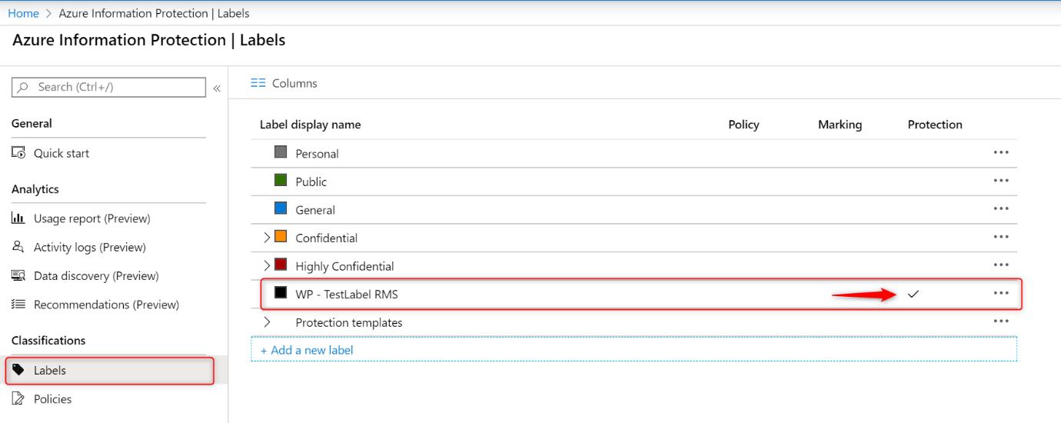

Open your Label again to get the Protection Template ID. Click on **Protection** on the left side. Copy the **Protection Template ID.**

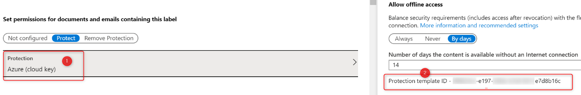

Please note that a lot is going to change. Read the [deprecation notice](https://techcommunity.microsoft.com/t5/azure-information-protection/announcing-timelines-for-sunsetting-label-management-in-the/ba-p/1226179) for more info.

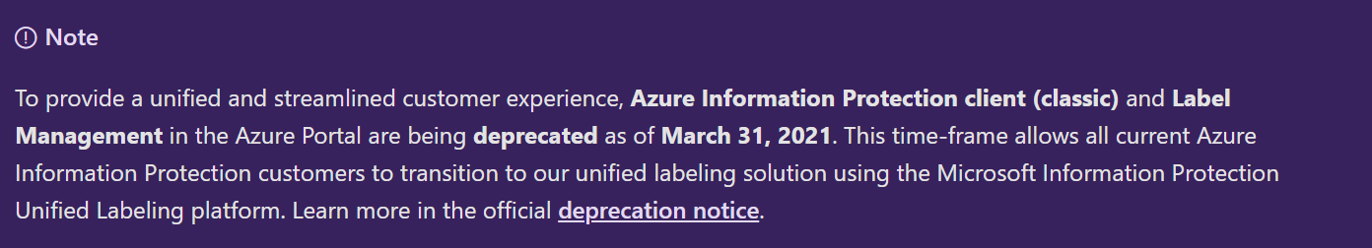

**Windows Information Protection mode**

I’ve configured the ‘**Windows Information Protection mode**’ to **Allow Overrides**. The **Network boundaries** are configured as described in my previous post [Windows Information Protection with Enrollment.](http://allthingscloud.blog/windows-information-protection-with-enrollment/) I’ve only configured Azure RMS for WIP for company owned, MDM enrolled devices.

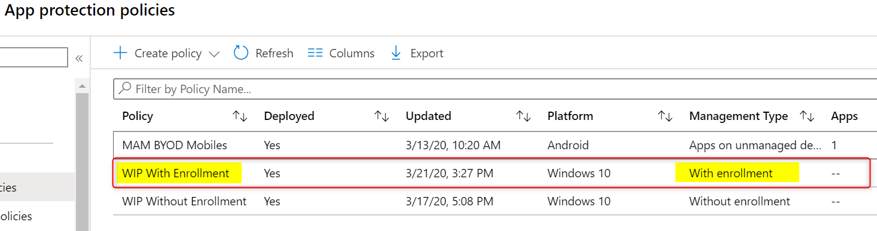

Open the policy and edit the **advanced settings**. Scroll down to Use Azure RMS for WIP and set the switch to On.

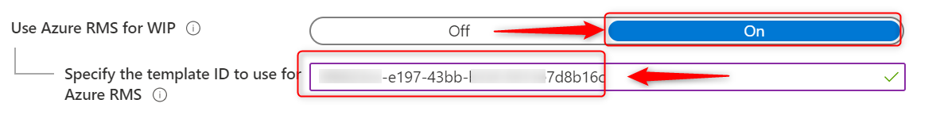

Finally paste the **Protection Template ID**and save your WIP policy.

**Azure RMS for WIP User experience**

When Users copy **Azure RMS WIP** protected files to a USB drive, the protection stays with your documents. Now everyone who has access to the protection policies will be able to open these files. Because I’ve configured my WIP policy to allow override, I need to copy documents as work protected to benefit from Azure RMS for WIP.

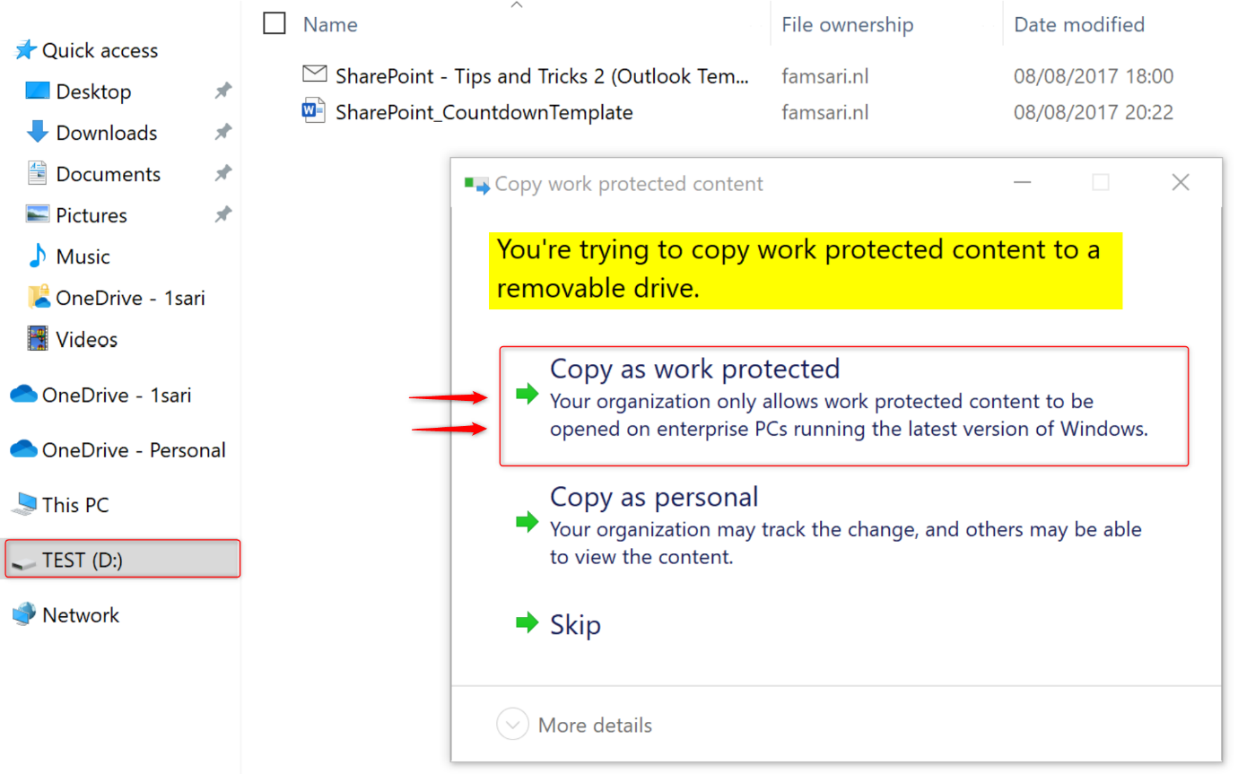

When you **copy files as work protected**, the File ownership will show the protected domain.

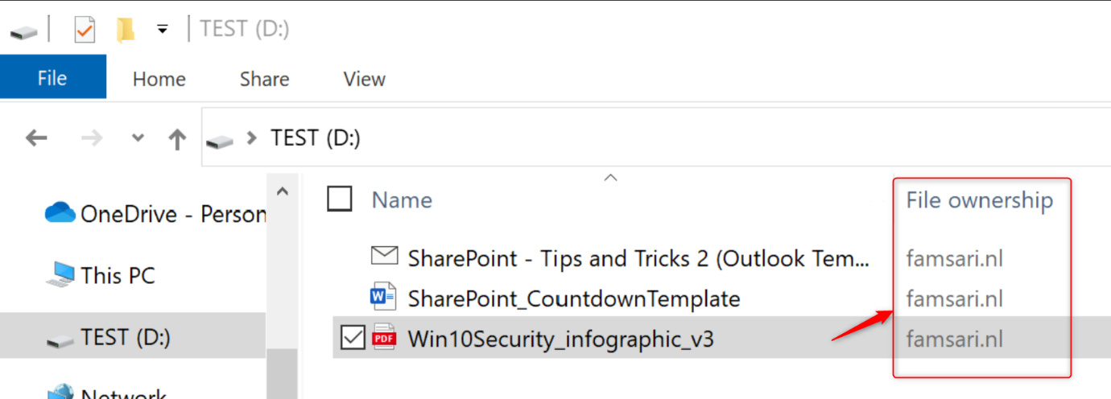

Everyone who has access to the protection template, will be able to open these files. This is just one method to protect data on USB drives without the risk of data leaks. Another method is to force USB drives or external storage to be Bitlocker encrypted before corporate data can be stored on it.

**Preventing data leaks on USB drives**

Should these devices be stolen or lost, the corporate data stored on the USB drive would be accessible by anybody that came to be in its possession. Most of the time, these drives are not even encrypted by BitLocker so this is a total GDPR nightmare.

Now Imagine I’ve lost the USB drive with corporate data and another me, found it on the street corner. Next, I plugin the USB drive to my personal Windows 10 device and see there is data stored on it.

**Warning:** Don’t plugin any USB drives you find on the street! It may well be infected with a virus or other malicious content!

Imagine again, I ignored the warning above. Have a look at the picture below:

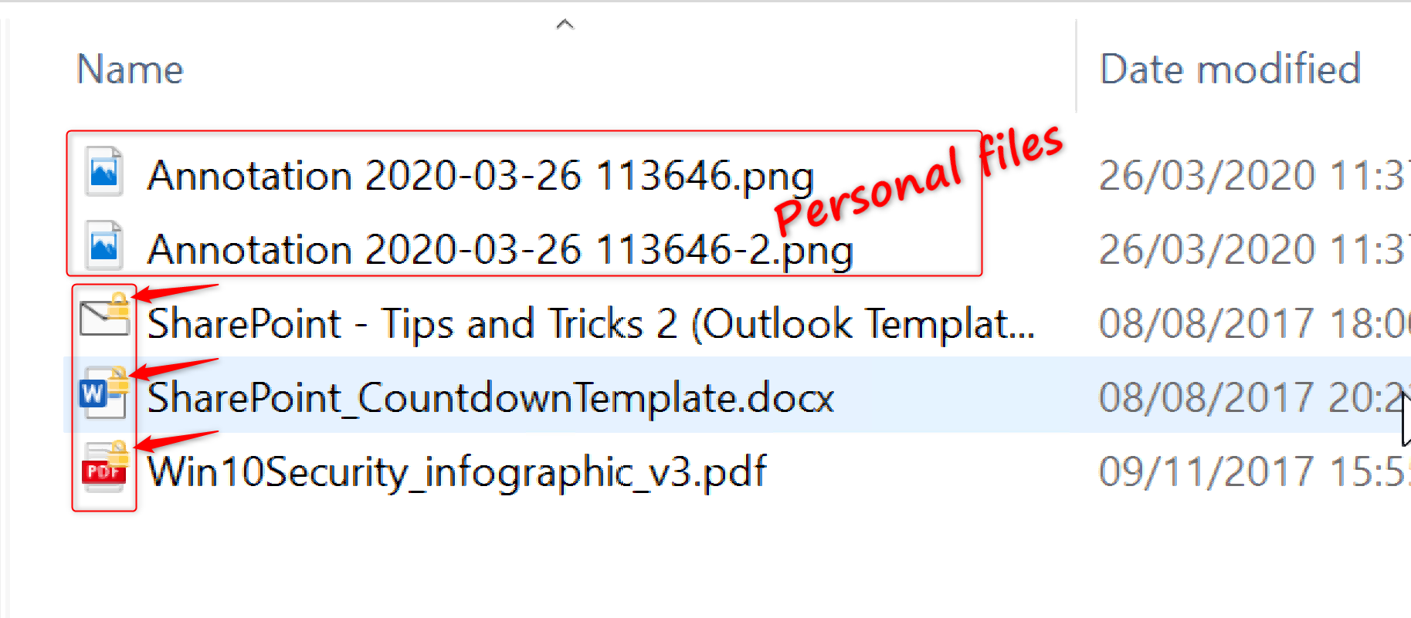 Some of these files show a key-lock in the icons and some don’t. Files that don’t show the key-lock are personal files (or corporate files that have been saved as personal) and I can open these without any issues. On the other hand, the files that have the key-lock in the icons are protected by Azure RMS for WIP. When I try to open any of these files, I see the next error:

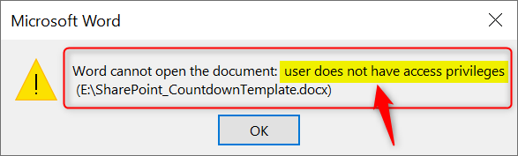

The USB drive itself is not Bitlocker encrypted, but the data is protected and includes a policy that defines who can access the data. As a result, I can’t open the work protected files on the lost USB drive I found on the street corner. Your corporate data is safe!

**Conclusion**

Azure RMS for WIP helps protect your corporate data even better because the protection stays with the data wherever it may be. There is a lot more to Azure RMS than what I’ve handled here in this post and I strongly advice you read up on Azure Right Management and Azure Information Protection. I’ve collected some of the resources I think might be a good start.

**WIP Without Enrollment Selective Wipe**

In my previous post I’ve walked through the [WIP-WE user experience](https://allthingscloud.blog/wip-we-user-experience/) (Windows Information Protection without enrollment) and showed you what the users experience when working on a Windows 10, BYOD (Bring Your Own Device). In the first part this post I’ll show you what happens to corporate data when an administrator performs a selective wipe on a personally owned BYOD (WIP Without Enrollment Selective Wipe). The second part, I’ll show you what happens when the user disconnects a device by removing his or her work account. Finally, I’ll finish this post by looking at Microsoft Office Outlook offline data files (OST files) and WIP limitations.

This post is part of a series. Have a look at my other posts for more information about WIP.

1. [Introduction to Windows Information Protection](https://allthingscloud.blog/windows-information-protection-wip/)
2. [Configuring MDM user scope and MAM user scope](http://allthingscloud.blog/configuring-intune-mdm-user-scope-and-mam-user-scope/)
3. [WIP-WE / MAM – Windows Information Protection without enrollment](http://allthingscloud.blog/windows-information-protection-without-enrollment/)
4. [Windows Information Protection with Enrollment](http://allthingscloud.blog/windows-information-protection-with-enrollment/)
5. [Windows Information Protection User Experience](https://allthingscloud.blog/windows-information-protection-user-experience/)
6. [WIP-WE User Experience – WIP Without MDM enrollment](http://allthingscloud.blog/wip-we-user-experience/)
7. [Set up Azure Rights Management for WIP](https://allthingscloud.blog/azure-rights-management-for-wip/)
8. **WIP Without Enrollment Selective Wipe (this post)**
9. [Troubleshooting Windows Information Protection](https://allthingscloud.blog/troubleshooting-windows-information-protection-on-windows-10/)
10. [Monitoring and collecting WIP audit event logs](https://allthingscloud.blog/monitoring-and-collecting-wip-audit-event-logs/)
11. WIP Learning mode
12. Limiting Access to SharePoint Online on unmanaged devices
13. Limiting Access to Exchange Online on unmanaged devices

**Prerequisites**

Make sure you have a test configuration up and running and make sure you have the prerequisites in place;

* Intune enabled as the MDM authority
* Windows 10 1703 and above (Pro, Enterprise, Education)
* EMS E3 licenses (or at the very least Intune and Azure AD premium P1)
* Configure your MAM provider in Azure AD for WIP without enrollment
* Azure AD registered Windows 10 device
* Set WIP Protection mode to **Block**
* Set **Revoke encryption keys on unenroll** to**On**

**Note:** By revoking the encryption keys, access to encrypted files is blocked and therefore a user no longer has access to encrypted (WIP protected) corporate data.

Check settings Accounts Access work or school and make sure your device is registered with Azure AD by adding a Work or school account. Have a look at [Azure AD registration](https://allthingscloud.blog/wip-we-user-experience/#azure-ad-registration) in my previous post for more on that.

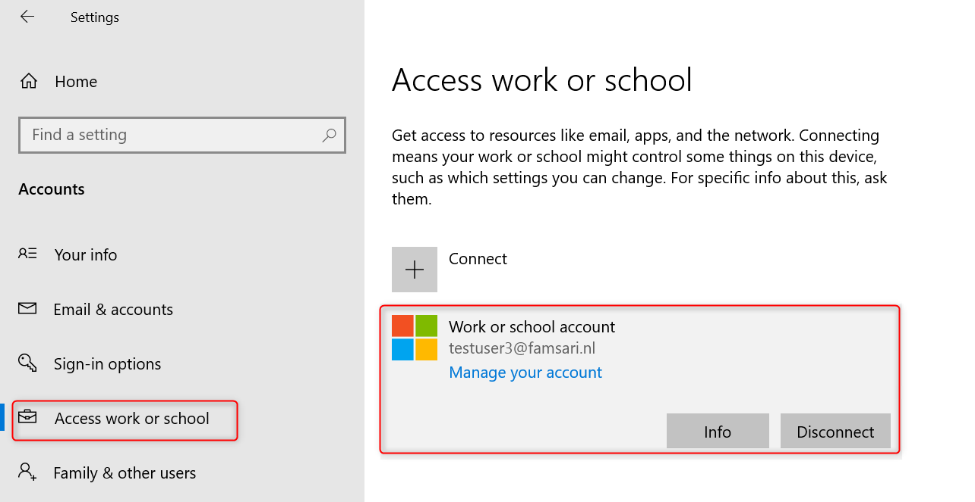

You can confirm this from the back-end by checking Azure AD devices. My test user is working on a Windows 10 device with the name **DESKTOP-BYOD**. Azure AD registered and not managed by MDM.

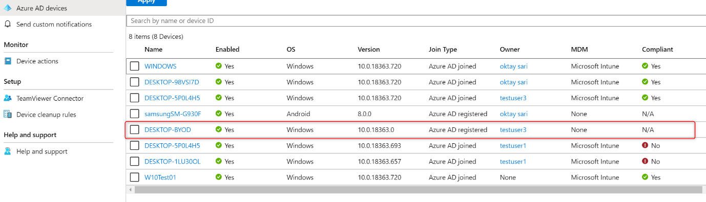

For now, I’ll have to assume everything is in place to get started with an actual WIP Without Enrollment Selective Wipe from the [management portal](https://endpoint.microsoft.com/#blade/Microsoft_Intune_DeviceSettings/AppsMenu/appSelectiveWipe).

**Before the selective wipe**

Now before you go ahead and start a **Selective Wipe**, have a quick look at your test device and make sure you have OneDrive for Business configured and you actually sync data to your device. I also have configured Outlook with e-mail data available. Otherwise there is no data to wipe ?

Is your corporate data protected with WIP? You can check the **File ownership** for a clue.

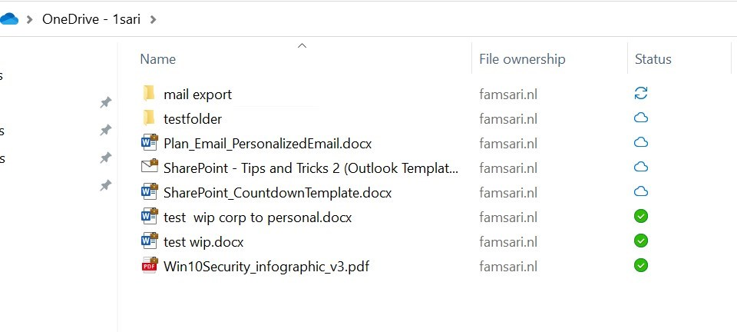

Office 365 Outlook is configured with a corporate e-mail profile

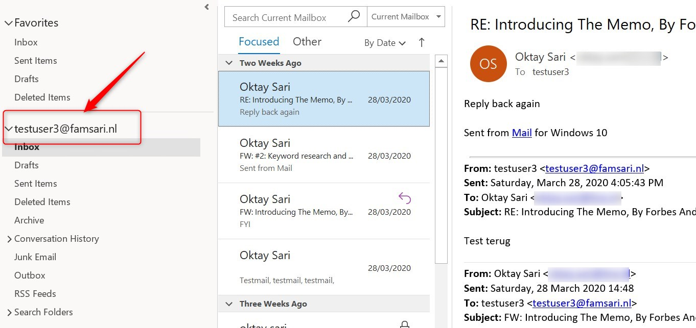

**Part 1: Admin triggered selective wipe**

To remove only organizational data from a device, an administrator can start a WIP Without Enrollment Selective Wipe on a Windows 10 device. Start by going to **Microsoft Intune > Client apps > App selective wipe**. You can also do this from the new [management portal](https://endpoint.microsoft.com/#blade/Microsoft_Intune_DeviceSettings/AppsMenu/appSelectiveWipe). It’s basically the same, but the menu looks a little different. For now I’m using portal.azure.com and go to Microsoft Intune.

* Go to Microsoft Intune >Client apps > App selective wipe
* Click + Create wipe request

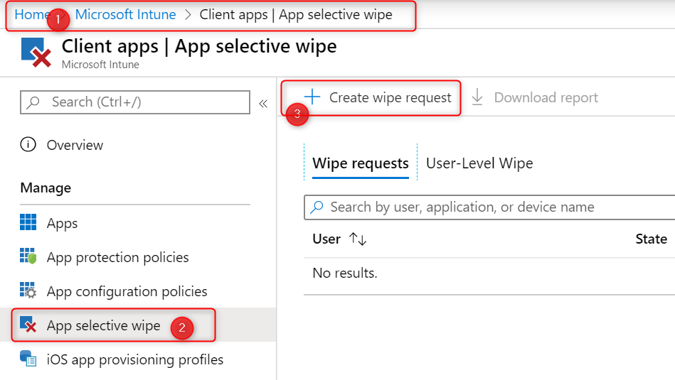

* Click **select user**. When you’ve selected a user, Intune will show any Windows 10 devices that are Azure AD registered.
* Choose a device on which you want to perform a **selective wipe**.
* Click on **Create**

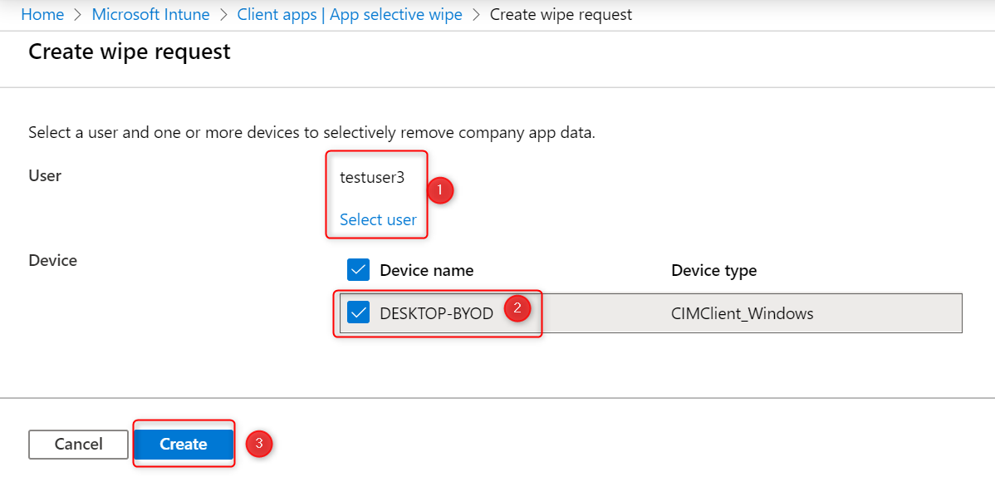

When you are ready, the WIP-WE Selective Wipe request will show as **pending**. There is a report that shows the overall status of the wipe requests you have executed.

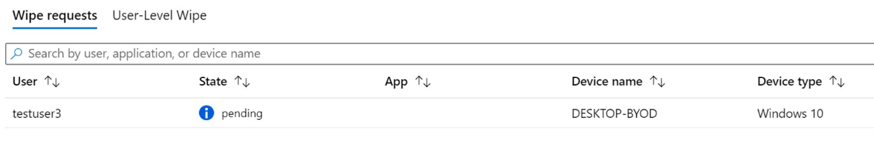

That’s all there is to it. The selective wipe request is created.

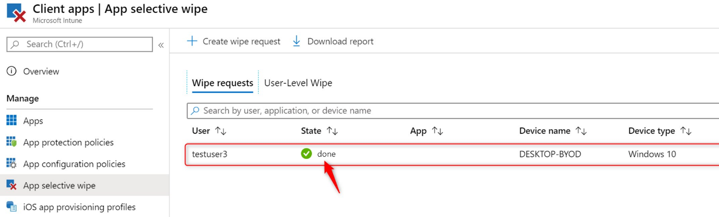

When the device has synced with Intune, it will start to revoke the encryption key and effectively block access. The report now shows the status of the wipe request has changed from **pending** to **done**.

**User Experience after a admin triggered selective wipe**

The very first thing that happens when the wipe request is received by a device, is a notification from the **Device Management Enrollment Service**. It tells you that the workplace account has been removed.

You did set the WIP configuration setting **Revoke encryption keys on unenroll**to**On**right? This is where the encryption key is revoked!

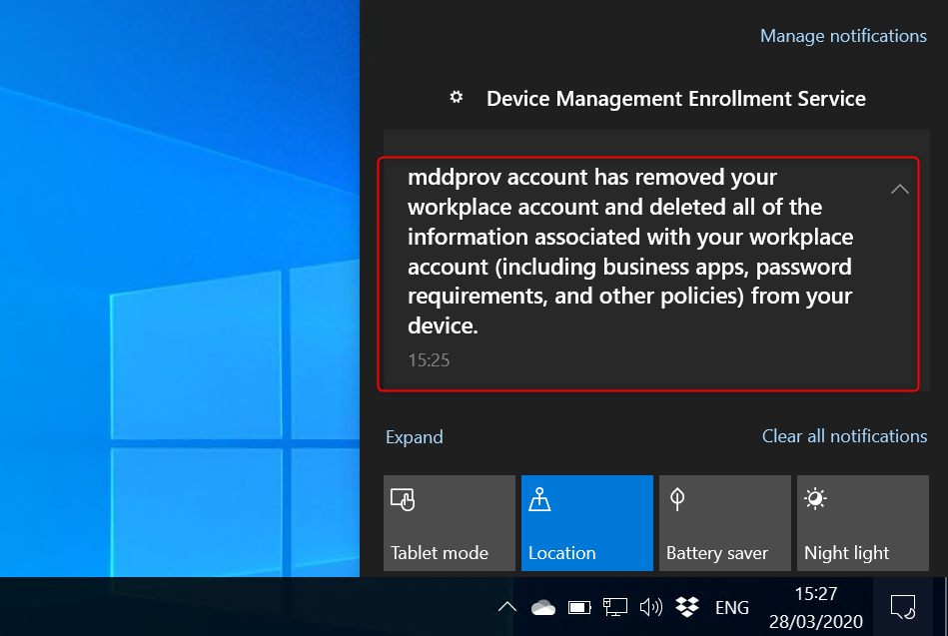

**OneDrive for Business after a selective wipe**

If OneDrive for Business or Outlook are open, they will close automatically. It’s not the best user experience since the apps basically crash. The second thing the user sees is an error message from Microsoft OneDrive. OneDrive for Business can’t sync data because the encryption key has been revoked.

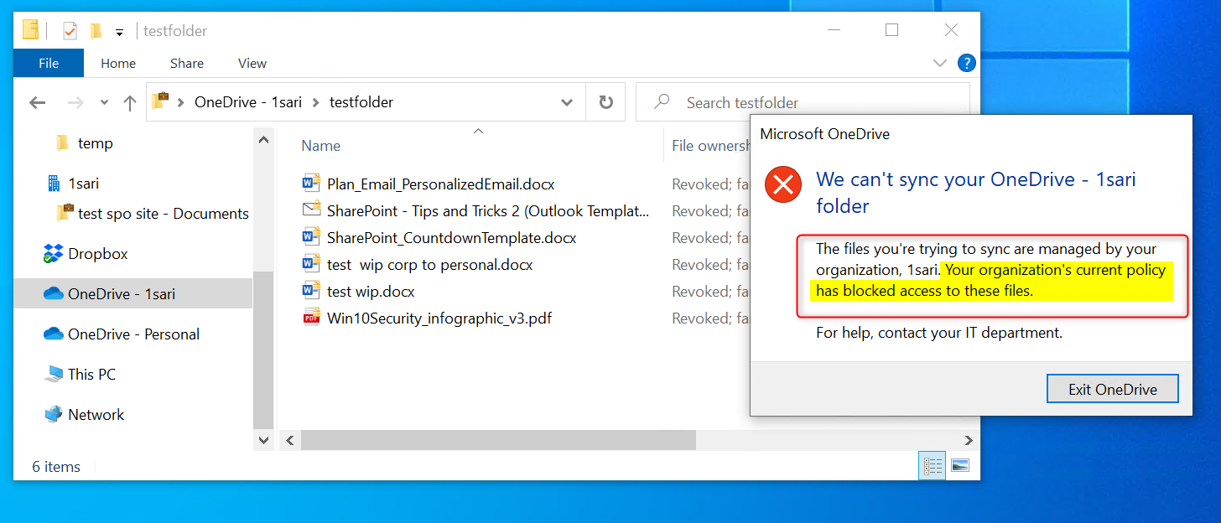

When the user opens Explorer, OneDrive for Business is no longer available. WIP Without Enrollment Selective Wipe seems to do the job right?

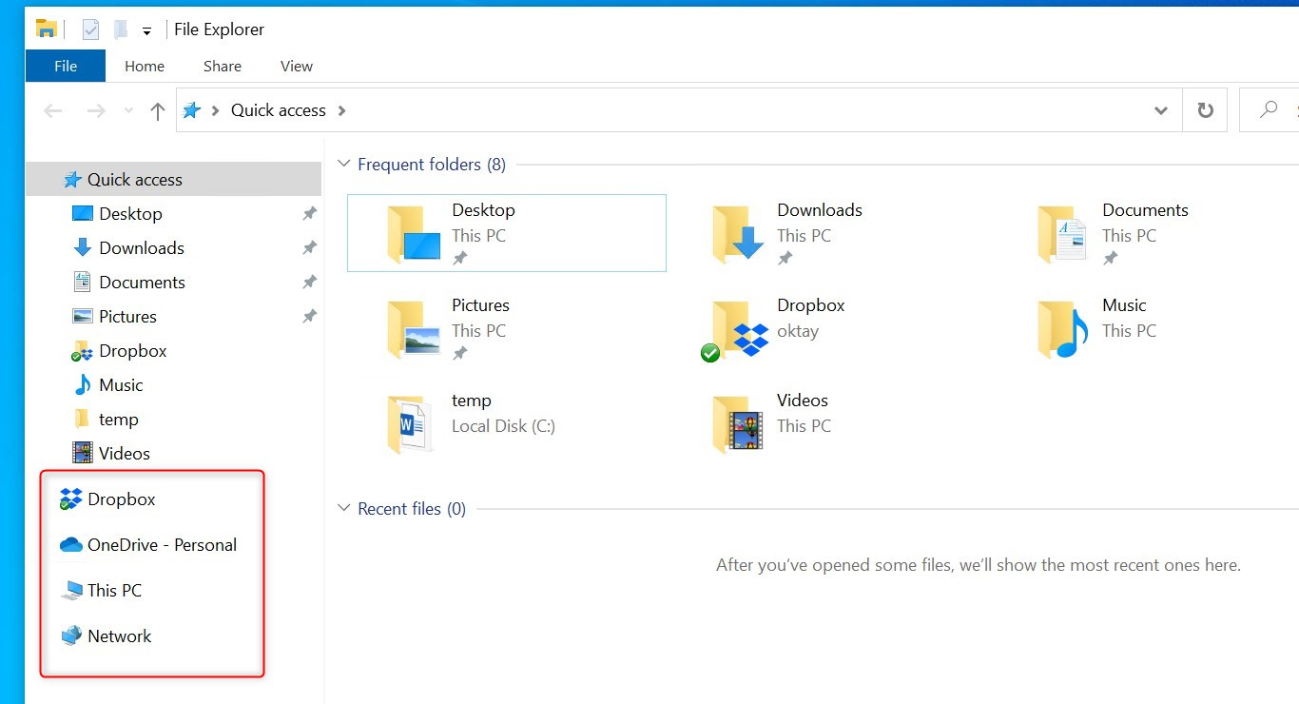

**Note:** The **selective wipe** process doesn’t actually remove locally stored corporate data! **It only revokes the encryption keys. T**hat in turn effectively removes access to locally stored corporate data.

If the user does stumble across locally stored corporate data, the “**File ownership**” column shows **Revoked;domain-name** . This tells us that the encryption key has been revoked.

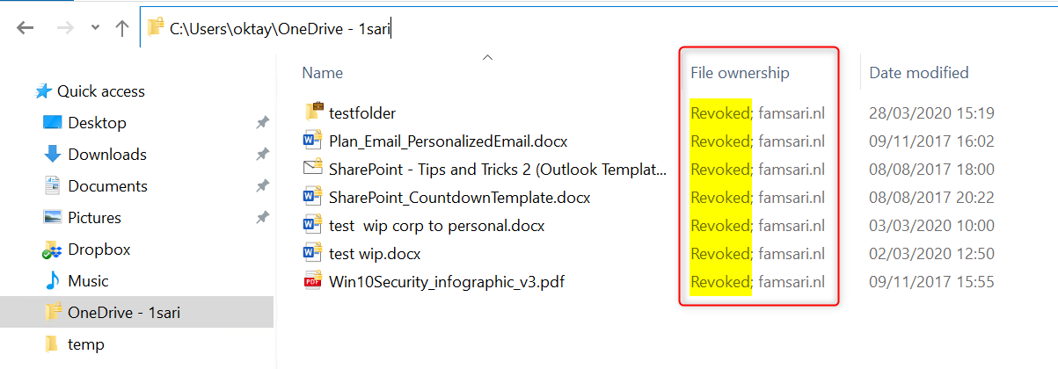

When opening a corporate document, an error message shows the user doesn’t have access privileges to open corporate documents.

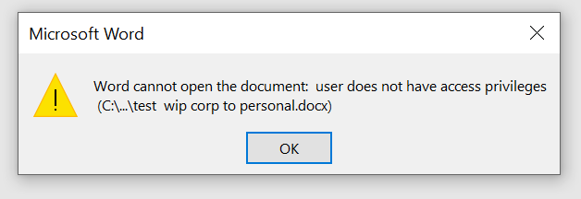

**Microsoft Office Outlook after a selective wipe**

Upon starting Outlook, two things can happen:

1. If there is a personal e-mail account configured, Outlook will start but you’ll have to start in **Safe Mode** to begin. In most cases you’ll have to re-configure another e-mail profile for your private e-mail. This seems like a buggy thing. You will also see that corporate e-mail has been removed after Outlook starts again.
2. When only a corporate e-mail profile is configured, the first time you start Outlook you’ll have to re-configure another e-mail profile. Either way, the user is confronted with error messages:

When you only have a corporate e-mail profile, you’ll see the this warning only:

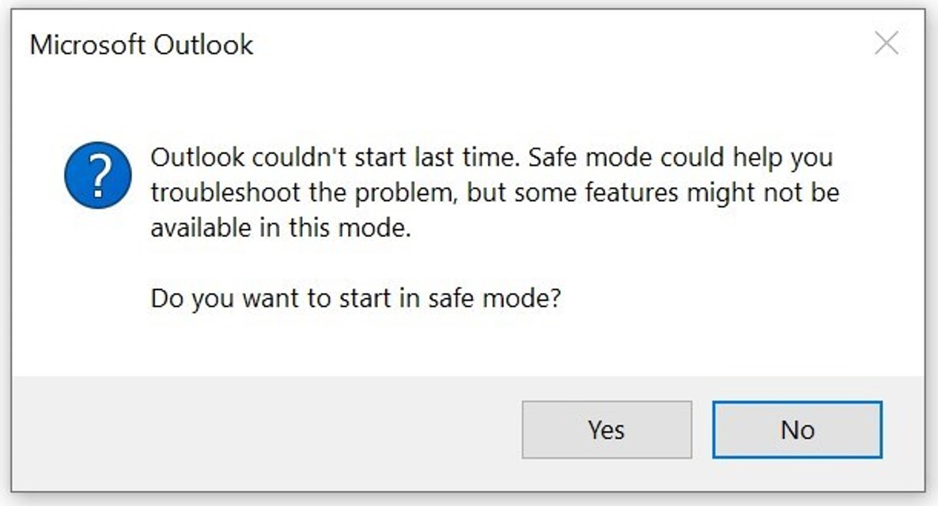

When you also have configured a personal email account like outlook.com, you’ll also see the next error message too:

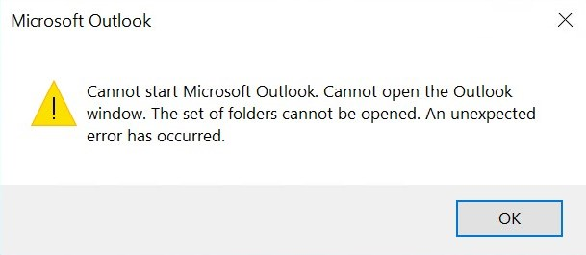

**Part 2: User disconnects Azure AD registered device**

When you no longer need to use your device for work, you can unregister or disconnect your device from Azure AD. Go to **Settings > Accounts > Access Work or School**. Select your account and click **Disconnect**.

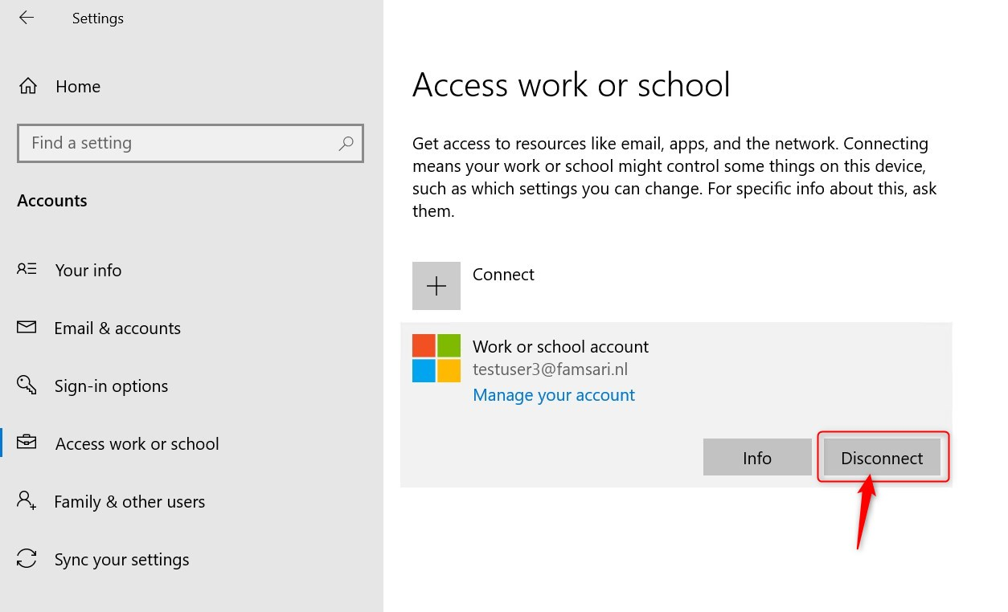

The next screen shows a warning.**Disconnecting your device will remove access to work resources**. Remember, this doesn’t actually remove locally stored corporate data.

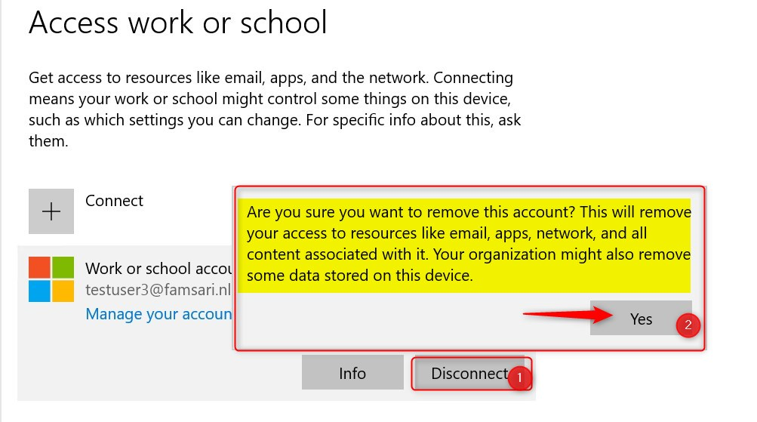

When you click **Yes**on this screen, the device will no longer be **Azure AD registered**. In most cases user experience will be affected almost immediately. From here on, the experience is the same as described above for both OneDrive for Business and Microsoft Outlook.

**Part 3: Microsoft Outlook offline data files and WIP**

There is an issue you need to be aware of when it comes to Outlook offline data files (emailprofile-name.ost) and Windows Information Protection (WIP). In particular with WIP-WE (MAM) and Bring Your Own Devices that are **only Azure AD registered**.

**By default, Microsoft Office Outlook offline data files are NOT marked as Work files, and are therefore not protected by WIP.**

Read that previous sentence again and then, have a look at: C:\Users\[username]\AppData\Local\Microsoft\Outlook\

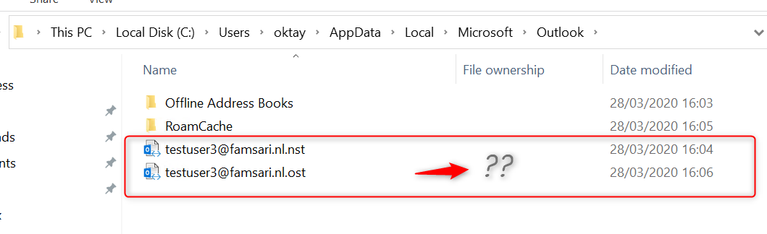

Microsoft recommends to use Microsoft Office Outlook profile in **Online mode**, or to **use encryption to protect OST files manually**. However, encryption is not something you can centrally manage very easily on Azure AD registered devices that are not managed by MDM.

A device that is **Azure AD registered** has only been registered in Azure AD. This registration gives you **no meaningful controls** over the device. You cannot push configuration profiles or enforce device based conditional access policies on devices that are only Azure AD registered. Your users would have to MDM enroll their devices for that to work.

**What happens to OST files upon selective wipe?**

When you execute a selective wipe, the OST file is untouched until you restart Outlook. When you restart Outlook or create another Outlook mail profile, the OST file is deleted automatically. Most users will not think of copying or moving the OST file after a selective wipe and before starting Outlook, but it does give a window of opportunity for a data breach. And yes, you can copy the OST file before a selective wipe is executed.

**What can I do with OST files, once I copied or moved them?**

Normally you could open the OST file with special software and convert it to a PST file. After that, You can open the PST file in Outlook and do anything you want with the data.

Of course, I tried to open the corporate OST file with various OST readers and OST to PST converters but was not able to read anything except folder-name structures. I’m no encryption specialist but everything is just scrambled and unreadable. Most OST viewers give an error indication the file is corrupt or encrypted.

So is there a form of encryption in place? Please tell me if you know something about this in the comments below.

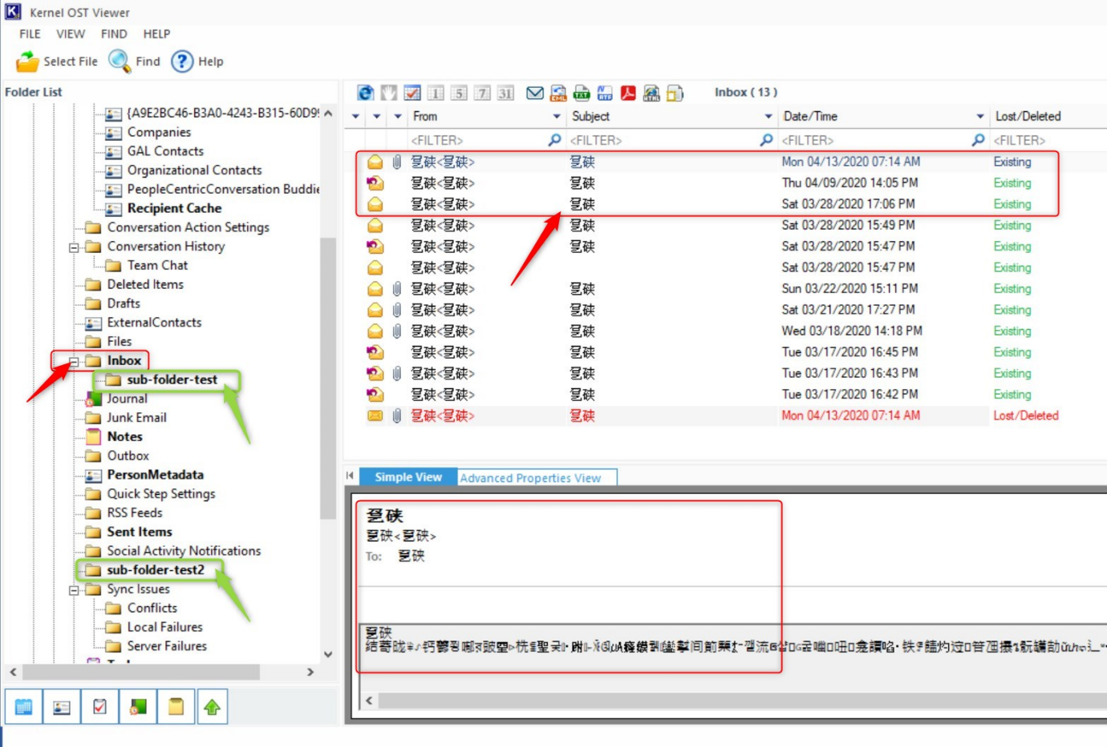

Just to be sure, I copied another OST file from my personal e-mail profile on the same device and same Outlook configuration. This time, I’m able to read everything and can even convert the file to PST.

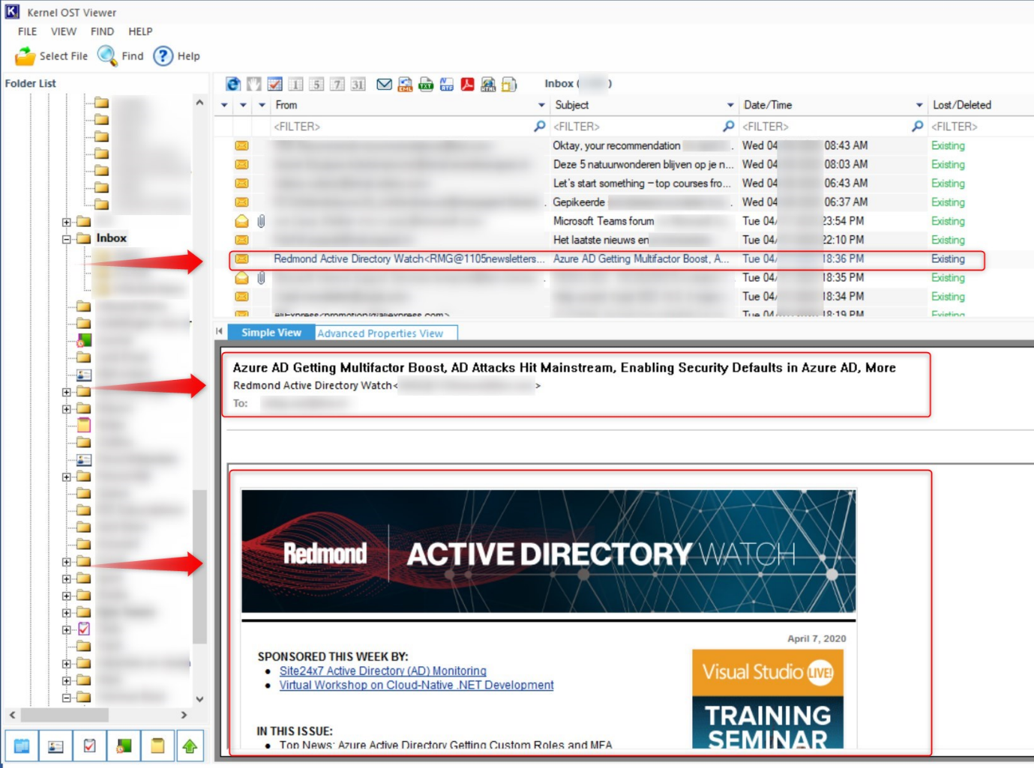

**My personal thoughts on this OST issue**

I find it strange that it’s not possible to work protect OST files. Hope someone can shed a lite on this anytime soon. Especially because other Outlook files seem to be protected by WIP. For example, when I export my mailbox to a PST file, by default it’s protected by WIP. I’m not able to safe it without WIP protection, no matter where I try to safe it.

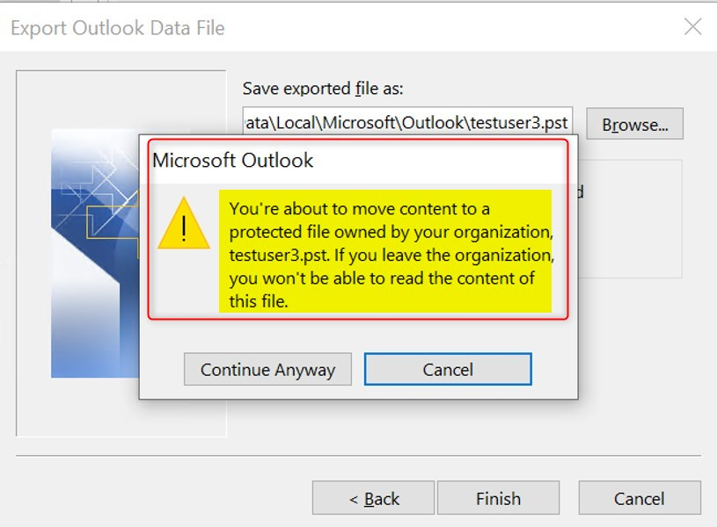

Outlook even warns about **moving content to a protected file** owned by my company, and I won’t be able to read the content when I leave the company. The PST file has the **File ownership** set to my protected domain.

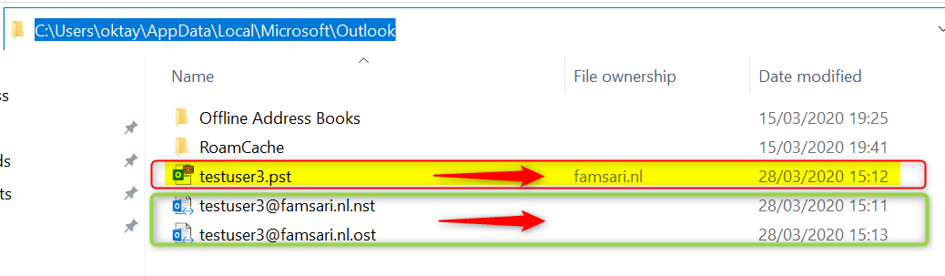

When you execute a selective wipe, the encryption key is revoked again and you can’t access the file anymore.

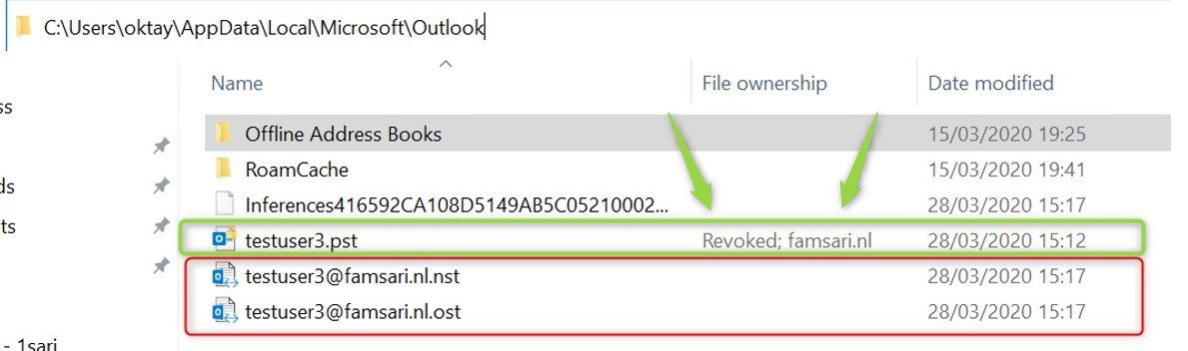

To make it even stranger, I found that **Offline Address Books are WIP protected by default**. How does that work?

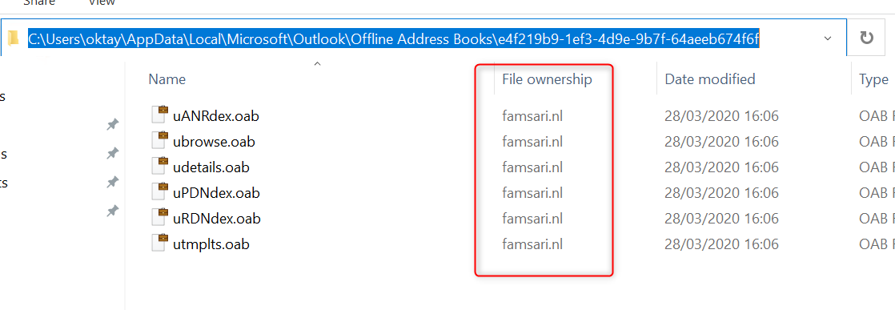

So why is it not possible to WIP protect OST files? I not so satisfied with Microsoft’s answer by putting it on the WIP limitations list. It seems to me, that it’s possible. I do believe that Microsoft continues to perfect Microsoft Intune and that this will be solved sometime in the future. Until then, we will have to work around this limitation.

**What can you do?**

I guess a best practice would be to go for **Outlook on the Web**combined with Conditional access policies to enforce restrictions.

You can restrict the ability for users to download attachments from email to a local device or block attachments entirely. By using a browser, users are able to view and edit these files safely , without leaking data to a personal devices. I’ll write more about that in another post in this series: Limiting Access to Exchange Online on unmanaged devices.

**Final Thoughts**

I hope this post helps you with implementing WIP and perhaps even challenges you to do your own testing and share your thoughts with us. I think some of this post can be confusing but non the less, I wanted to share my findings and hope to learn more. Please leave a comment or share this post if you think it might help others.

# Troubleshooting Windows Information Protection on Windows 10

[November 4, 2020](https://allthingscloud.blog/troubleshooting-windows-information-protection-on-windows-10/)  [Oktay Sari](https://allthingscloud.blog/author/oktay-sari/)  [Enterprise Mobility + Security](https://allthingscloud.blog/category/enterprise-mobility-security/), [Information Protection](https://allthingscloud.blog/category/information-protection/), [Intune](https://allthingscloud.blog/category/intune/), [MAM](https://allthingscloud.blog/category/mam/), [Mobile Device Management](https://allthingscloud.blog/category/mobile-device-management/), [Troubleshooting](https://allthingscloud.blog/category/troubleshooting/), [Windows 10](https://allthingscloud.blog/category/windows-10/), [Windows Information Protection](https://allthingscloud.blog/category/windows-information-protection/)

Troubleshooting Windows Information Protection can be a lengthy and time consuming process. If all goes according to plan, you can sit back and relax. If not, I hope this post will help you get on the right track again.

There are a couple of other post you might want to read: This post is part of a series.

1. [Introduction to Windows Information Protection](https://allthingscloud.blog/windows-information-protection-wip/)
2. [Configuring MDM user scope and MAM user scope](http://allthingscloud.blog/configuring-intune-mdm-user-scope-and-mam-user-scope/)
3. [WIP-WE / MAM – Windows Information Protection without enrollment](http://allthingscloud.blog/windows-information-protection-without-enrollment/)
4. [Windows Information Protection with Enrollment](http://allthingscloud.blog/windows-information-protection-with-enrollment/)
5. [Windows Information Protection User Experience](https://allthingscloud.blog/windows-information-protection-user-experience/)
6. [WIP-WE User Experience – WIP Without MDM enrollment](http://allthingscloud.blog/wip-we-user-experience/)
7. [Set up Azure Rights Management for WIP](https://allthingscloud.blog/azure-rights-management-for-wip/)
8. [WIP Without Enrollment Selective Wipe](https://allthingscloud.blog/wip-without-enrollment-selective-wipe/)
9. **Troubleshooting Windows Information Protection (this post)**
10. [Monitoring and collecting WIP audit event logs](https://allthingscloud.blog/monitoring-and-collecting-wip-audit-event-logs/)
11. WIP Learning mode
12. Limiting Access to SharePoint Online on unmanaged devices
13. Limiting Access to Exchange Online on unmanaged devices

## Troubleshooting Windows Information Protection

There are many things to consider when you start troubleshooting Windows Information Protection (WIP). For enrolled devices ([Windows Information Protection With Enrollment](https://allthingscloud.blog/windows-information-protection-with-enrollment/)) you have more options, logging and control than for devices that are not MDM enrolled. ([WIP-WE](https://allthingscloud.blog/windows-information-protection-without-enrollment/)). It might be helpful to have a couple of test devices at hand to do some fieldwork. Make sure you also read official Microsoft documentation that is available: [Limitations while using Windows Information Protection (WIP)](https://docs.microsoft.com/en-us/windows/security/information-protection/windows-information-protection/limitations-with-wip)

## Troubleshooting WIP topics:

1. [Your WIP policy does not apply](https://allthingscloud.blog/troubleshooting-windows-information-protection-on-windows-10/#your-wip-policy-does-not-apply)
2. [You want to limit access to SharePoint or Exchange Online on BYOD](https://allthingscloud.blog/troubleshooting-windows-information-protection-on-windows-10/#You-want-to-limit-access-to-SharePoint-or-Exchange-Online-on-BYOD)
3. [Downloads from SharePoint or OWA in 3rd party browsers are unprotected](https://allthingscloud.blog/troubleshooting-windows-information-protection-on-windows-10/#Downloads-from-SharePoint-or-OWA-in-3rd-party-browsers-are-unprotected)
4. [You have no internet connection with 3rd party browsers and WIP](https://allthingscloud.blog/troubleshooting-windows-information-protection-on-windows-10/#You-have-no-internet-connection-with-3rd-party-browsers-and-WIP)
5. [File downloads have no WIP protection](https://allthingscloud.blog/troubleshooting-windows-information-protection-on-windows-10/#You-have-no-internet-connection-with-3rd-party-browsers-and-WIP)
   * Files downloaded from SharePoint online are not WIP protected
   * downloads from OneDrive Online are not WIP protected
   * Files downloaded from Word online are not WIP protected
   * Files saved as from Word online or Excel Online are not WIP protected
   * When users download multiple files, WIP protection does not apply.
6. [Personal devices automatically MDM enroll with Intune](https://allthingscloud.blog/troubleshooting-windows-information-protection-on-windows-10/#Personal-devices-automatically-MDM-enroll-with-Intune)
7. [WIP-WE does not work without Azure AD registration](https://allthingscloud.blog/troubleshooting-windows-information-protection-on-windows-10/#WIP-WE-does-not-work-without-Azure-AD-registration)
   * WIP-WE policies do not apply to BYOD
8. [Office Outlook offline data files (PST and OST files) are not protected](https://allthingscloud.blog/troubleshooting-windows-information-protection-on-windows-10/#Office-Outlook-offline-data-files-are-not-protected)
9. [Your RMS template does not apply to your WIP protected devices](https://allthingscloud.blog/troubleshooting-windows-information-protection-on-windows-10/#Your-RMS-template-does-not-apply)

### Your WIP policy does not apply

Check your [MDM and MAM users scopes](https://allthingscloud.blog/configuring-intune-mdm-user-scope-and-mam-user-scope/). Also check the Intune App Protection policy and the assigned groups. Make sure the user is in the included group and not excluded. For WIP-WE make sure the device is Azure AD registered. Without Azure AD registration WIP-WE will not work.

### You want to limit access to SharePoint or Exchange Online on BYOD

Check the Microsoft Documentation:

* [Conditional Access: Session](https://docs.microsoft.com/en-us/azure/active-directory/conditional-access/concept-conditional-access-session)
* [Limiting access on unmanaged devices to SPO](https://docs.microsoft.com/nl-nl/sharepoint/control-access-from-unmanaged-devices)
* [Limited access with Exchange Online](https://techcommunity.microsoft.com/t5/outlook-blog/conditional-access-in-outlook-on-the-web-for-exchange-online/ba-p/267069)

I’ll be writing other blog posts about these topics and in particular discuss the user experience with session control.

### Downloads from SharePoint or OWA in 3rd party browsers are unprotected

WIP-WE is great but has it’s limitations. With WIP-WE targeting BYOD you don’t have full control over every app users have installed on their personal devices. **With WIP-WE you only have control over enlightened apps**. This is important to understand so let it sink in for a moment. Even if you add apps like Chrome or Firefox to your **Targeted apps** list for WIP-WE, it will do nothing. There is no documentation I could find about this behavior, except for a little text above your Targeted apps that gives a hint.

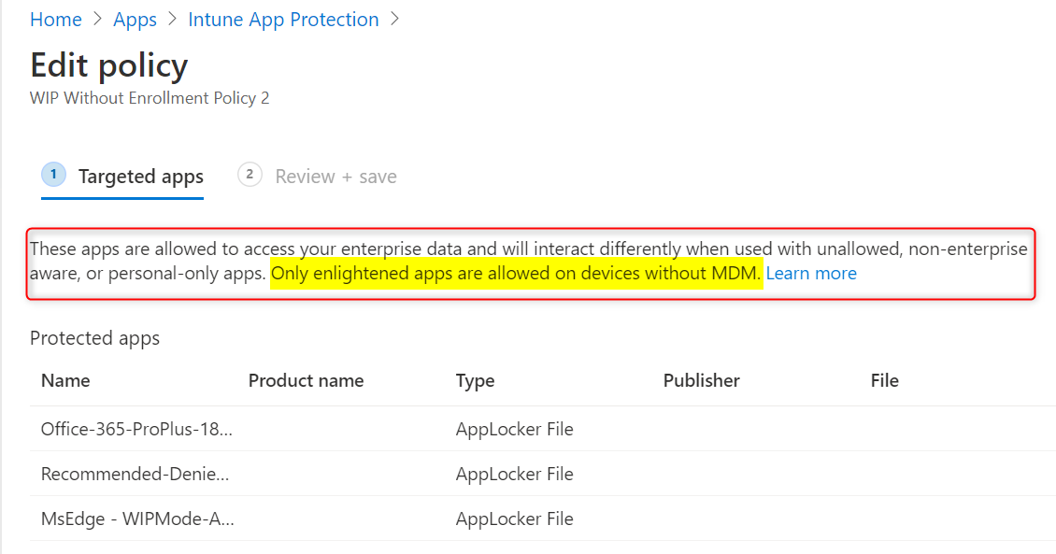

**You can’t get Firefox, Chrome or any other unenlightened app to mark files as corporate on a BYOD that is only registered in Azure AD without MDM**. Without MDM enrollment, these apps are considered personal only.

To better understand why, let’s have a look at how it works with MDM enrolled devices:

On a corporate device that is MDM enrolled in Intune, you can protect corporate data within most unenlightened apps by adding them to your targeted apps list. When unenlightened apps like Firefox and Chrome are listed as allowed apps, **everything you do in these browsers, is considered corporate and protection is applied**. So reading your personal e-mail or browsing Facebook with Chrome, is also considered corporate.

Any configuration settings or profiles you have in these browsers are encrypted. When you remove WIP from these devices, you’ll probably have to re-install these targeted applications because encryption can’t be undone completely. That is why Microsoft recommends to only add enlightened apps or any LOB apps.

Back to BYOD and Azure AD registered devices without MDM; When you add app to the list Microsoft has very scarce documentation available but here’s a hint:

“These apps are allowed to access your enterprise data and will interact differently when used with unallowed, non-enterprise aware, or personal-only apps. **Only enlightened apps are allowed on devices without MDM.**”

**You can only use enlightened apps on devices without MDM**. If you do decide to MDM enroll BYOD then be aware of the consequences.

On personal devices, you do not want to encrypt everything in unenlightened (targeted) apps. This would ruin the day when users decide to remove Azure AD registration, only to find out that they have to re-install apps they use personally every day.

A possible solution is to combine WIP-WE with DLP, session control and conditional access. If you want users to use Office 365 apps and the OneDrive client on BYOD, WIP-WE is a good solution, but you still have the problem with 3rd party browsers.

#### **Limiting Access to SharePoint Online.**

If you combine WIP-WE with DLP by setting restrictions on SharePoint Online browser sessions, you can block downloads in any browser. This still enables users to work online, but only within the browser session. Users cannot download anything from SPO ore ODB. They can still use the OneDrive client to sync their personal folders and since the OneDrive for Business client is an enlightened app, WIP-WE can do its job. SharePoint Online is now in a read-only mode.

#### **Limiting Access to Exchange Online and OWA**

The same applies to Exchange online. Use Session control and conditional access to limit access to Exchange Online sessions. This basically limits user access to Exchange online in any browser by blocking download of attachments. Users can still work in Exchange online, but in a read-only mode. They can still open word documents to work with in Word Online, but can’t download documents.

The good thing is, this also blocks any copy/paste actions in browsers, preventing data leaks.

Microsoft Documentation:

* [Conditional Access: Session](https://docs.microsoft.com/en-us/azure/active-directory/conditional-access/concept-conditional-access-session)
* [Limiting access on unmanaged devices to SPO](https://docs.microsoft.com/nl-nl/sharepoint/control-access-from-unmanaged-devices)
* [Limited access with Exchange Online](https://techcommunity.microsoft.com/t5/outlook-blog/conditional-access-in-outlook-on-the-web-for-exchange-online/ba-p/267069)

Combine WIP-WE with session control and conditional access to provide the best possible work experience on BYOD. I know it’s not a perfect solution and it could have been easier, but it’s something we can work with.

### You have no internet connection with 3rd party browsers and WIP

If you find out that after configuring WIP, you can’t use 3rd party browsers to access any internet site, it’s probably because you didn’t configure the **/*AppCompat*/** string. [Please read the documentation here](https://docs.microsoft.com/en-us/windows/security/information-protection/windows-information-protection/create-wip-policy-using-intune-azure#cloud-resources). If it’s still not working after adding this string, check to see if you copy/pasted any spaces before or after /.

Copy paste without “ marks:

* “/*AppCompat*/” will work.
* “/*AppCompat*/ ” will not work! Notice the space after the forward slash /

### File downloads from SharePoint or OneDrive have no WIP protection

When you download files from SharePoint Online or Onedrive, check the download URL’s. You’ll see that these URL’s change depending on your location and the download action. The same applies to files you save from Word Online or download as a PDF. The URL’s also change when you download multiple files from SharePoint Online or OneDrive. Here are some examples of problems you may encounter:

* Files downloaded from SharePoint online are not WIP protected
* Downloaded from OneDrive Online are not WIP protected
* Files downloaded from Word online are not WIP protected
* Files saved as from Word online or Excel Online are not WIP protected
* When users download multiple files, WIP protection does not apply.

So go ahead and download some files from OneDrive and SharePoint. Then check the download links:

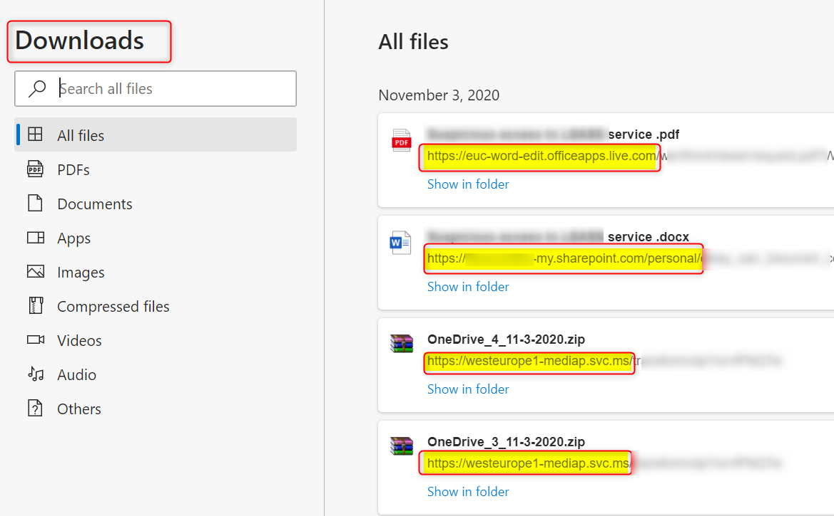

Depending on your location, you’ll  see some of the following URL’s:

* euc-powerpoint.officeapps.live.com
* euc-excel.officeapps.live.com
* northeurope1-mediap.svc.ms
* northeurope1-mediap.svc.ms
* euc-word-edit.officeapps.live.com
* euc-excel.officeapps.live.com
* euc-powerpoint.officeapps.live.com

Have a look at [**Office 365 URLs and IP address ranges**](https://docs.microsoft.com/en-us/microsoft-365/enterprise/urls-and-ip-address-ranges?view=o365-worldwide) and in particular **sections 39 and 46**

**Add .svc.ms|.officeapps.live.com to your cloud resources** and test again. It this does not solve your problems, you’ll have to add all (sub)domains from sections 39 and 46.

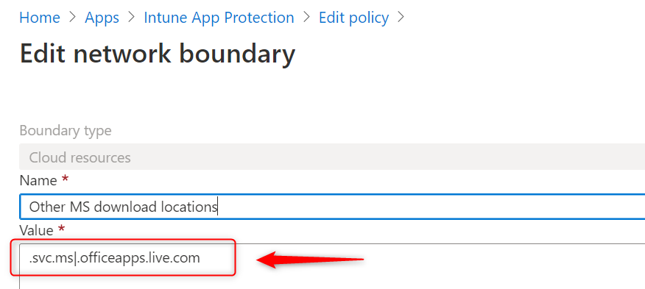

For your convenience:

.svc.ms|.online.office.com|.broadcast.officeapps.live.com|.excel.officeapps.live.com|.onenote.officeapps.live.com|.powerpoint.officeapps.live.com|.rtc.officeapps.live.com|.shared.officeapps.live.com|.view.officeapps.live.com|.visio.officeapps.live.com|.word-edit.officeapps.live.com|.office.live.com

### Personal devices automatically MDM enroll with Intune

This can be confusing but most of the time there is a logical explanation. If you want to block personal Windows 10 devices from MDM enrolling their devices with Intune, you’ll need to set enrollment restrictions for Windows 10. Please read the [MS documentation](https://docs.microsoft.com/en-us/mem/intune/enrollment/enrollment-restrictions-set#blocking-personal-windows-devices) for more info.

Also have a look at my previous blog about [Configuring MDM and MAM user scopes](https://allthingscloud.blog/configuring-intune-mdm-user-scope-and-mam-user-scope/). The Microsoft documentation has updated info so please read it if you run into problems. Check out [Set up enrollment for Windows devices](https://docs.microsoft.com/en-us/mem/intune/enrollment/windows-enroll). The following text has changed a couple of times since I started troubleshooting Windows Information Protection.

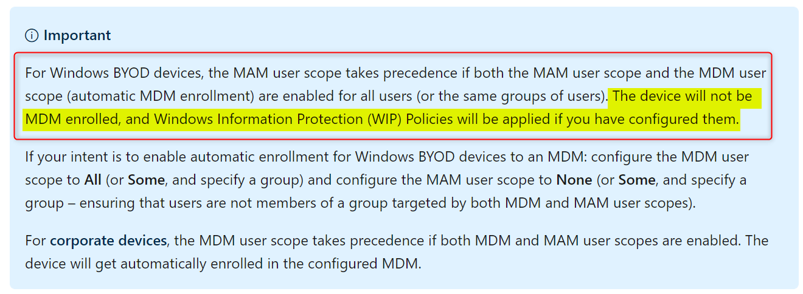

### WIP-WE does not work without Azure AD registration

WIP-WE will only work when a device is Azure AD registered. When users sign into a Office 365 application, the device will not register by default. This also applies to the checkmark “Allow my organization to manage my device”. If the user removes this checkmark, app protection is not enforced and you’ll have no control over corporate data.

By default, users are not enforced to register their personal devices with Azure AD. They can simply skip this step. Luckily, there is a way to enforce Azure AD registration for BYOD, but this will impact every user you target and on all their devices (personal and corporate).

**Azure Active Directory terms of use**

By configuring Azure Active Directory terms of use, you can force users to Azure AD register their devices before getting access to corporate data. Depending on how you configure this, you’ll be able to force Azure AD registration on every device.

Please read the official Microsoft documentation for more info and make sure you fully understand the impact:

* [Azure Active Directory terms of use](https://docs.microsoft.com/en-us/azure/active-directory/conditional-access/terms-of-use)
* [Choosing the right Terms solution for your organization](https://techcommunity.microsoft.com/t5/intune-customer-success/choosing-the-right-terms-solution-for-your-organization/ba-p/280180)
* [Quickstart: Require terms of use to be accepted before accessing cloud apps](https://docs.microsoft.com/en-us/azure/active-directory/conditional-access/require-tou)

To configure your terms of use, go to <https://aka.ms/catou>

To require users to accept your terms of use on every device they use to access corporate data, set **Require users to consent on every device** to **On**.

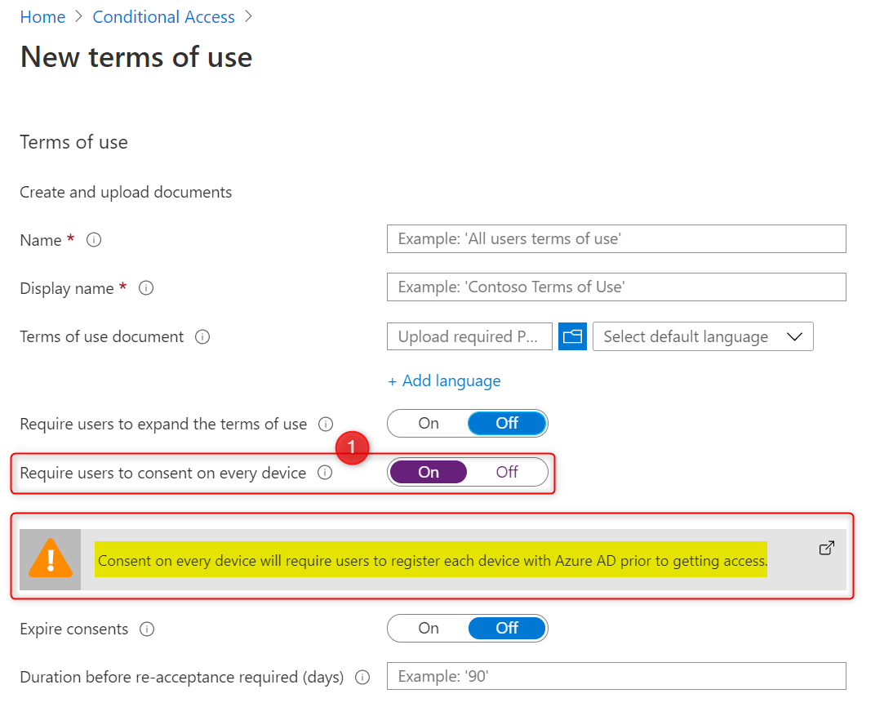

As you can read in the highlighted section, the user will be required to register their device in Azure AD prior to getting access. Make sure you target the correct user groups. I suggest you use a dynamic user group, where users have the right subscription assigned. You’ll need a subscription that includes Azure AD Premium P1 (Azure AD Premium P1, P2, EMS E3,EMS E5, M356 E3 or M365 E5).

### Office Outlook offline data files (PST and OST files) are not protected

This one bothered me for quite some time.

When performing selective wipe on BYOD (Azure AD registered), the ost file remains on the device. Normally this is not an issue but the file is not WIP protected to start with! This can be a security risk. I did some testing and share my thought here;

* When I export the Inbox to a PST it is WIP protected no matter where I save the PST file. This is a good thing.
* I noticed that all files in AppData\Local\Microsoft\Outlook\Offline Address Books\ (.oab files) are WIP protected upon creation, so that’s also good.
* When a selective wipe is performed, the oab files and pst file show “revoked” as “File Ownership” This is good and I have no access to these files until I add my work account again.

I copied the OST file from a BYOD (azure ad registered/WIP-WE policy applied) to another device and tried to open it using various ost viewers and ost2pst converters but wasn’t able to read or convert. In ost viewers I can see the Mailbox structure and e-mails but everything is scrambled. Some of the ost viewer even gave a error message saying the file was encrypted or corrupted.

To make sure, I copied another ost file from yet another test-device where I have no WIP protection and simply configured a test e-mail account in outlook. This time I can open the file in my ost viewers and convert it to pst without any issues. I can read emails and everything else.

Although there is a [user voice](https://microsoftintune.uservoice.com/forums/291681-ideas/suggestions/40034839-extend-wip-to-protect-outlook-mailbox-data) for this one, it did not receive many votes so I guess it will stay on the [WIP limitations list](https://docs.microsoft.com/en-us/windows/security/information-protection/windows-information-protection/limitations-with-wip) for a while. Please test this in your own tenant and make sure it works as you expect.

### Your RMS template does not apply to your WIP protected devices

Microsoft Azure Rights Management (**Azure RMS**) helps secure files when users want to share data using removable USB drives. For this to work , you must have Azure Rights Management set up. When Users copy WIP protected files to a USB drive, the protection stays with the data. There’s another blog about [Azure Rights Management with WIP](https://allthingscloud.blog/azure-rights-management-for-wip/) you might want to check out. Please note that Label management in the Azure portal and AIP is going to be [deprecated](https://techcommunity.microsoft.com/t5/microsoft-security-and/announcing-timelines-for-sunsetting-label-management-in-the/ba-p/1226179) by March 31, 2021. If you have already moved to the new **unified labeling** and migrated labels to the Microsoft 365 compliance center, you are on the right track.

There is one thing you might encounter when you create a unified label and specify the protection template ID for Azure RMS in your WIP policy.

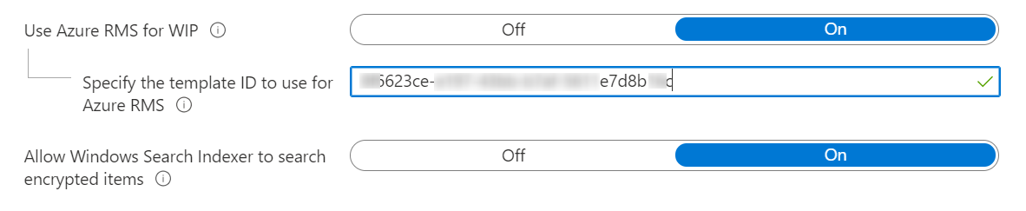

The template ID might not apply or deploy to your devices. First, you have to publish your unified label! If you don’t publish the label, it will not work. Secondly, you’ll have to be patient. It can take up to 24 hours or a little more.

1. Make sure you have published your unified label
2. Specify the Azure RMS template ID in your WIP policy
3. Start a sync on your test device. Go from Settings–>Accounts–>Access work or school.
4. Create an Advanced Diagnostic Report from within the Account Settings page
5. Open the MDMDiagReport.html file
6. Search for **RMSTemplateIDForEDP**
7. Check the ID. If it matches the ID you specified in step 2, it’s all good.
8. Be patient. Wait at least for 24 hours and test again

#### Conclusion

I hope this post helps you with troubleshooting Windows Information Protection. I’ll update this blog when I have something to share but if you have something you’d like to share, I invite you to share your thoughts and give your feedback below.

**Monitoring and collecting WIP audit event logs**

Let’s have a look at collecting WIP audit event logs using Azure Monitor and how to read and monitor event logs from Windows 10 devices. Windows Information Protection offers data separation, keeping corporate and personal data separate, and leak protection, by blocking the use of cut and paste actions. Most events triggered by Windows Information Protection are logged in the event log. Collecting WIP audit event logs to a central place Like Log Analytics will help a lot.

You can find these event logs under: **Application and Services Logs\Microsoft\Windows**

* EDP-Application-Learning
* EDP-Audit-Regular
* EDP-Audit-TCB

For example, when file ownership is changed from work to personal, or when corporate data is shared by moving a file to a USB drive or by copy/paste actions between apps. These actions are written to the event logs. To be able to audit the event logs from all your devices you will need to consolidate all these logs in one place. Otherwise it’s going to be a full-time job. In this post we’ll be collecting WIP audit event logs using Azure Monitor and Azure Log Analytics.

There are a couple of other post you might want to read: This post is part of a series.

1. [Introduction to Windows Information Protection](https://allthingscloud.blog/windows-information-protection-wip/)
2. [Configuring MDM user scope and MAM user scope](http://allthingscloud.blog/configuring-intune-mdm-user-scope-and-mam-user-scope/)
3. [WIP-WE / MAM – Windows Information Protection without enrollment](http://allthingscloud.blog/windows-information-protection-without-enrollment/)
4. [Windows Information Protection with Enrollment](http://allthingscloud.blog/windows-information-protection-with-enrollment/)
5. [Windows Information Protection User Experience](https://allthingscloud.blog/windows-information-protection-user-experience/)
6. [WIP-WE User Experience – WIP Without MDM enrollment](http://allthingscloud.blog/wip-we-user-experience/)
7. [Set up Azure Rights Management for WIP](https://allthingscloud.blog/azure-rights-management-for-wip/)
8. [WIP Without Enrollment Selective Wipe](https://allthingscloud.blog/wip-without-enrollment-selective-wipe/)
9. [Troubleshooting Windows Information Protection](https://allthingscloud.blog/troubleshooting-windows-information-protection-on-windows-10/)
10. **Monitoring and collecting WIP audit event logs (this post)**
11. WIP Learning mode
12. Limiting Access to SharePoint Online on unmanaged devices
13. Limiting Access to Exchange Online on unmanaged devices

**Prerequisites**

* Intune MDM enrolled Windows 10 device
* an existing or a new Log Analytics workspace
* The Microsoft Monitoring agent installed on MDM enrolled Windows 10 devices
* Be sure to check the [network requirements](https://docs.microsoft.com/en-us/azure/azure-monitor/platform/log-analytics-agent#network-requirements)

**WIP monitoring Limitations**

The Microsoft Monitoring Agent collects the events and sends them to Azure Log Analytics. Deploying software using Intune, can only be done on devices that are MDM enrolled. **Therefore,** **you’ll need Windows 10 devices that are MDM enrolled with Intune**. Collecting WIP audit event logs from personal (BYOD) devices (Azure AD registered) is not possible by default. This is only possible when users choose to MDM enroll their personal devices! I haven’t tested installing the MMA manually on BYOD Azure AD registered devices, but that might be an option to further explore.

**WIP and Azure Log Analytics Workspace**

Use an existing Workspace or create a new Log Analytics Workspace. I’m assuming you know how to set up Log Analytics. If not, check out the [Microsoft documentation here](https://docs.microsoft.com/en-us/azure/azure-monitor/learn/quick-create-workspace).

The Microsoft documentation about [Collecting WIP audit logs using Azure Monitor](https://docs.microsoft.com/en-us/windows/security/information-protection/windows-information-protection/collect-wip-audit-event-logs#collect-wip-audit-logs-using-azure-monitor) is quite OK on this one, but does need an update. The **Workspace ID** and **Primary key** have been moved from **advanced settings**to**agents management**. I’ve added some screenshots to further explain the process.

1. Go to **Log Analytics**->**Advanced Settings**->**Data**->**Windows Event Logs**
2. **add the logs you want to be send to Azure Log Analytics**

There are 3 logs you’ll want to collect data from and I’ll go into more detail a little further below.

* Microsoft-Windows-EDP-Application-Learning/Admin
* Microsoft-Windows-EDP-Audit-Regular/Admin
* Microsoft-Windows-EDP-Audit-TCB/Admin

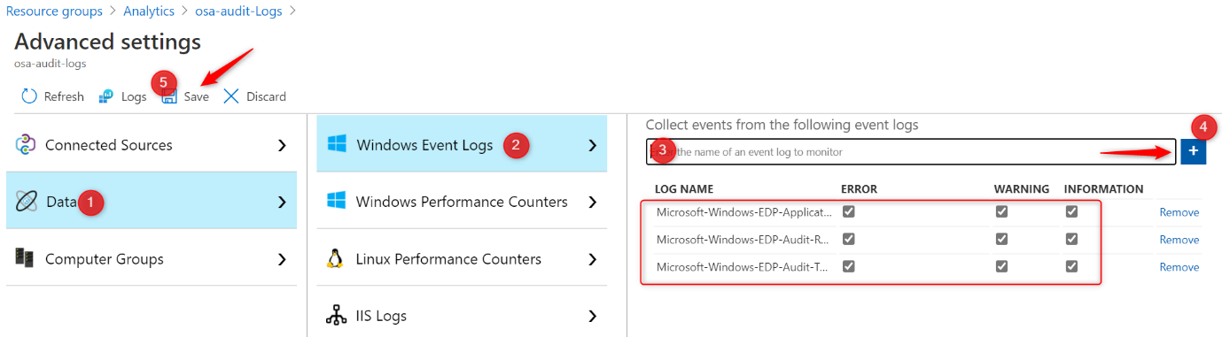

**Note: Don’t forget or skip step 2! Otherwise you’ll not be able to analyze the logs in Azure.**

* Download the Microsoft [Monitoring Agent here.](https://docs.microsoft.com/en-us/azure/azure-monitor/platform/agent-windows#install-agent-using-dsc-in-azure-automation)You can also download the agent from Azure Log Analytics. Click on Agents management on the right and download your agent from there.

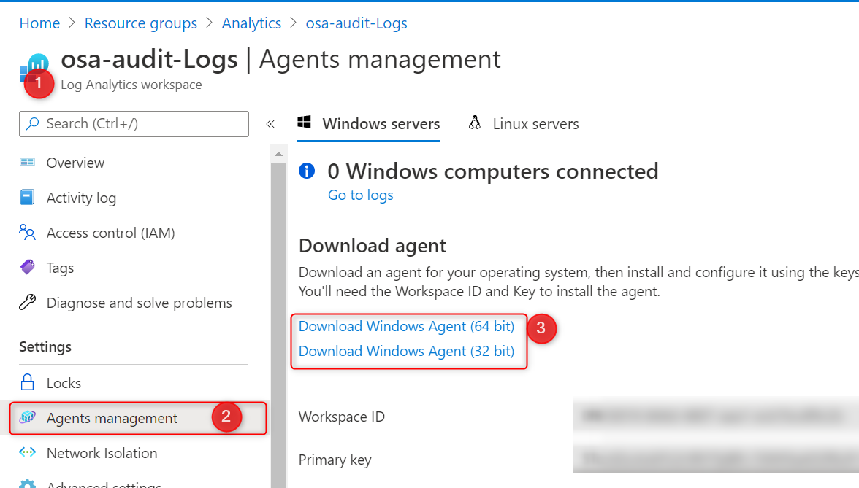

* The download contains a .EXE file but you can extract the .MSI file. I use 7-zip to do this

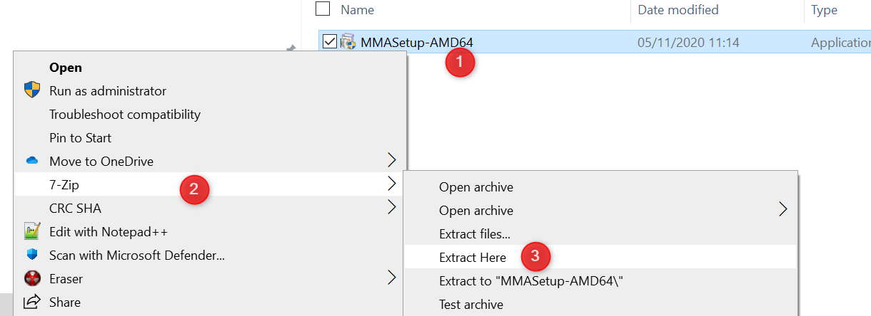

* Now you can deploy the MSI file with Intune. You only need 1 file: **MOMAgent.msi**

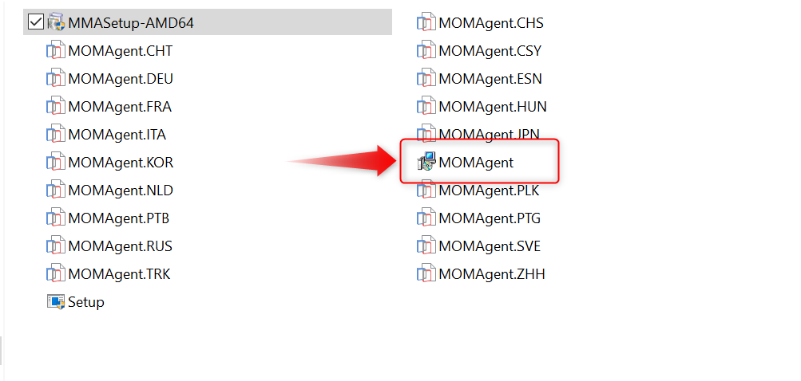

* Install the MOMAgent.msi to your WIP protected devices using the **Workspace ID** and **Primary key** from “Log AnalyticsAgents Management” where you’ve downloaded the agent.

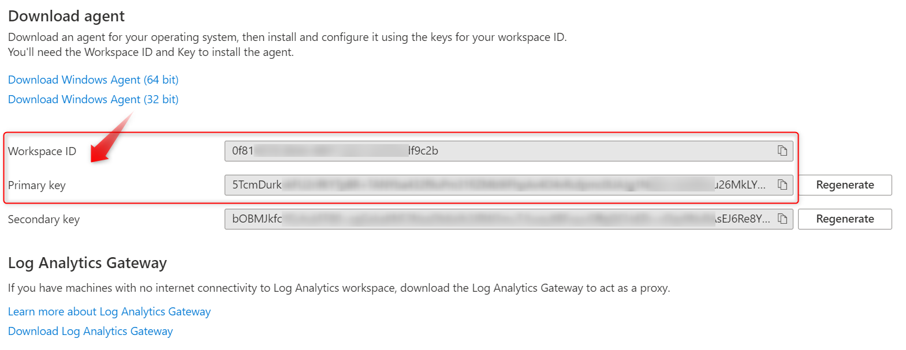

* To deploy the MSI file via Intune, and make sure you update the command-line arguments:

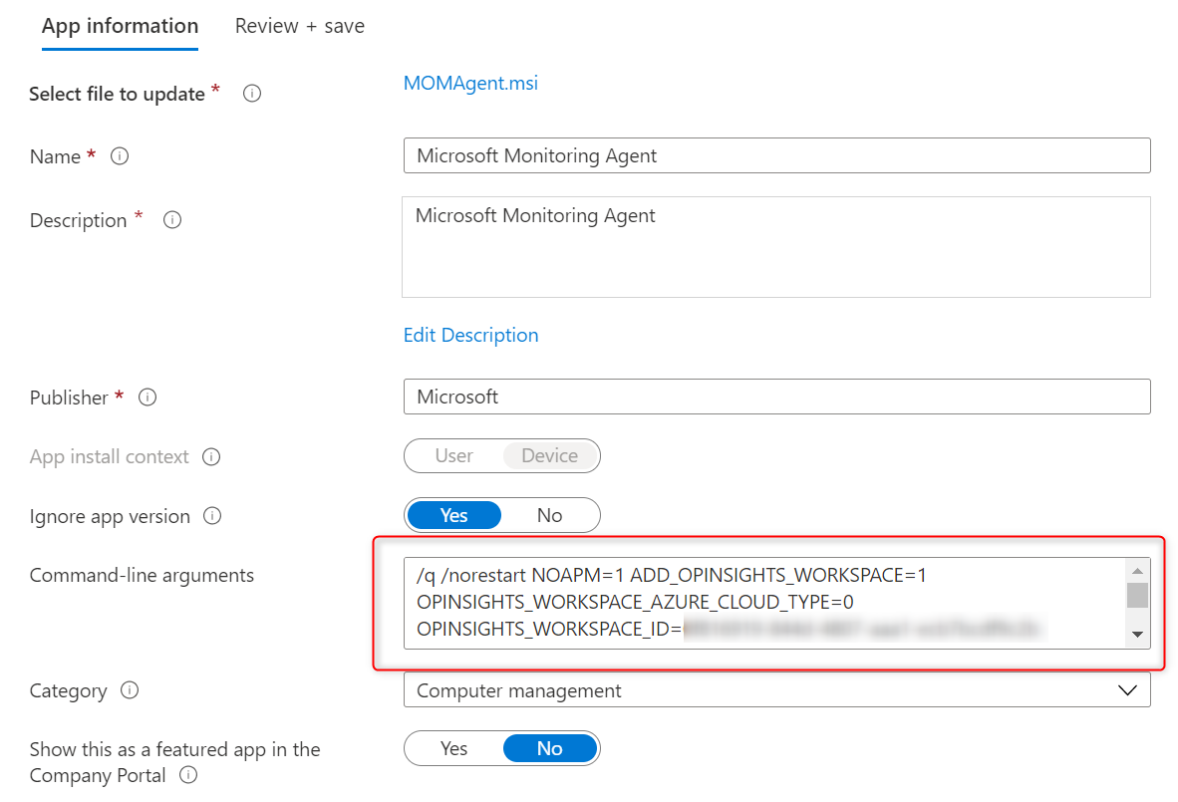

/q /norestart NOAPM=1 ADD_OPINSIGHTS_WORKSPACE=1 OPINSIGHTS_WORKSPACE_AZURE_CLOUD_TYPE=0 OPINSIGHTS_WORKSPACE_ID=0f81xxxx-0000-xxxx-0000-xxxxxxxf9c2b OPINSIGHTS_WORKSPACE_KEY=5TcmDurkxxxxxxxxxxxxxxx000000000000xxxxxxxx0000000000xxxxxxxxxx0000000000xxxxxxxxxx0000026MkLYQ AcceptEndUserLicenseAgreement=1

Copy

**REPLACE** the **WORKSPACE_ID** & **WORKSPACE_KEY** with your own keys. The above keys in bold are for illustration purposes only but I guess you get that.

* You can check the agent deployed status in Intune and start receiving data in about 10 minutes after installation completes.

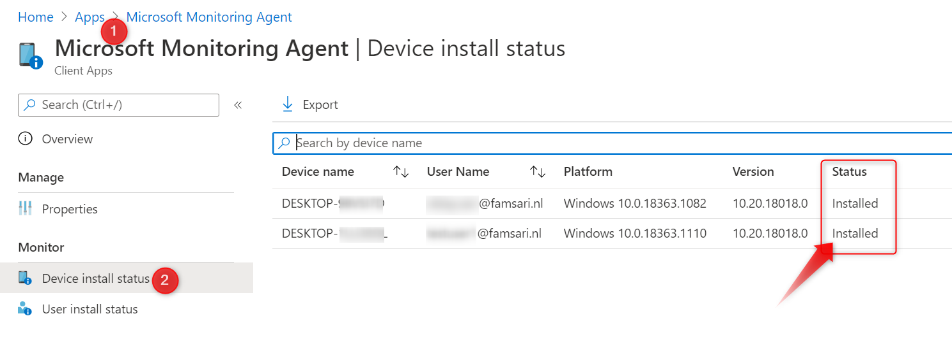

**Analyzing WIP event logs**

So you’ve configured your Log Analytics Workspace and installed the Microsoft Monitoring Agent on your devices right? You cannot wait to see what data is going to pop-up in Log Analytics. But what kind of data can you find in the 3 Event logs you’ve added in step 2 before?

If you followed this post to add the event logs to your Log Analytics Workspace there a 3 logs to monitor for events.

1. Microsoft-Windows-EDP-Application-Learning/Admin
2. Microsoft-Windows-EDP-Audit-Regular/Admin
3. Microsoft-Windows-EDP-Audit-TCB/Admin

**Microsoft-Windows-EDP-Application-Learning/Admin**

This log will collect information on applications that try to access enterprise resources. When you look at the events on the device itself, you’ll see **event ID 401** “**An application tried to access enterprise resources**” When you look at the details, you will also see which app was trying to access your WIP protected data. In this example it’s Dropbox.

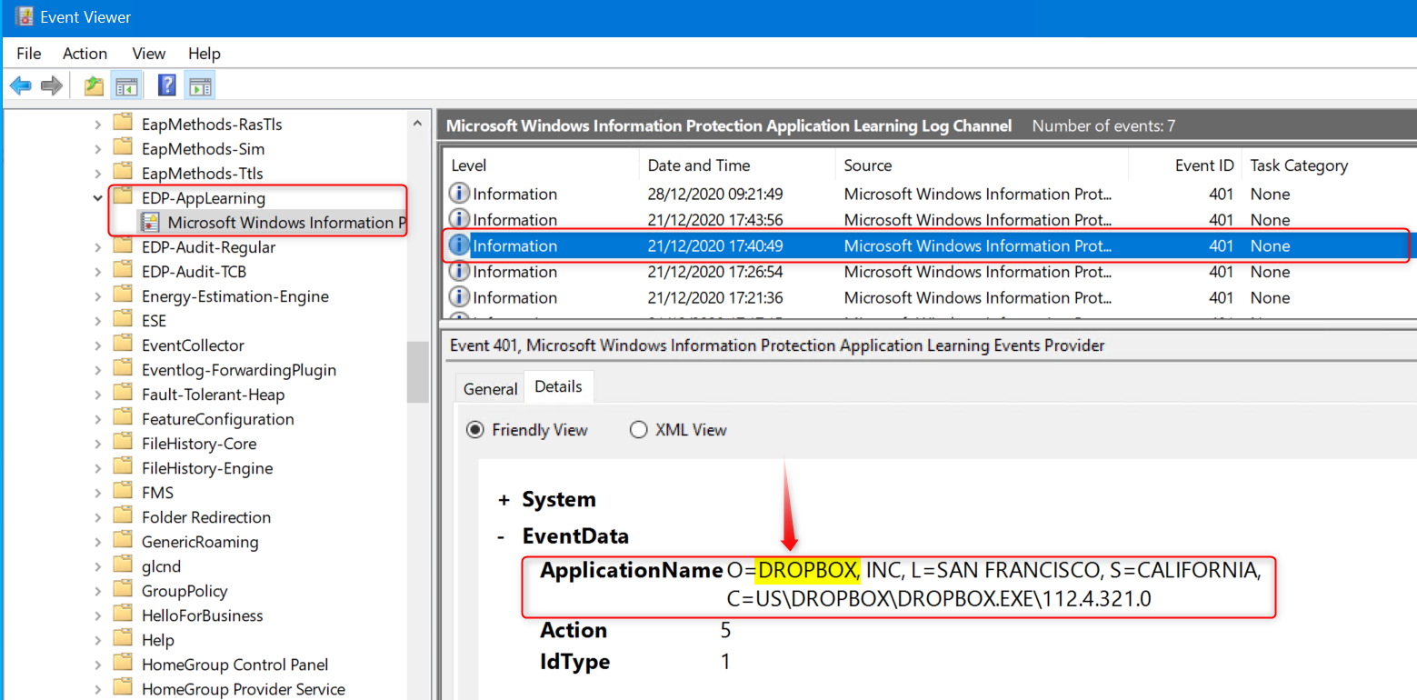

In the example above, the app trying to access enterprise data is Dropbox. I know **Dropbox is not on the allowed apps list** so this tells me it probably did not succeed in accessing or synchronizing data to Dropbox. But I have my WIP policy set to “Allow override”. What if the user changes file properties and removes protection by changing the File ownership to personal? That action will end up in **Microsoft-Windows-EDP-Audit-TCB/Admin**.

More on that later, but first let’s have a look at another example. The user is going to upload a WIP protected file as an attachment in Gmail. When using Google Chrome, **which is also not on the allowed apps list**, the action is logged. Same as with Dropbox. There was an attempt to access WIP protected data with an application, but the user probably clicked on the No button when confronted with the “Use work content here?” pop-up, so it’s OK up to this point.

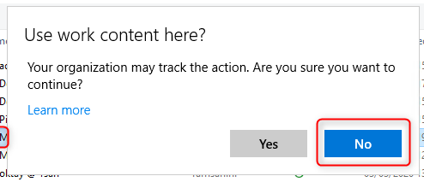

When the user clicks on **Yes,**the WIP protection is removed and another event is written to **Microsoft-Windows-EDP-Audit-Regular.**

**Microsoft-Windows-EDP-Audit-Regular/Admin**

When applications access WIP protected files and the user is allowed to remove protection, upon doing so, this action will be audited and the event written to the **Microsoft-Windows-EDP-Audit-Regular/Admin**log.

In the next example, a user tries to upload a WIP protected file using the Opera browser to Gmail. As you’ve seen before, the action will be audited and an event is written to **Microsoft-Windows-EDP-Application-Learning/Admin**when the user clicks on **No**. If the user clicks on Yes and removes the WIP protection, the action is also audited and an event is written to **the Microsoft-Windows-EDP-Audit-Regular/Admin.** Do you still follow me on this one?

Have a look at the screenshot below from the event log on my Windows 10 test device.

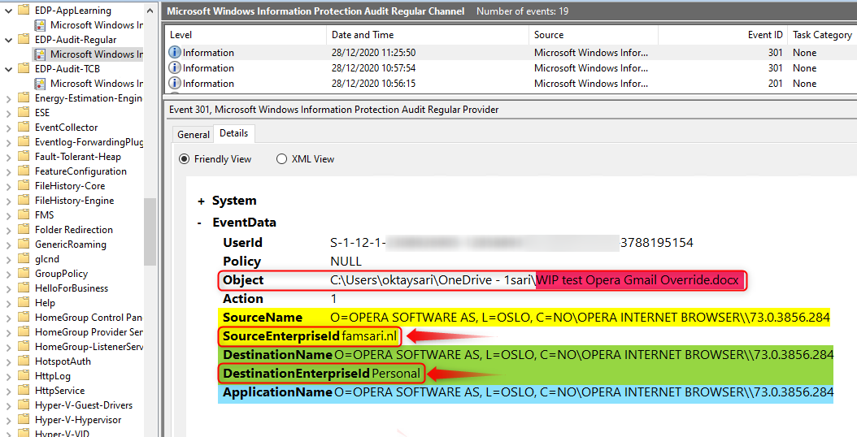

* The **Object** is a word document named **WIP test Opera Gmail Override.docx**
* **SourceName**is the name of the application from where the file is being accessed.
* **SourceEnterpriseId**is showing the enterprise tag. The file is protected!
* **DestinationName**is the name of the application to where the file is being transferred/copied.
* **DestinationEnterpriseId** shows the file has changed from corporate to personal!
* And then you have the **ApplicationName** which is the Opera browser in this example.

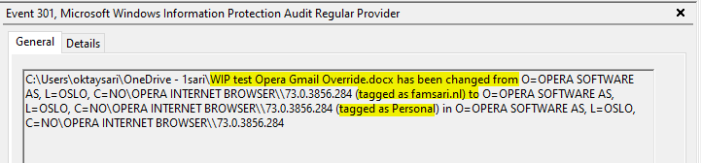

**Microsoft-Windows-EDP-Audit-TCB/Admin**

The final log we’ll have a look at is **Microsoft-Windows-EDP-Audit-TCB/Admin.**This event log audits events where protection has been removed by a user, for example by right clicking on a protected file and using the **File ownership** menu option to **change from Work to Personal**.

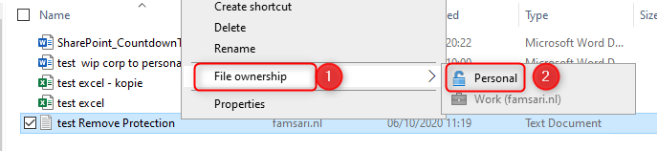

When you check the event in the logs, you’ll see the Enterprise tag has been removed from the file.

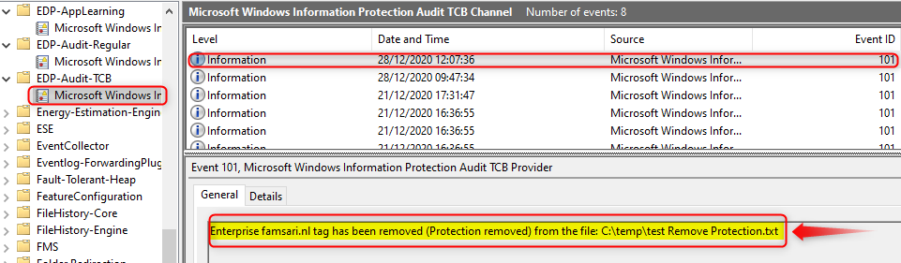

So there you have it. These are the 3 event logs you’ll want to monitor. What you don’t want to do is check each and every device you manage manually. That’s just crazy when you have Azure Log Analytics to do the hard work for you.

**Searching in Azure Log Analytics logs**

Now that the Microsoft Monitoring Agent has been installed to your devices, it starts collecting WIP related information and send that over to Azure Log Analytics for storage and further analysis. You’ve seen how to check the event logs on the device itself but you can do this from a central place for all your devices.

Go to your **Azure portal** and browse to **Log Analytics workspaces.**Open the workspace you’ve setup earlier and then click on **Logs** (1).

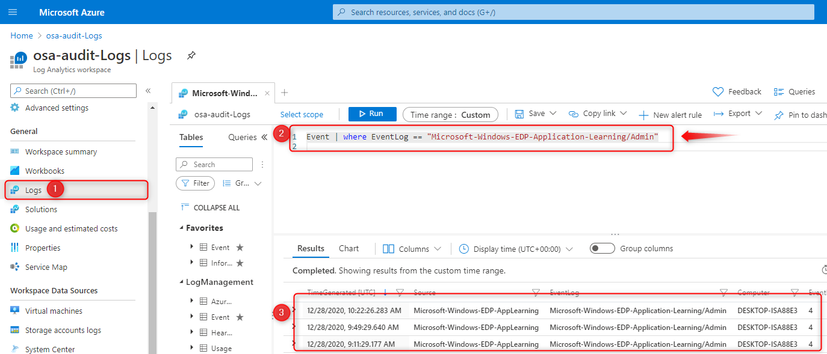

If everything is setup correctly you should be able to run a query (2) like:

Event | where EventLog == "Microsoft-Windows-EDP-Application-Learning/Admin"

Copy

This will show you all entries written to the event logs of all your devices. The information is formatted differently but contains the same information as on the device itself.

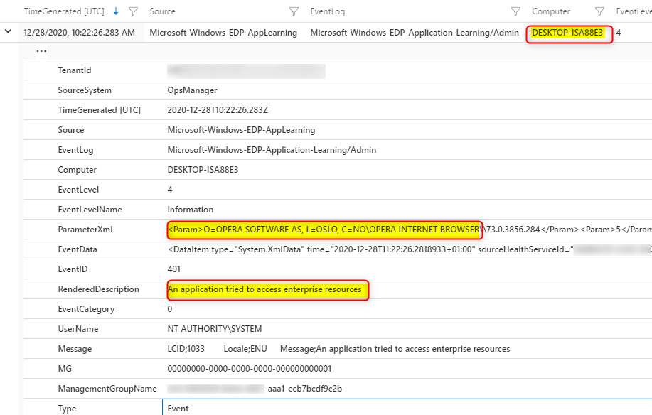

Also try these 2 other queries to see what’s come up;

Event | where EventLog == "Microsoft-Windows-EDP-Audit-TCB/Admin"

Event | where EventLog == "Microsoft-Windows-EDP-Audit-Regular/Admin"

Copy

**Unenlightened apps**

I guess it’s a limitation or falls under the category “**Works as designed**” but when you add an unenlightened app to the allowed app list, **nothing is audited** for that app or written to the event logs! If you think about it, it works as designed. By adding the app to the allowed app list, you basically tell WIP to trust everything a user does within that app.

These apps will consider all data to be corporate, encrypting everything created or edited by default so think about this before you add unenlightened apps. Microsoft recommends only adding LOB apps to your allowed apps list

I’ve added Firefox as an example and signed-in to Google Gmail. I can now upload an attachment to e-mail or open a PDF file in Firefox without any issues and NO audit trail. I did not see the Override or cancel question! Same is true for Wordpad. If you add it to the allowed app list, a user can open a word document without being audited.

This alone is reason enough for me to only add enlightened apps to the list and to be very cautious when adding unenlightened apps. Just make sure you understand the consequences when you do add unenlightened apps.

The big difference between FireFox (unenlightened) and Edge (enlightened) is that Edge can differentiate between corporate and personal data whereas unenlightened apps like FireFox cannot. So If I was to upload a WIP protected file to Gmail using Edge, I would have to Override the WIP protection policy by clicking on **Override**:

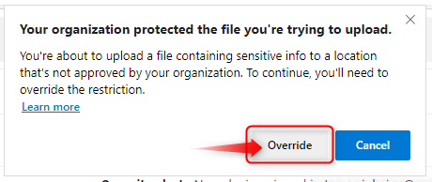

And only then, the protection is removed from the file while at the same time being audited. As you can see below, I have removed protection from a WIP protected file using the Edge browser while transferring enterprise data to mail.google.com.

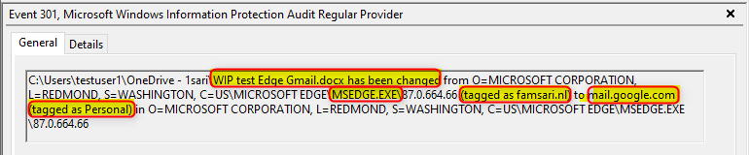

Edge should be the browser for business related work! You can still deploy other browsers, but don’t add them to the approved apps list or set the app entry to **deny**.

**Other limitations or considerations**

Let’s have a look at the results when we run the query;

Event | where EventLog == "Microsoft-Windows-EDP-Audit-Regular/Admin"

Copy

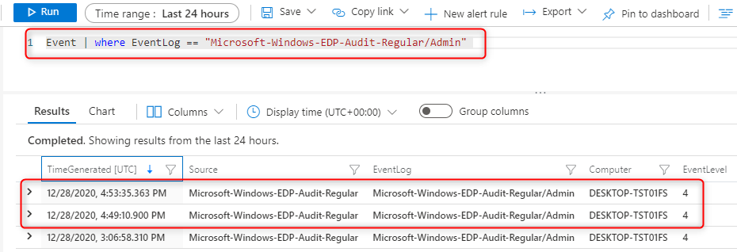

When I open the first result I can see what’s in the event log. I’m interested in 2 columns in particular; **EventData** and **RenderedDescription.**The information here is better to understand when you look at the event log on the device itself:

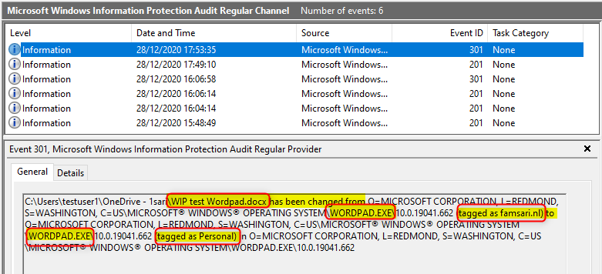

This is normal and to replicate this, you will have to open Wordpad, then in Wordpad go to the Menu File to open a document. Browse to your OneDrive folder and try to open a word document.

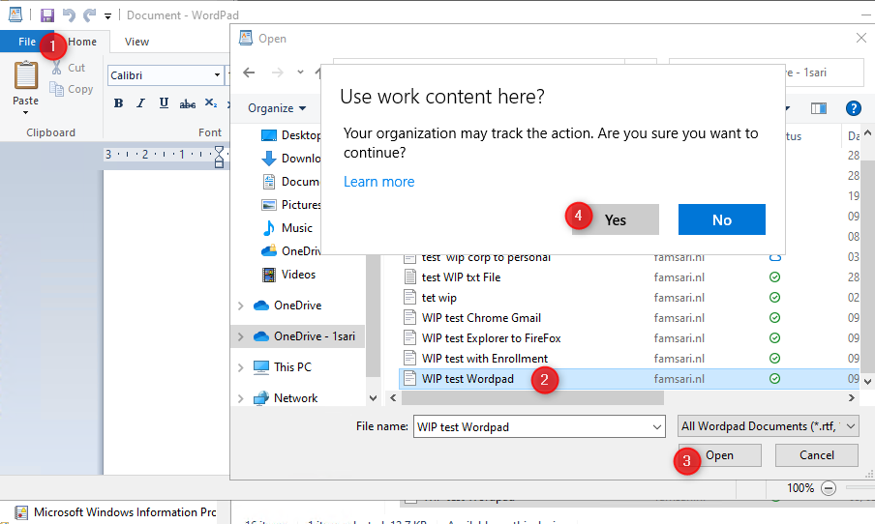

When you click on Yes, the action is audited and written to the event log because Wordpad is **NOT** on the allowed app list. So Basically you used Wordpad to open a WIP protected file in OneDrive. All good right?

Now when you open explorer and drag the same file from explorer.exe to wordpad, it’s audited but the information is incomplete. Have a look at the information below.

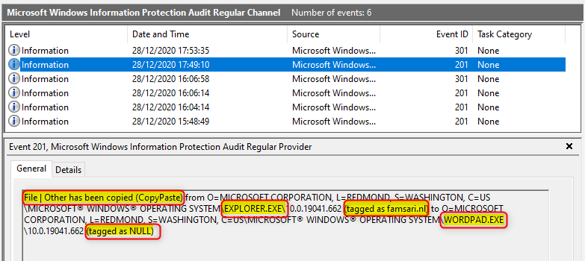

I know explorer.exe has been used to drag a file to wordpad, but I can’t see the actual filename. I can see the file is tagged as corporate when I started this action. After opening (overriding WIP) the file it should also show the protection was removed, but it only shows **tagged as NULL**.

To make it even more complex, The CopyPaste action from Explorer to Wordpad also writes an event to the **Microsoft-Windows-EDP-Application-Learning/Admin**log. But opening the document from within Wordpad itself, does not…Why is that?? I guess I have to talk to Microsoft about this and see if there’s a uservoice or not.

**Administrators job – What to do with all this?**

Azure Log Analytics gives you the option to monitor most of all WIP related logs for all your devices from one single console. It also comes with powerful **alert rules** for queries so you don’t have to do all the hard work.

For example: You can configure an alert rule to send you an e-mail when WIP protection has been removed from 5 or more files in less then 10 minutes.

If you’re a Kusto Query Rockstar (which I’m not yet….) you can be very specific when creating alert rules for your queries. Please share your queries if you feel they can add value.

Here’s an example email from an alert rule I created for testing purposes:

